**Course Description**

Now that you have learned the foundations of pandas, this course will give you the chance to apply that knowledge by answering interesting questions about a real dataset! You will explore the Stanford Open Policing Project dataset and analyze the impact of gender on police behavior.

During the course, you will gain more practice cleaning messy data, creating visualizations, combining and reshaping datasets, and manipulating time series data. Analyzing Police Activity with pandas will give you valuable experience analyzing a dataset from start to finish, preparing you for your data science career!

**1. Preparing the data for analysis**

Before beginning your analysis, it is critical that you first examine and clean the dataset, to make working with it a more efficient process. In this chapter, you will practice fixing data types, handling missing values, and dropping columns and rows while learning about the Stanford Open Policing Project dataset.



In this course, you'll be practicing a lot of what you've learned about pandas already to answer interesting questions about a real dataset. You'll gain valuable experience analyzing a dataset from start to finish, which will help to prepare you for your data science career.

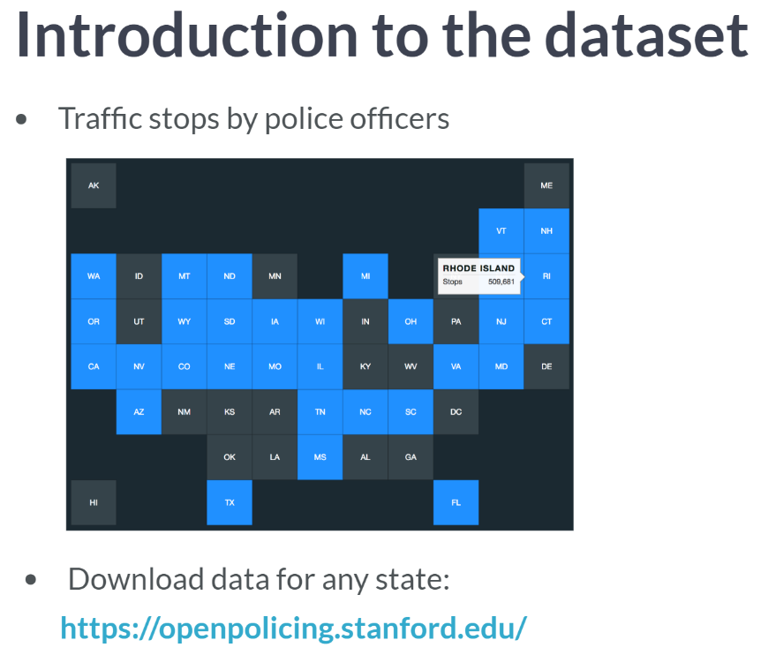  
Let's start by introducing the data. You'll be working with a dataset of traffic stops by police officers that was collected by the Stanford Open Policing Project. They've collected data from 31 US states, but in this course you'll be focusing on data from the state of Rhode Island.

For size reasons, some of the columns and rows have been removed, but you can download the full dataset for any of the 31 states from the project's website.

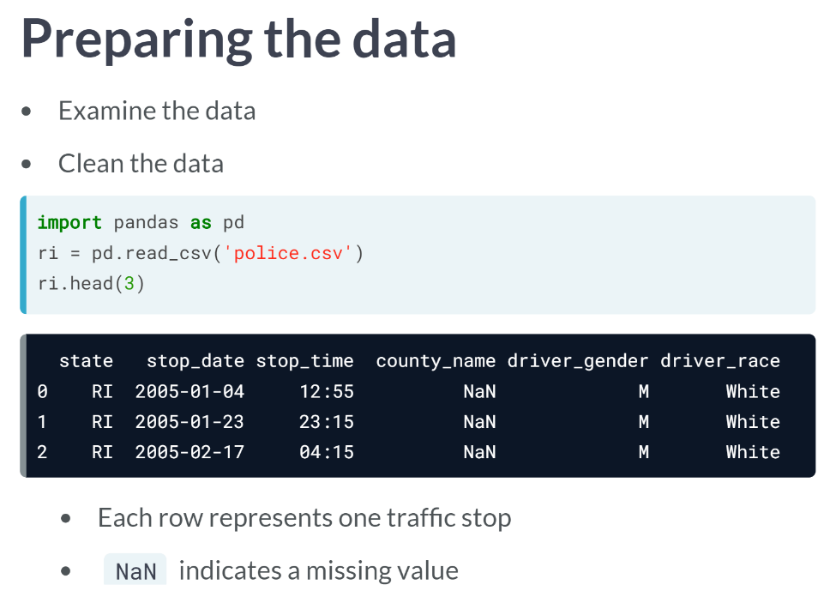  
This first chapter is about preparing the data for analysis.

Before beginning an analysis, it's critical that you first examine the data to make sure that you understand it, and then clean the data, to make working with it a more efficient process.

As always, we'll start by importing pandas as pd. We'll use the ***read_csv()*** function to read in the dataset from a file, and then store it in a DataFrame called ri, which stands for Rhode Island.

We'll use the ***head()*** method in order to take a quick glance at the DataFrame, though there are many more columns than can fit on this screen. Each row represents a single traffic stop.

You'll notice that the *county_name* column contains *NaN* values, which indicate missing values. These are often values that were not collected during the data gathering process, or are irrelevant for that particular row.

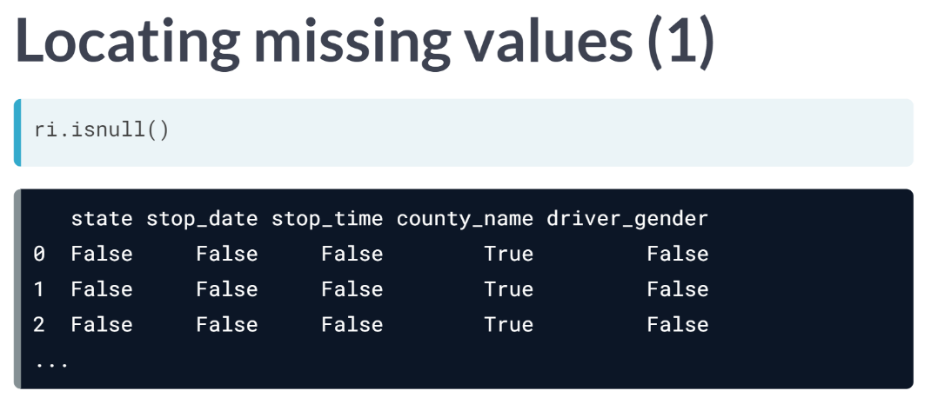  
It's important that you locate missing values so that you can proactively decide how to handle them. You may recall that the ***isnull()*** method generates a DataFrame of True and False values: True if the element is missing, and False if it's not.

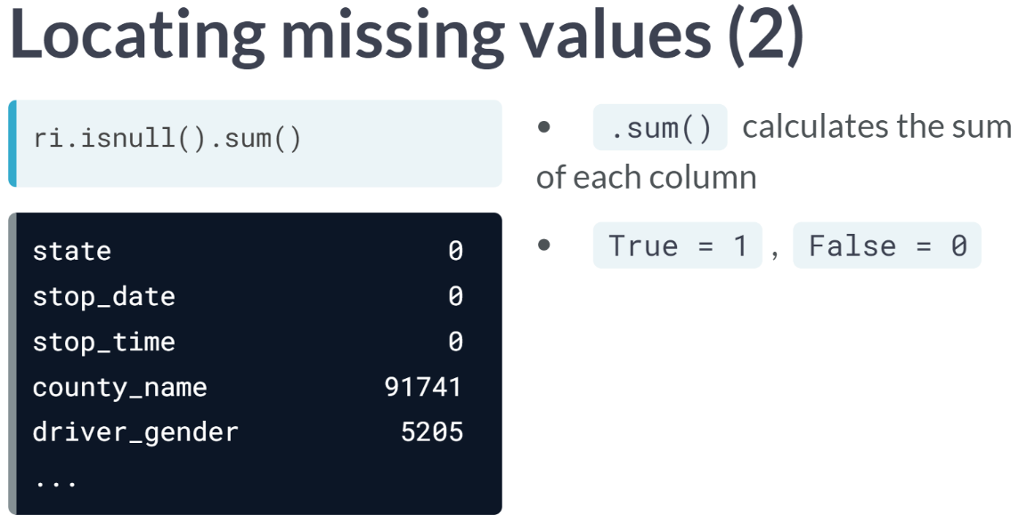  
One useful trick is to take the sum of this DataFrame, which outputs a count of the number of missing values in each column.

How does that calculation work? Well, the ***sum()*** method calculates the sum of each column by default, and *True* values are treated as *ones*, while *False* values are treated as *zeros*.

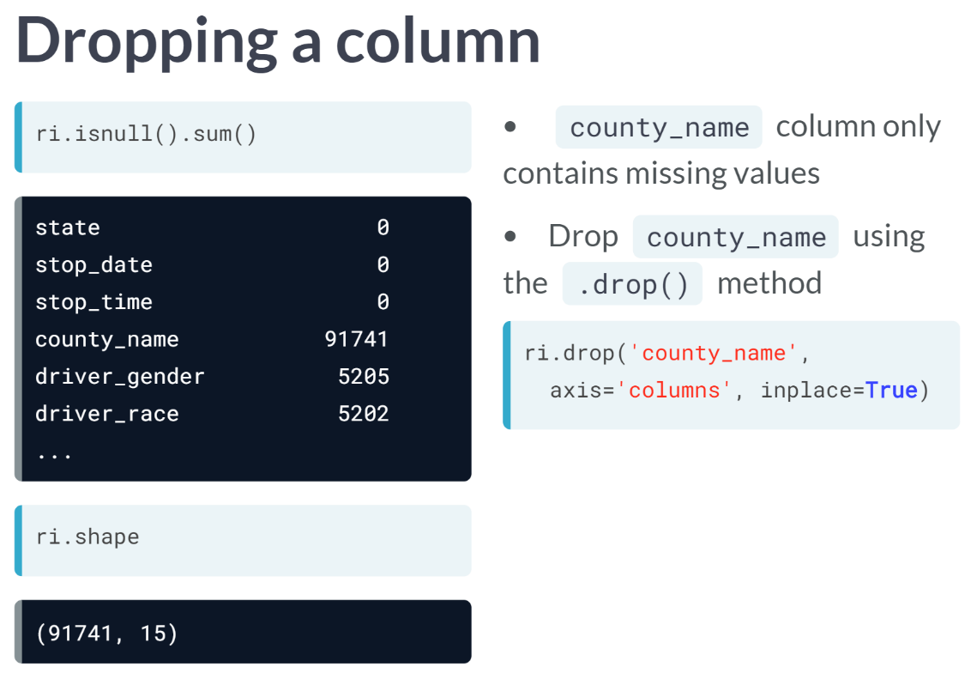  
Let's compare these missing value counts to the DataFrame's shape. You'll notice that the *county_name* column contains as many missing values as there are rows, meaning that it only contains missing values.

Since it contains no useful information, this column can be dropped using the ***drop()*** method.

Besides specifying the column name, you need to specify that you're dropping from the *columns* axis, and that you want the operation to occur in place, which avoids an *assignment* statement.

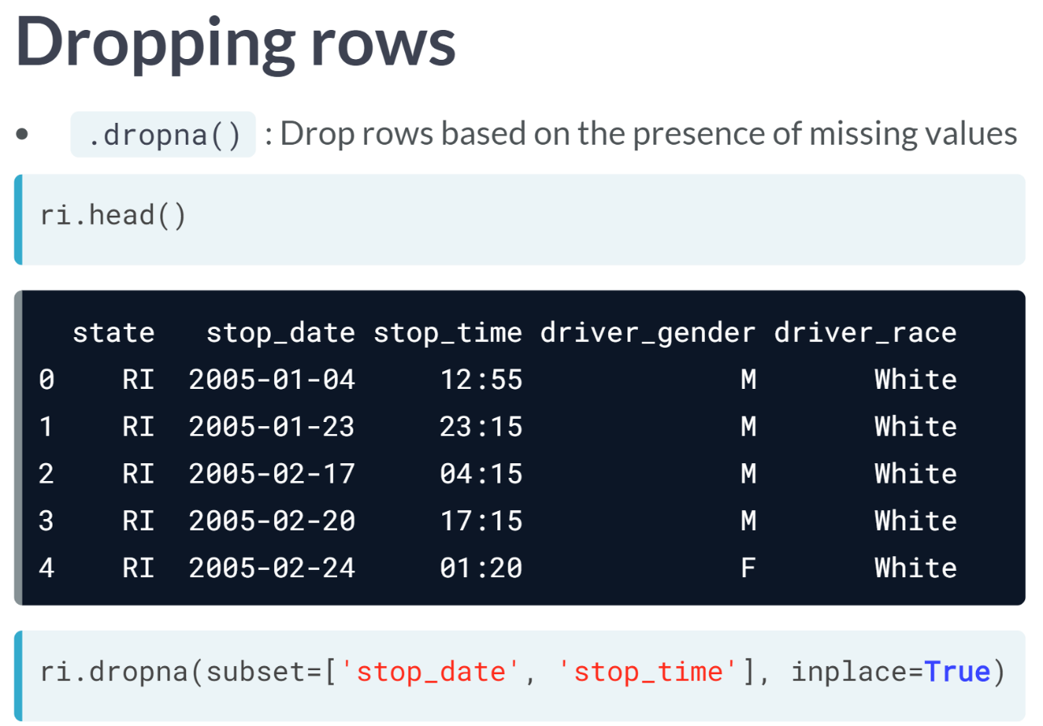  
Finally, let's take a look at one more method related to missing values. The ***dropna()*** method is a great way to drop rows based on the presence of missing values in that row. For example, let's pretend that the *stop_date* and *stop_time* columns are critical to our analysis, and thus a row is useless to us without that data.

We can tell pandas to drop all rows that have a missing value in either the *stop_date* or *stop_time* column. Because we specified a subset, the ***dropna()*** method only takes these two columns into account when deciding which rows to drop. Now it's your turn to practice using these functions to examine and clean this dataset.

# Examining the dataset

Throughout this course, you'll be analyzing a dataset of traffic stops in Rhode Island that was collected by the [**Stanford Open Policing Project**](https://openpolicing.stanford.edu/).

Before beginning your analysis, it's important that you familiarize yourself with the dataset. In this exercise, you'll read the dataset into pandas, examine the first few rows, and then count the number of missing values.

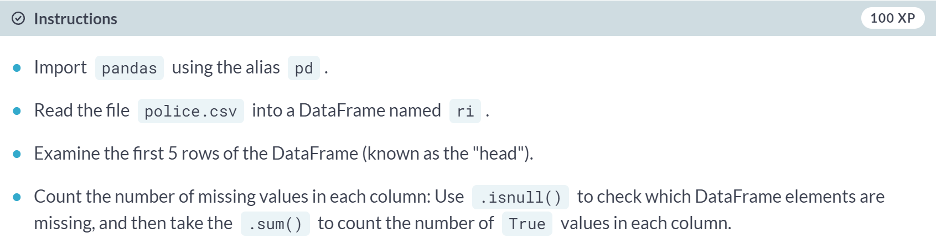

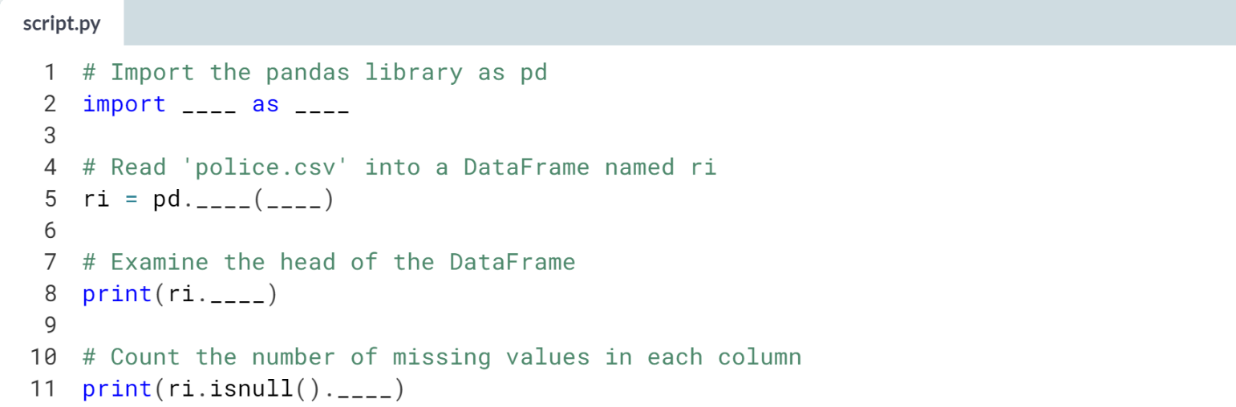

Hint

1. Read the file by passing *'police.csv'* to the ***pd.read_csv()*** function.
2. Use the ***.head()*** method to examine the first 5 rows.
3. To count the number of missing values, chain together the ***.isnull()*** and ***.sum()*** methods.

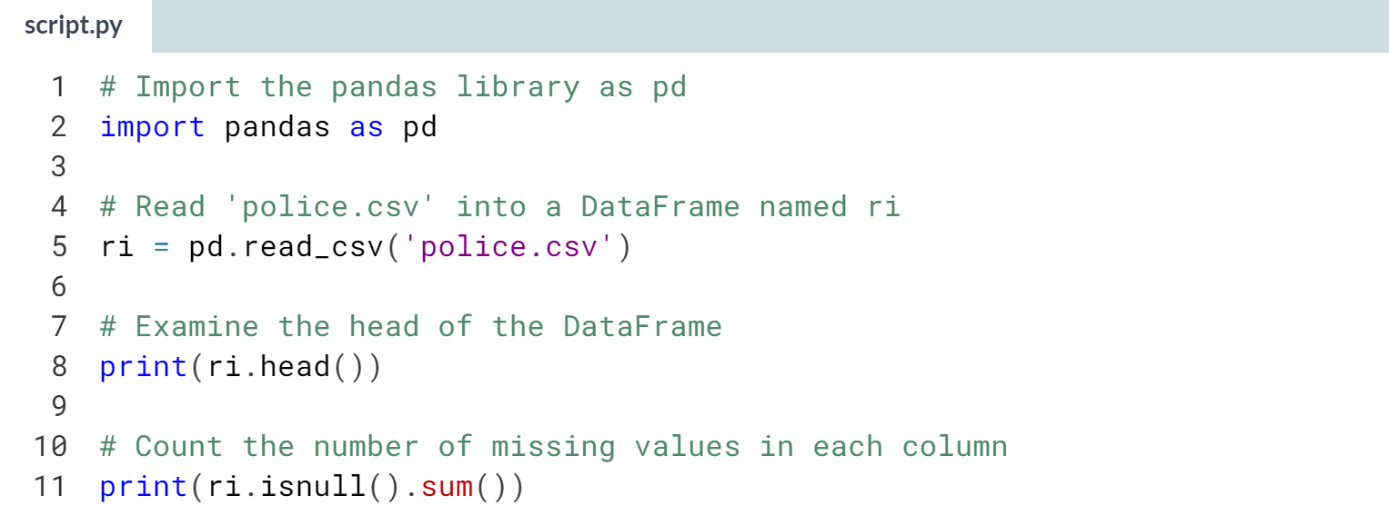

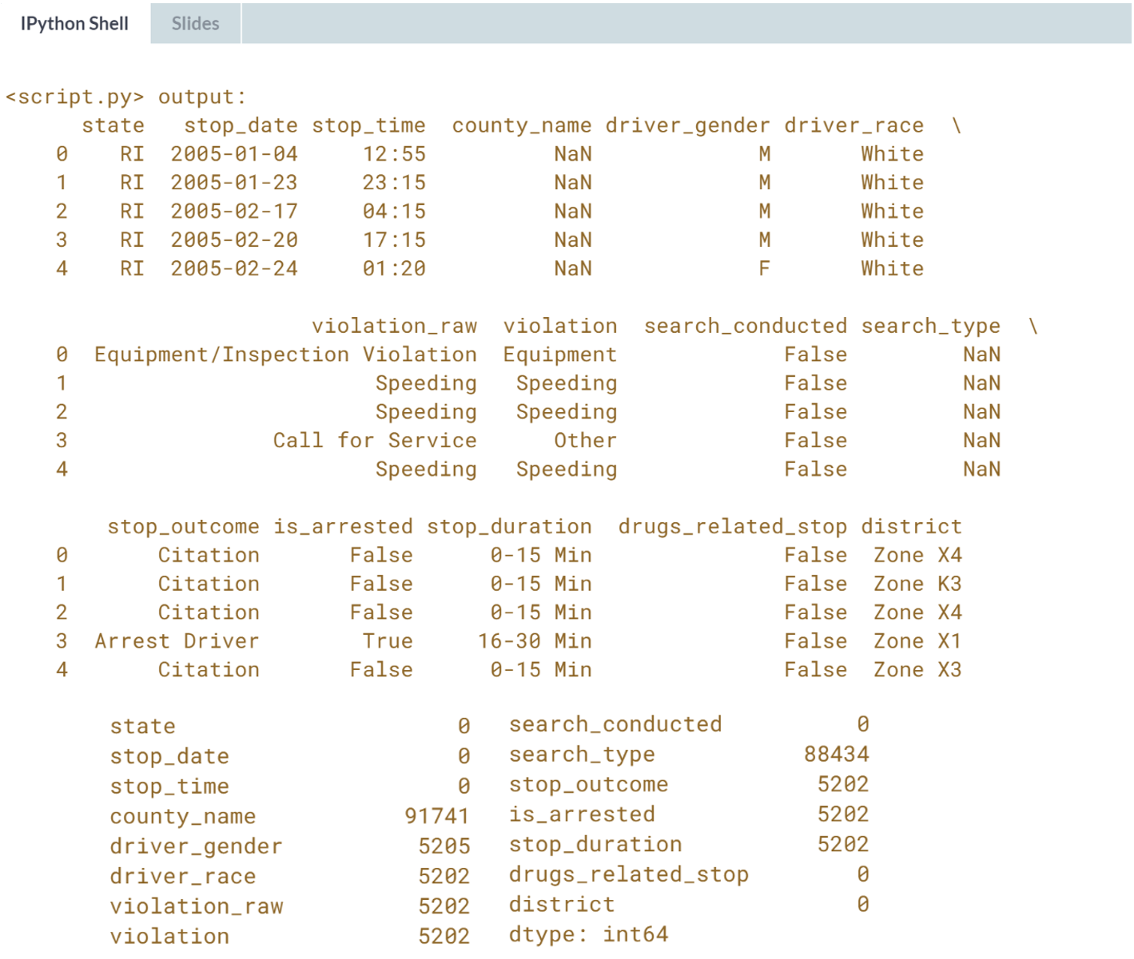It looks like most of the columns have at least some missing values. We'll figure out how to handle these values in the next exercise!

# Dropping columns

Often, a DataFrame will contain columns that are not useful to your analysis. Such columns should be dropped from the DataFrame, to make it easier for you to focus on the remaining columns.

In this exercise, you'll drop the county_name column because it only contains missing values, and you'll drop the state column because all of the traffic stops took place in one state (Rhode Island). Thus, these columns can be dropped because they contain no useful information. The number of missing values in each column has been printed to the console for you.

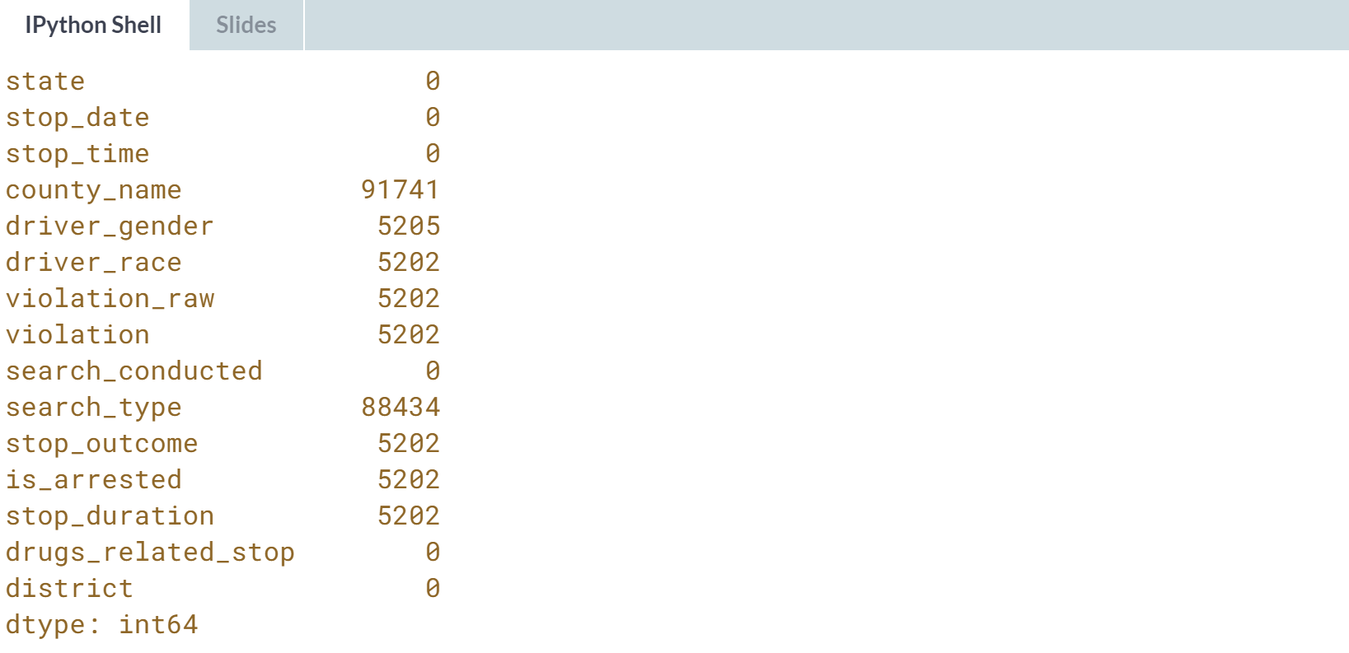

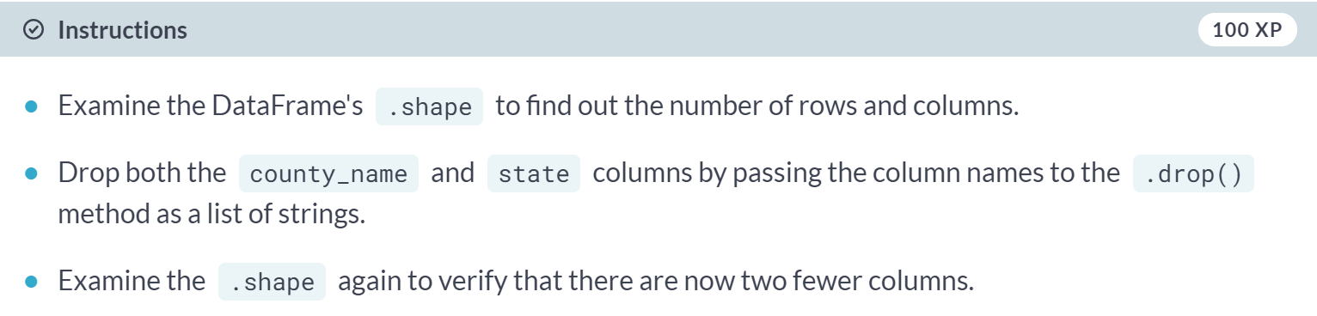

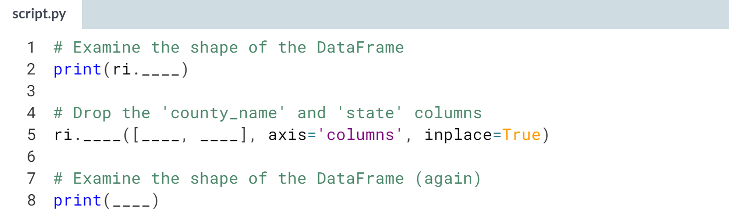

Hint

1. Since **.shape** is an attribute (not a method), make sure not to type parentheses after it.
2. Pass the column names to the ***.drop()*** method as a list of strings: **['county_name', 'state']**.

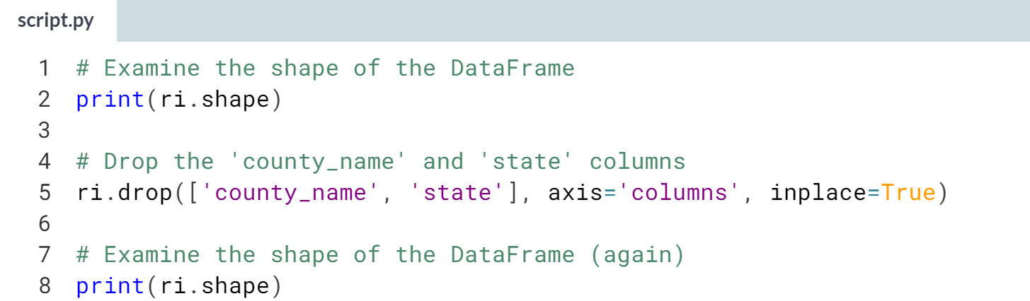

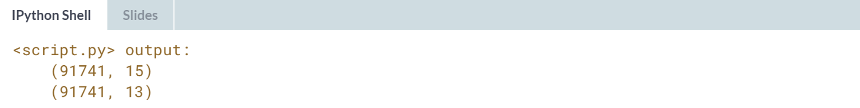

Great job! We'll continue to remove unnecessary data from the DataFrame in the next exercise.

# Dropping rows

When you know that a specific column will be critical to your analysis, and only a small fraction of rows are missing a value in that column, it often makes sense to remove those rows from the dataset.

During this course, the driver_gender column will be critical to many of your analyses. Because only a small fraction of rows are missing driver_gender, we'll drop those rows from the dataset.

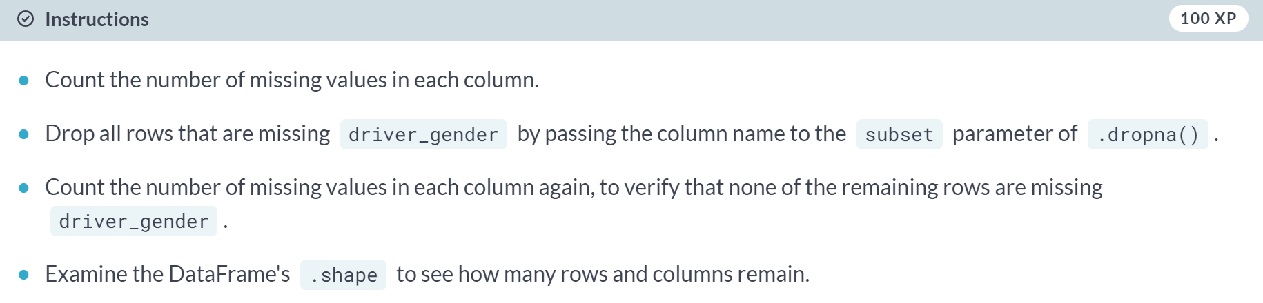

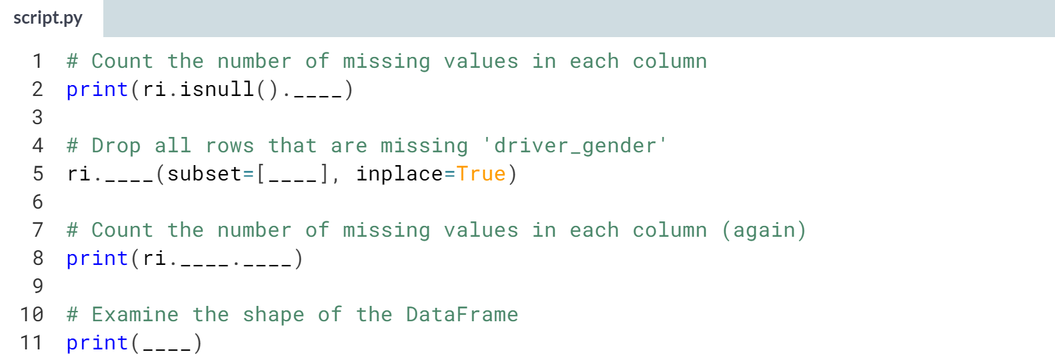

Hint

1. To count the number of missing values, chain together the ***.isnull()*** and ***.sum()*** methods.
2. Drop these rows using the ***.dropna()*** method, not the ***.drop()*** method.
3. Pass the *driver_gender* column to the subset parameter as a list of one string: **['driver_gender']**.

(Solution on the next page)

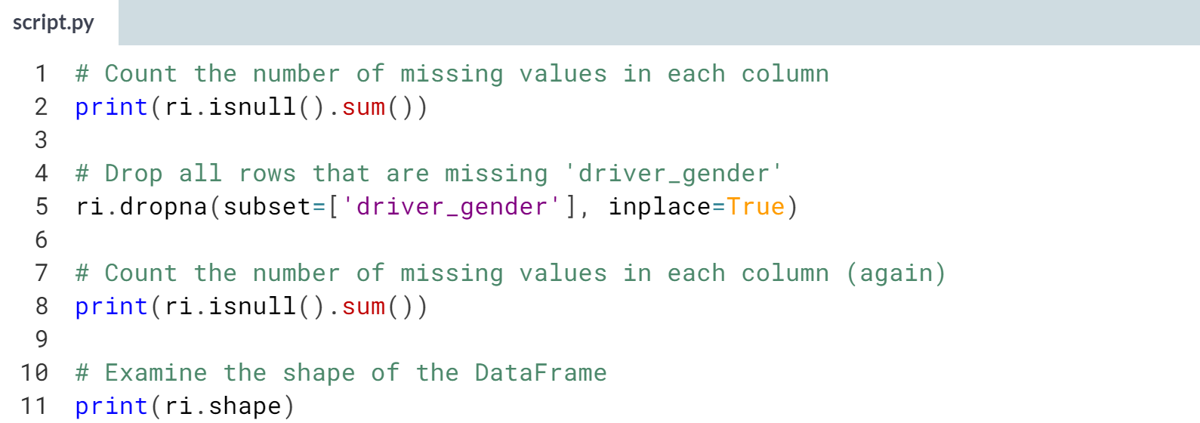

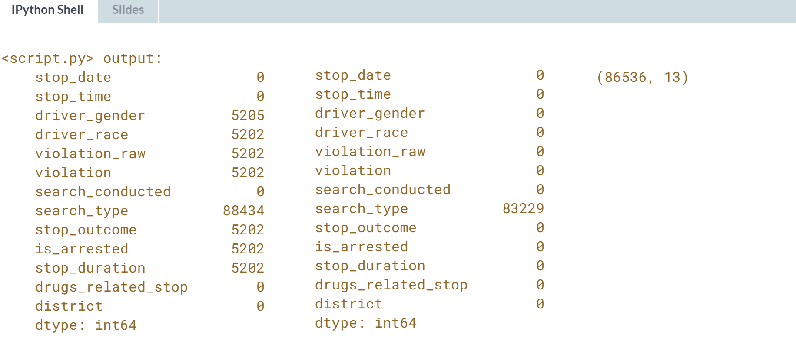

Excellent! We dropped around 5,000 rows, which is a small fraction of the dataset, and now only one column remains with any missing values.



In the last set of exercises, you began cleaning the dataset by removing columns and rows that will not be useful for your upcoming analyses. Now, we're going to continue cleaning the dataset by ensuring that each of the columns has the proper data type.

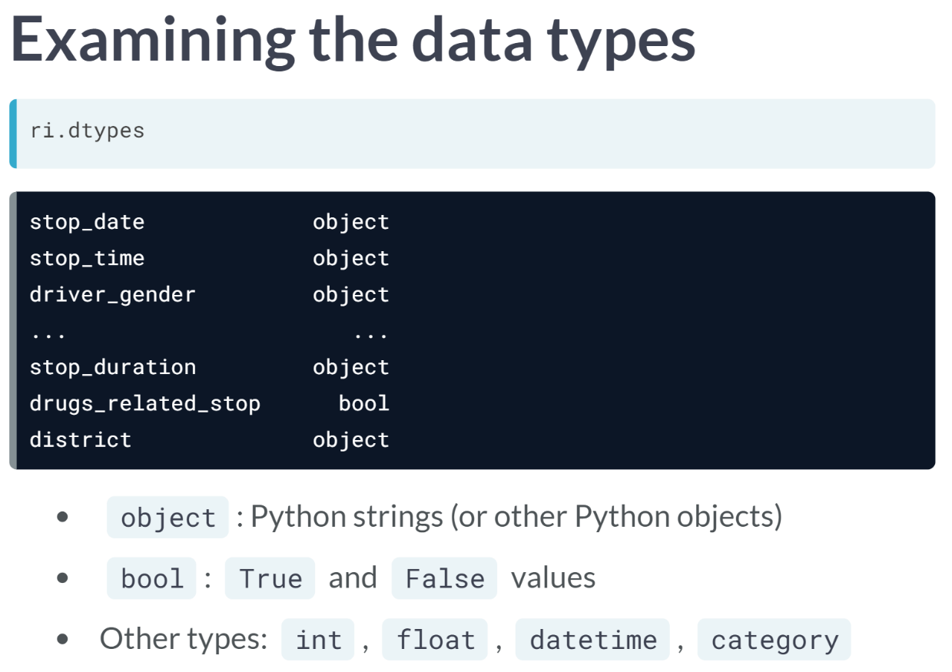  
Let's take a look at the dtypes attribute of the DataFrame. Every Series has a data type, which was automatically inferred by pandas when it was reading in the CSV file.

As you can see, the only data types currently in use are object and bool. The object data type usually means that a Series is made up of Python strings, though it can indicate the presence of other Python objects such as lists.

The bool data type is short for Boolean, which means that a Series is made up of True and False values. pandas also supports other data types, such as int for integers, float for floating point values, datetime for dates and times, and category for categorical variables.

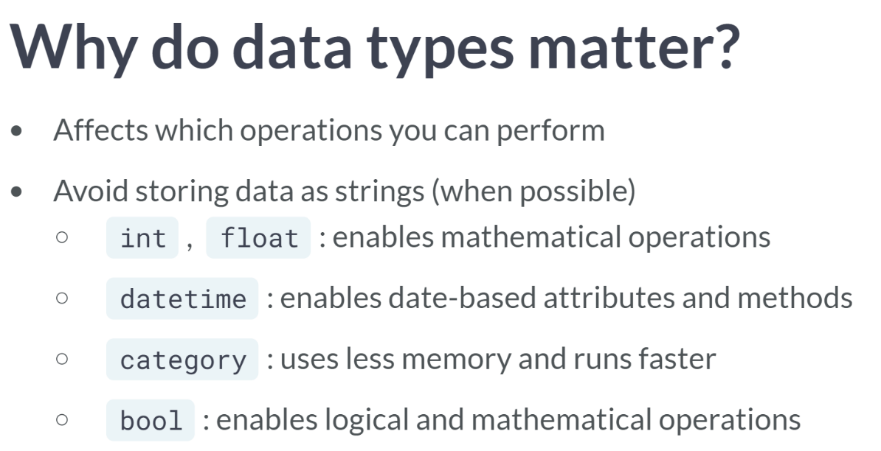  
But why does the data type of a pandas Series even matter? Data types matter mostly because they affect which operations you can perform on a given Series.

In particular, it's beneficial not to store data as strings when possible.

For example, mathematical operations can be performed on ints and floats, but those operations will fail if the numbers are stored as strings.

The datetime type enables a rich set of date-based attributes and methods that are not possible with strings.

The category data type results in less memory usage and faster processing than strings. And the bool data type enables logical and mathematical operations that we'll use during the course.

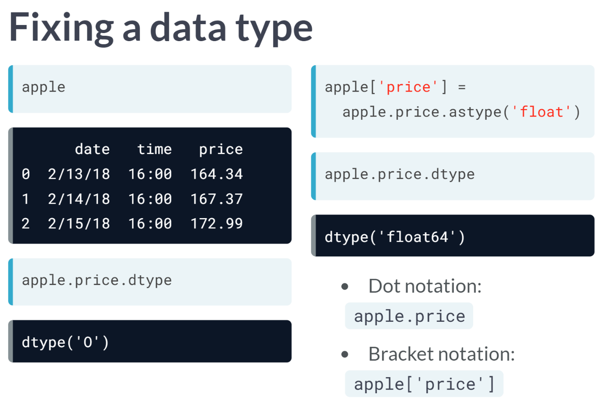  
Let's see an example of how you might fix an improper data type. We'll imagine a DataFrame named apple that has a Series named price, which stores the closing price of Apple company stock each day.

You can check the data type of the price Series using its *dtype* attribute. It reports a *dtype* of "O", which stands for object and means that the numbers are actually stored as strings.

To change the data type of the price Series from object to float, you can use the *astype()* method, to which you pass the new data type as an argument. Then, you simply overwrite the original Series. If you check the data type again, you can see that it has changed to float.

You might have noticed that on the right side of the equals sign, I used dot notation to refer to the price Series, rather than bracket notation. They mean the same thing, but I'll be using dot notation throughout this course, because I find that dot notation makes pandas code more readable.

However, it's worth noting that you MUST use bracket notation on the left side of an assignment statement to create a new Series or overwrite an existing Series. It's now time for you to practice examining and fixing data types in our dataset.

# Finding an incorrect data type

The dtypes attribute of the ri DataFrame has been printed for you. Your task is to explore the ri DataFrame in the IPython Shell to determine which column's data type should be changed.

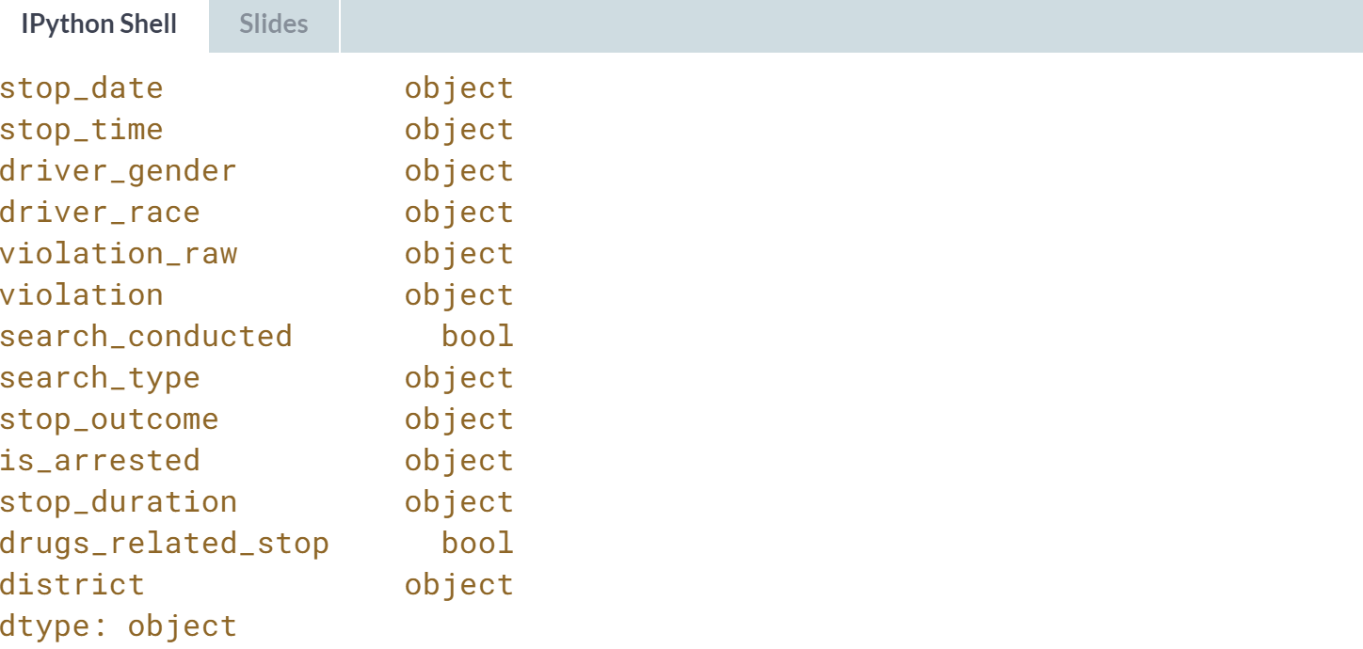

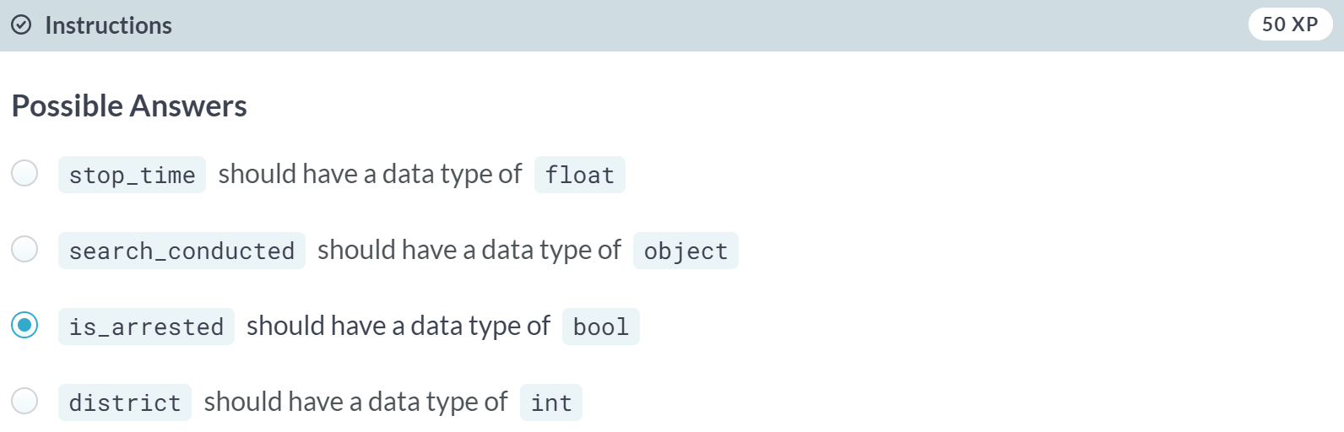

Correct! We'll fix the data type of the *is_arrested* column in the next exercise.

# Fixing a data type

We saw in the previous exercise that the is_arrested column currently has the object data type. In this exercise, we'll change the data type to bool, which is the most suitable type for a column containing True and False values.

Fixing the data type will enable us to use mathematical operations on the is_arrested column that would not be possible otherwise.

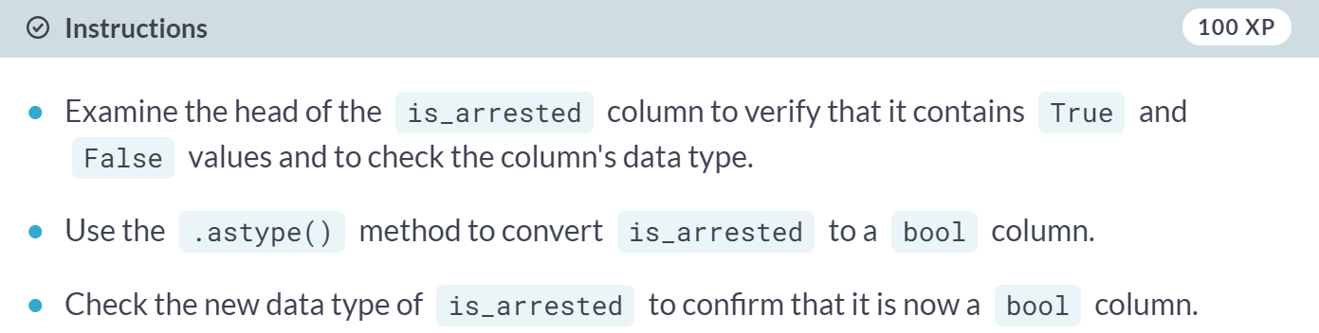

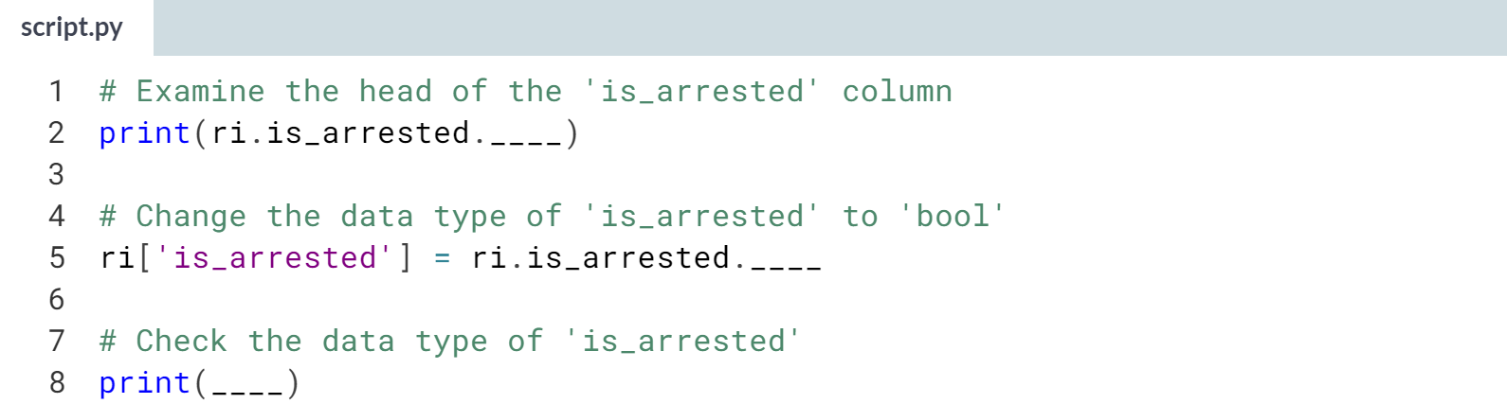

1. Use **.dtype** to check the data type of **is_arrested**.
2. Pass the string *'bool'* to the ***ri.is_arrested.astype()*** method, and then overwrite the existing **ri['is_arrested']** column with the result.

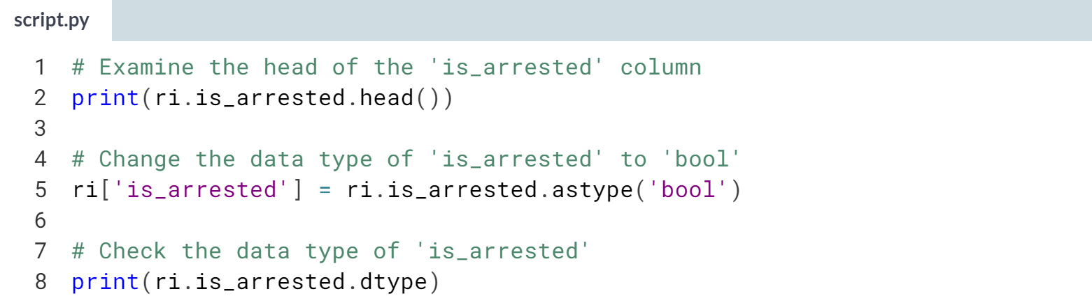

(Result on the next page)

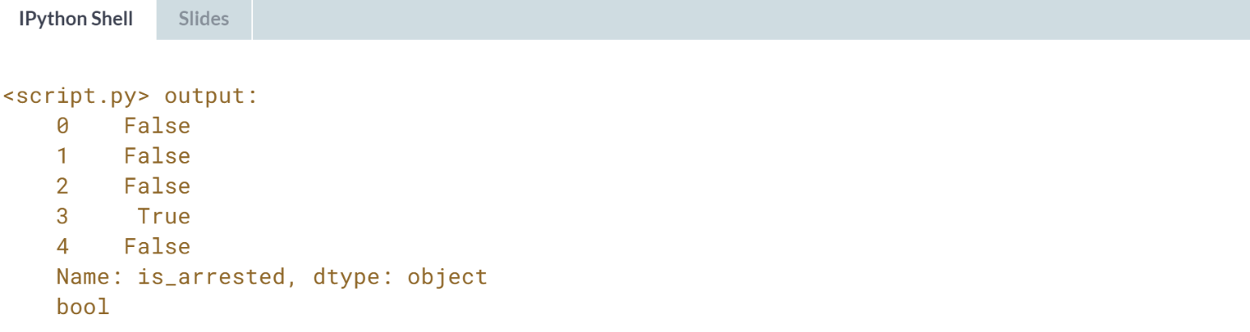

Great! It's best to fix these data type problems early, before you begin your analysis.



In the last exercise, you fixed the data type of the *is_arrested* column. Now, we're going to build a *DatetimeIndex* for our DataFrame.

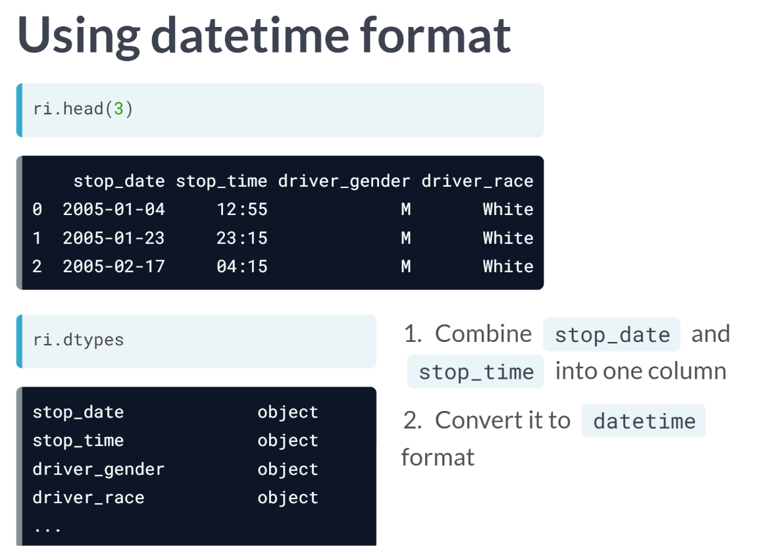  
Let's take a look at the head of the dataset again.

As you can see, the date and time of each traffic stop are stored in separate columns, both of which are object columns. Because we'll be using *stop_date* and *stop_time* in our analysis, we're going to combine these two columns into a single column and then convert it to pandas' datetime format.

This will be beneficial because unlike object columns, datetime columns provide date-based attributes that will make our analysis easier.

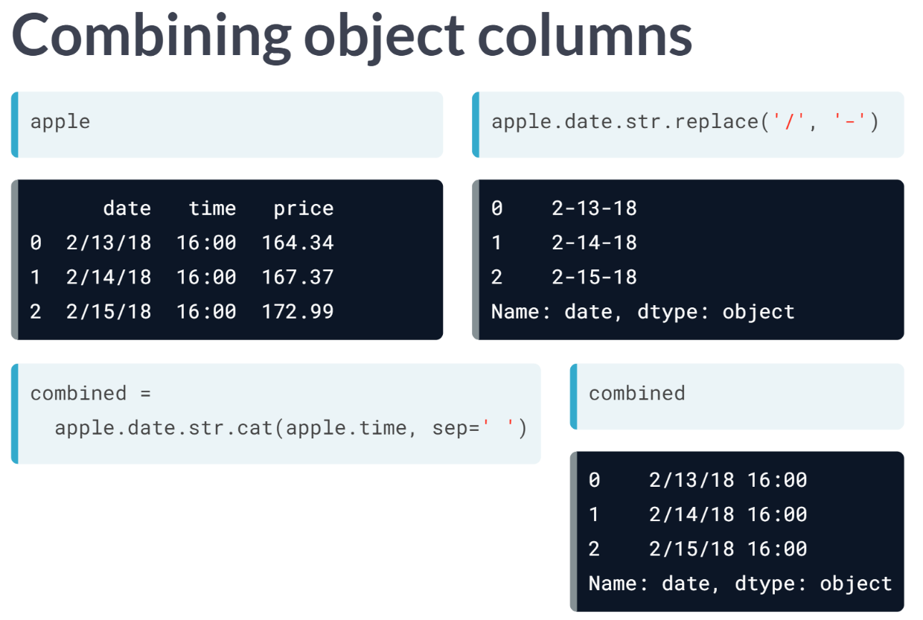  
Let's see an example of this using the apple stock price DataFrame from the previous video. Date and time are stored in separate columns, so the first task is to combine these two columns using a string method.

As you might remember from previous courses, string methods, such as ***replace()***, are Series methods available via the str accessor. In this example, we're replacing the forward slash in the date column with a dash. It outputs a new Series in which the string replacement has been made, though this change is temporary since we haven't saved the new Series.

Anyway, to combine the columns, we're going to use the ***str.cat()*** method, which is short for concatenate. We'll concatenate the date column with the time column, and tell pandas to separate them with a space, storing the result in a Series object named combined.

You can see that the combined Series contains both the date and time. It's still an object column, but it's now ready for conversion to datetime format.

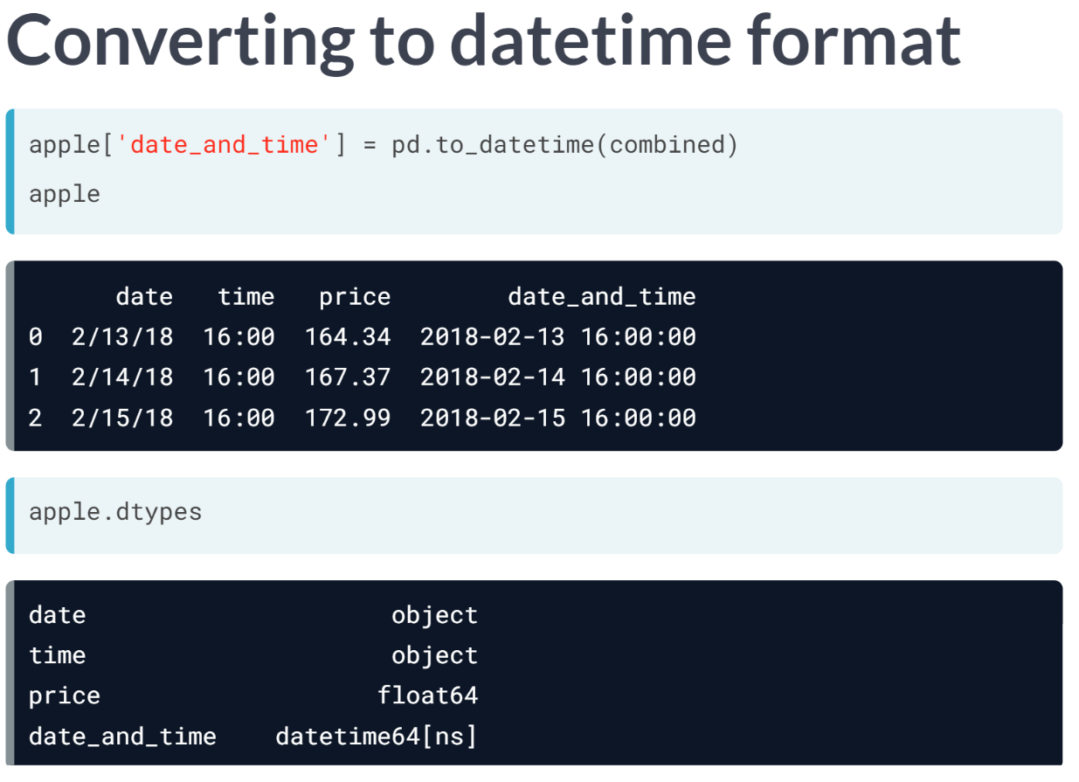  
To convert the combined Series to datetime format, you simply pass it to the ***to_datetime()*** function and store the result in a new column.

We didn't even need to specify that the original data was in month-day-year format, instead pandas just figured it out.

Looking at the updated DataFrame, you can see that the new column contains both the date and time, and that it is stored in a more standard way.

From the dtypes attribute, you can see that the new data type of the new column is datetime, instead of object.

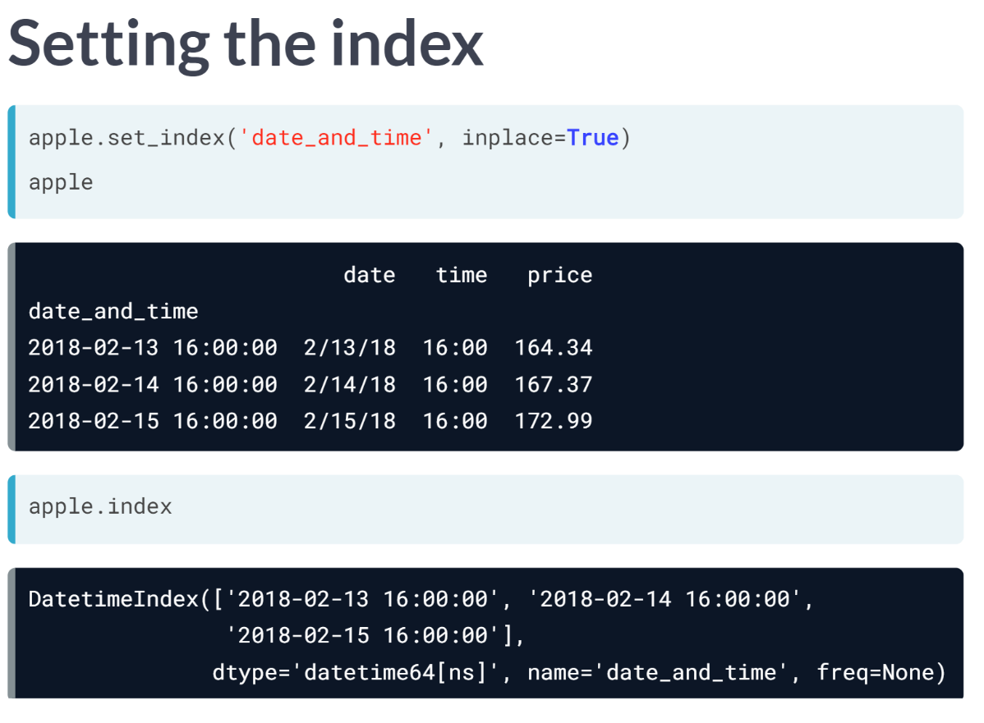  
One final step that we'll take is to set the datetime column as the index. That will make it easier to filter the DataFrame by date, plot the data by date, and so on.

We'll use the ***set_index()*** method and specify that the operation should occur in place to avoid an assignment statement. You can see that the default index has been replaced with the datetime column. And the index is now a special type called DatetimeIndex.

As a reminder, when an existing column becomes the index, it is no longer considered to be one of the DataFrame columns.

Now that you've seen how to create a DatetimeIndex for the apple DataFrame, you can practice these steps on our dataset of traffic stops. This is the final step before we begin our analysis of the dataset in the next chapter.

# Combining object columns

Currently, the date and time of each traffic stop are stored in separate object columns: stop_date and stop_time.

In this exercise, you'll combine these two columns into a single column, and then convert it to datetime format. This will enable convenient date-based attributes that we'll use later in the course.

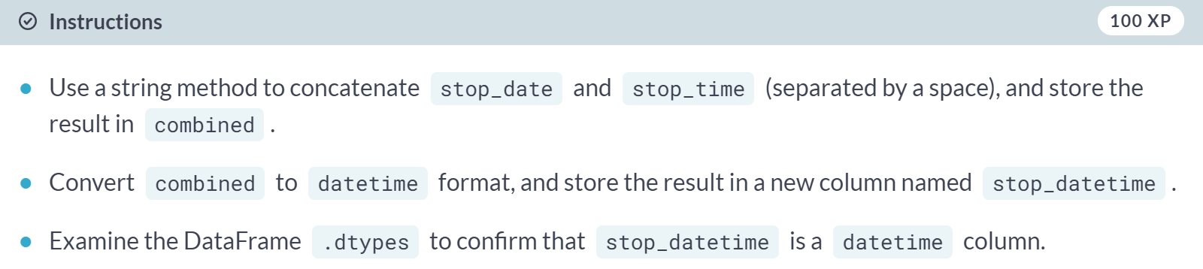

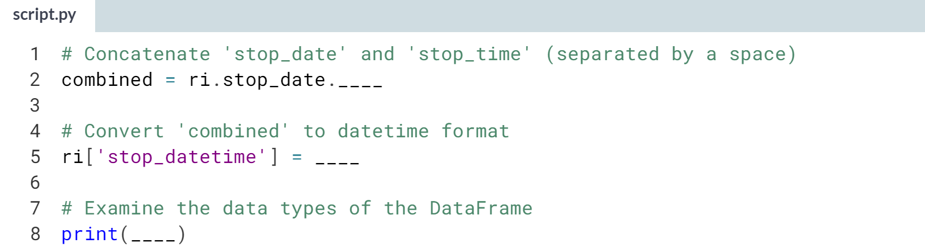

1. Pass **ri.stop_time** to the ***ri.stop_date.str.cat()*** method, and include the **sep=' '** argument.
2. Use the ***pd.to_datetime()*** function to convert combined to datetime format.

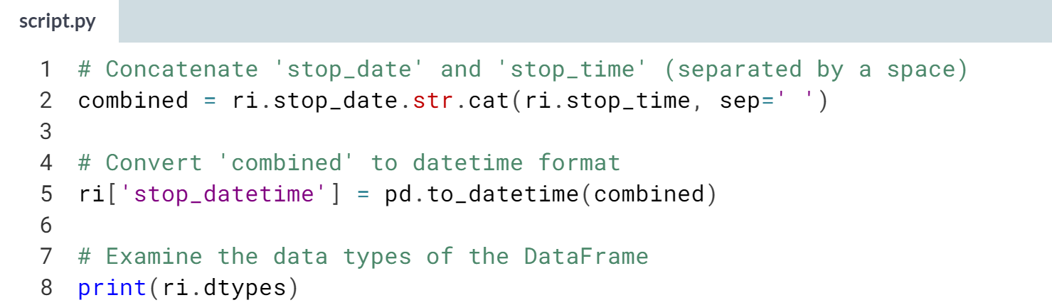

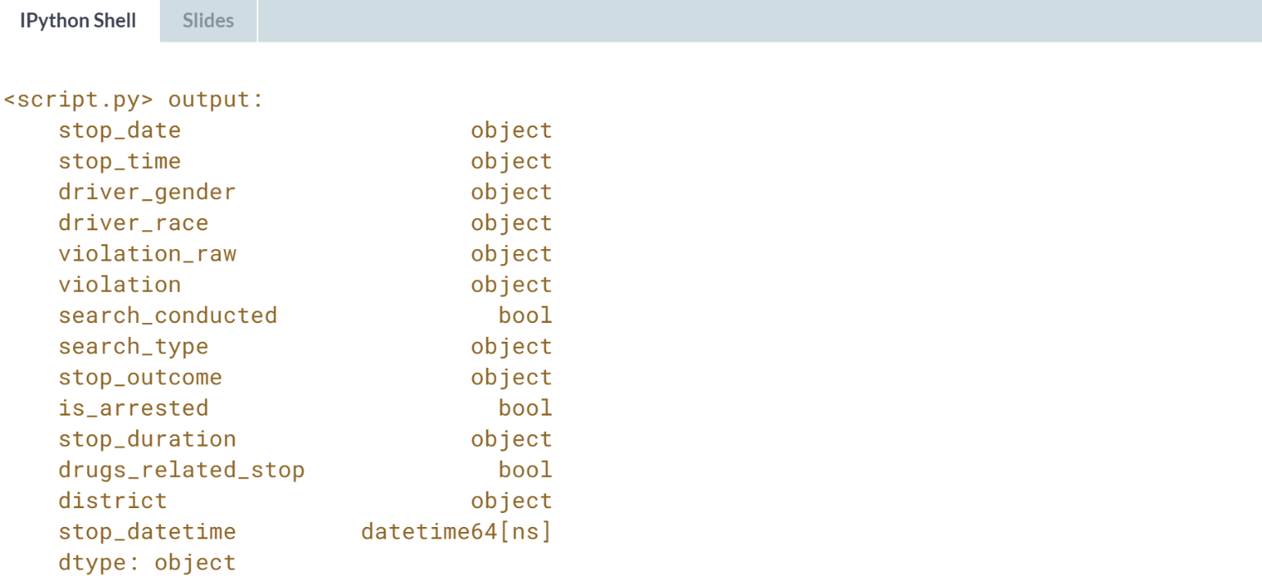

Excellent! Now we're ready to set the *stop_datetime* column as the index.

# Setting the index

The last step that you'll take in this chapter is to set the stop_datetime column as the DataFrame's index. By replacing the default index with a DatetimeIndex, you'll make it easier to analyze the dataset by date and time, which will come in handy later in the course!

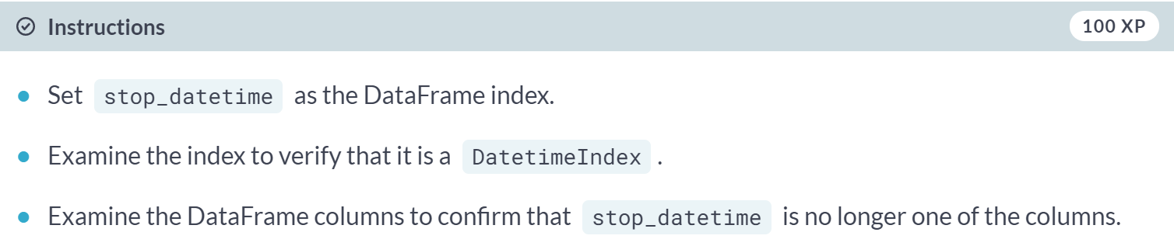

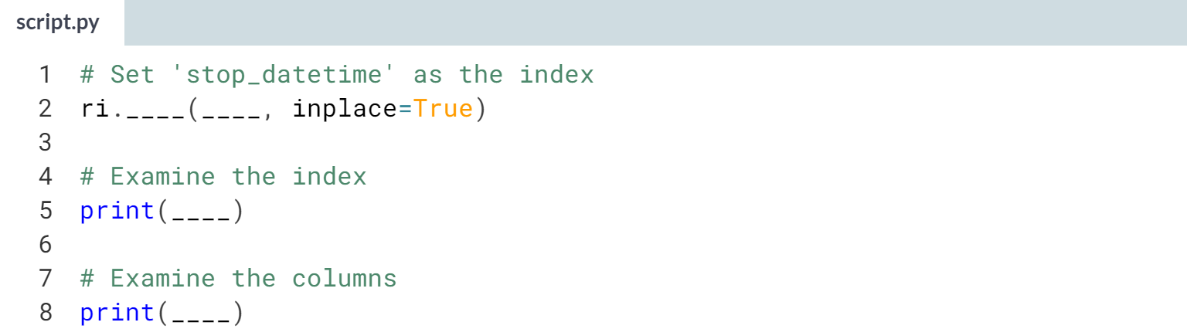

Hint

1. Pass *'stop_datetime'* to the ***set_index()*** method and include the **inplace=True** argument.
2. Use the **.index** attribute to examine the DataFrame's index.
3. Use the **.columns** attribute to examine the DataFrame's columns.

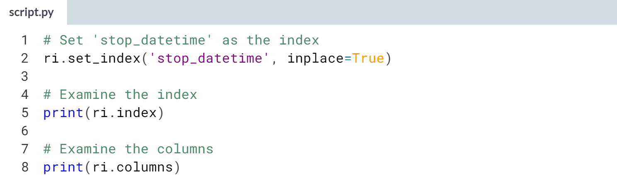

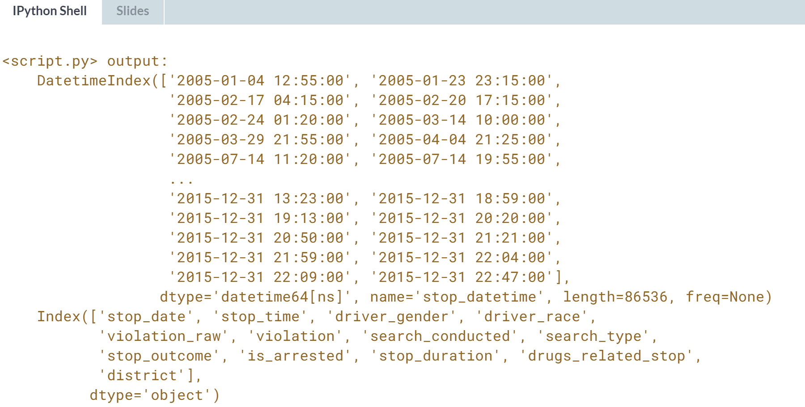

Congratulations! Now that you have cleaned the dataset, you can begin analyzing it in the next chapter.

**2. Exploring the relationship between gender and policing**

Does the gender of a driver have an impact on police behavior during a traffic stop? In this chapter, you will explore that question while practicing filtering, grouping, method chaining, Boolean math, string methods, and more!



In this chapter, we will use the dataset to explore the relationship between gender and policing, and you will figure out how to use pandas to answer specific questions. Let's start by discussing a few methods that will help you with your analysis.

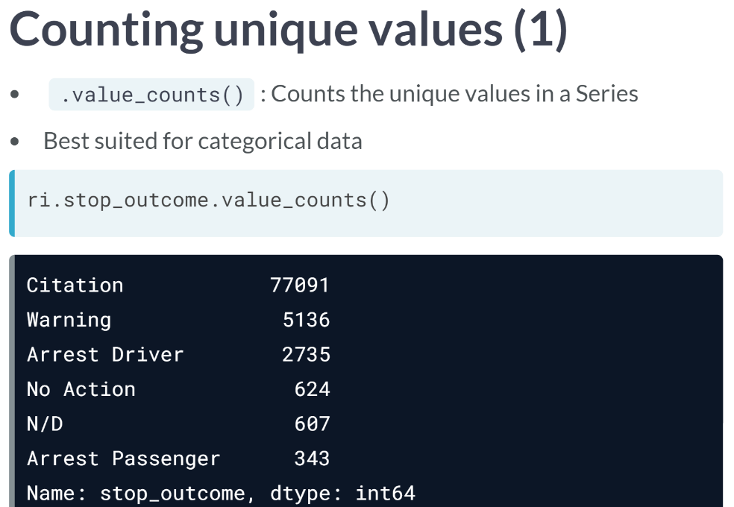  
For example, we can apply ***value_counts()*** to the *stop_outcome* column, which contains the outcome of each traffic stop. The results are displayed in descending order, so you can see that the most common outcome is a Citation, also known as ticket.

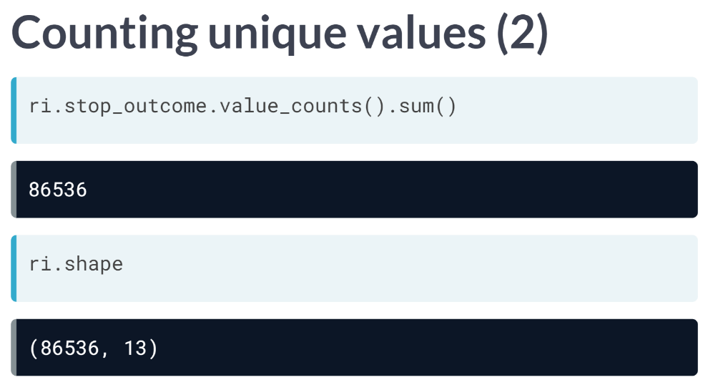  
Because ***value_counts()*** outputs a pandas Series, you can take the sum of this Series by simply adding the ***sum()*** method on the end. This is known as method chaining. The ***sum()*** of the ***value_counts()*** is equal to the number of rows in the DataFrame, which will be the case for any Series that has no missing values.

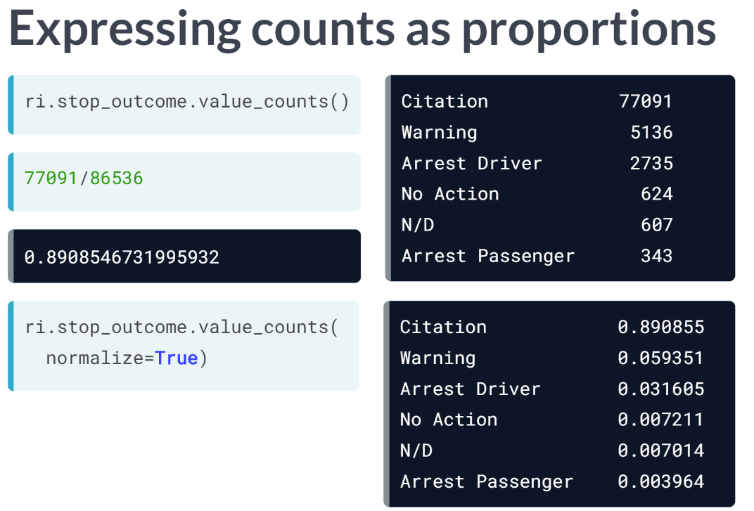  
Rather than examining the raw counts, you might prefer to see the stop outcomes as proportions of the total. If you want to know what percentage of traffic stops ended in a citation, you will divide the number of citations by the total number of outcomes.

Rather than doing these calculations manually, you can instead set the normalize parameter of ***value_counts()*** to be *True*, and it will output proportions instead of counts.

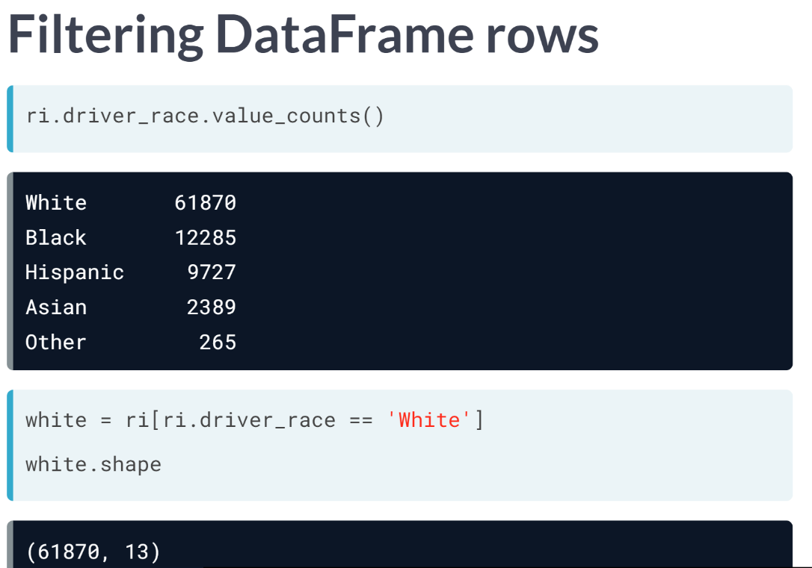  
Let's now take a look at the ***value_counts()*** for a different column, *driver_race*, where they are five unique categories present. If you wanted to filter the DataFrame to only include drivers of a particular race, such as White, you would write that as a condition and put it inside brackets. By using this method, you can now analyze this smaller DataFrame separately.

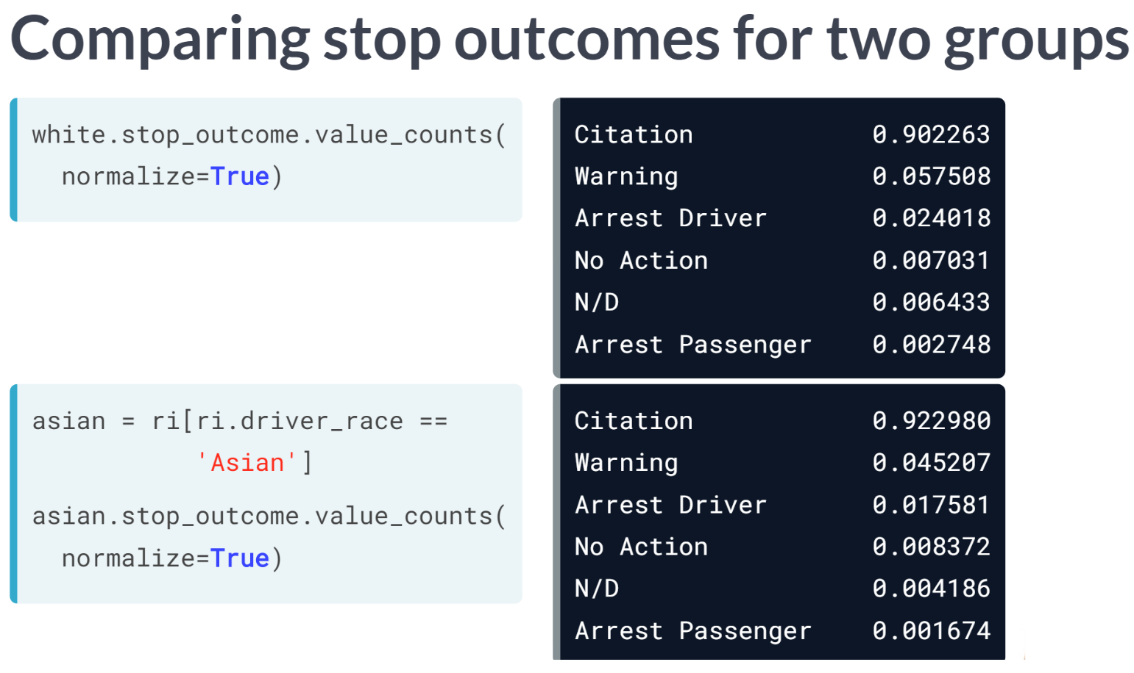  
For example, you could repeat the analysis of stop outcomes while focusing on only White drivers. You select the *stop_outcome* column and then chain the ***value_counts()*** method on the end.

Also, we can look at the same statistics for different race by simply changing the condition inside the brackets and then repeating the calculation.

# Examining traffic violations

Before comparing the violations being committed by each gender, you should examine the violations committed by all drivers to get a baseline understanding of the data.

In this exercise, you'll count the unique values in the violation column, and then separately express those counts as proportions.

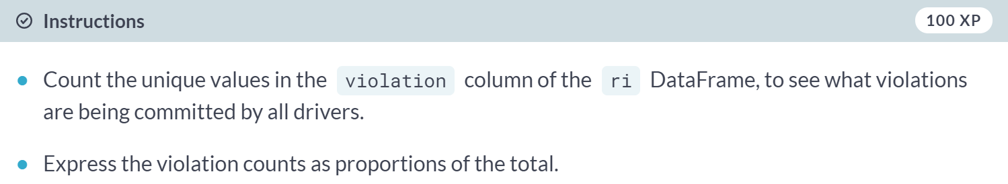

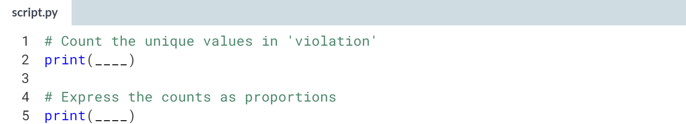

Hint

1. To compute the counts, use the ***.value_counts()*** method on the violation column.
2. Express the counts as proportions by including the **normalize=True** argument in ***.value_counts()***.

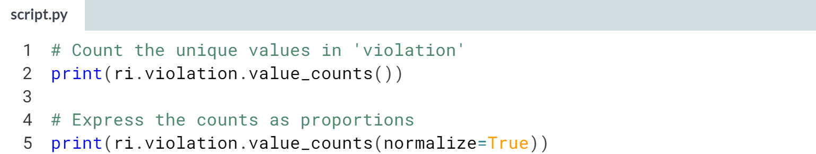

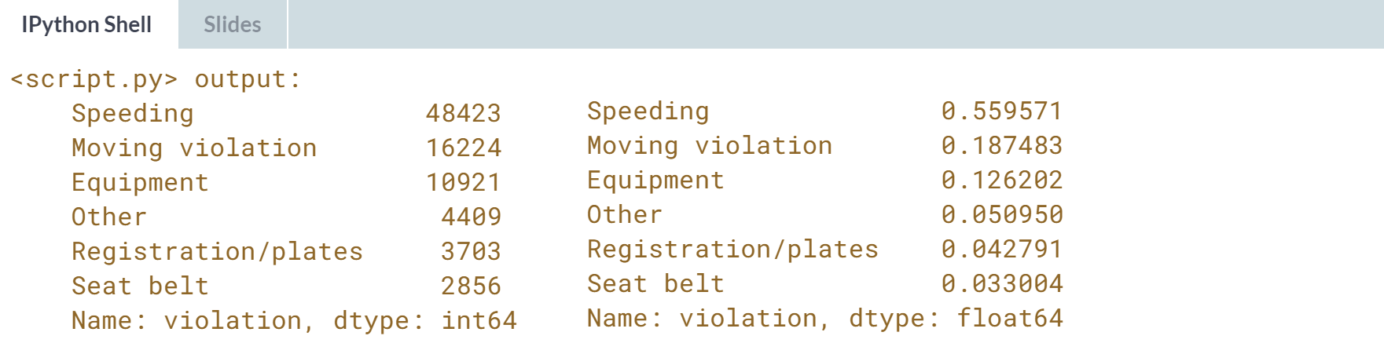

Interesting! More than half of all violations are for speeding, followed by other moving violations and equipment violations.

# Comparing violations by gender

The question we're trying to answer is whether male and female drivers tend to commit different types of traffic violations.

In this exercise, you'll first create a DataFrame for each gender, and then analyze the violations in each DataFrame separately.

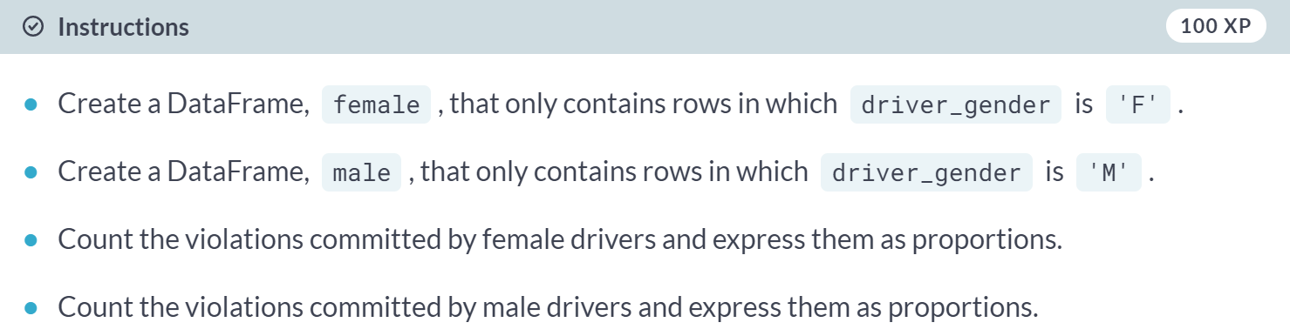

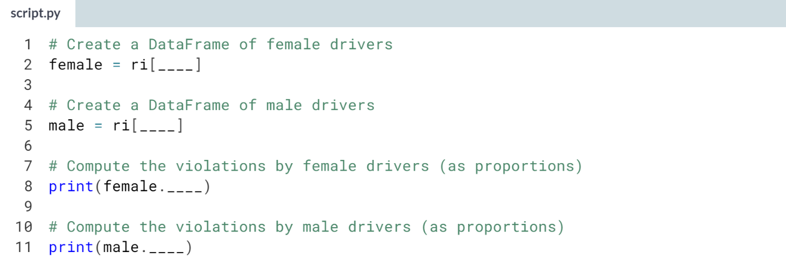

1. Filter the *ri* DataFrame using brackets and include the condition **ri.driver_gender == 'F'** or **ri.driver_gender == 'M'**.
2. Count the violations by using ***.value_counts()*** on the violation column and include the **normalize=True** argument to express the counts as proportions.

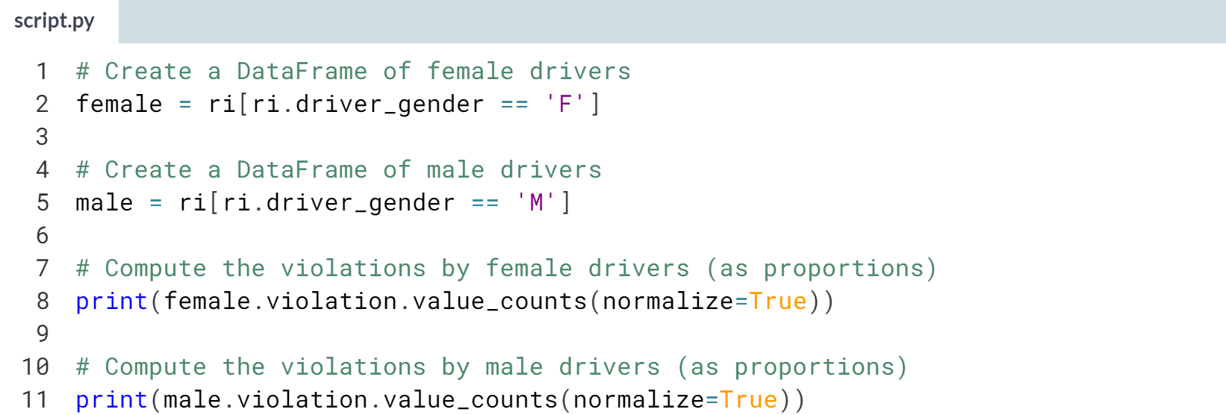  
(Result on the next page)

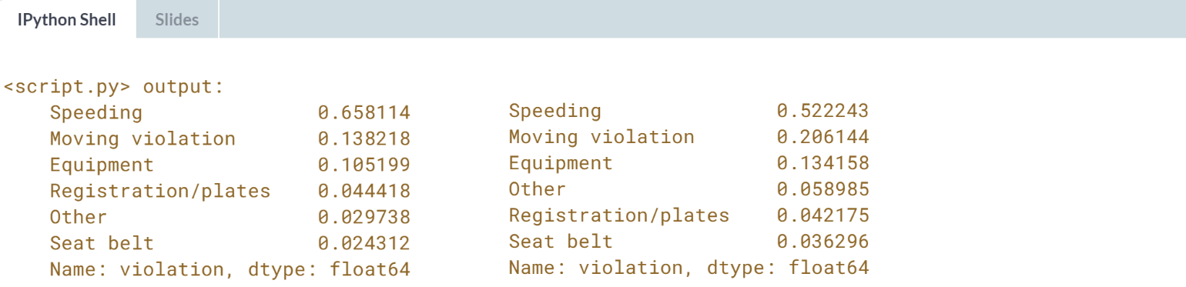

About two-thirds of female traffic stops are for speeding, whereas stops of males are more balanced among the six categories.

This doesn't mean that females speed more often than males, however, since we didn't consider the number of stops or drivers.



In this section, we will narrow our focus to the relationship between gender and stop outcomes for one specific violation, named speeding.

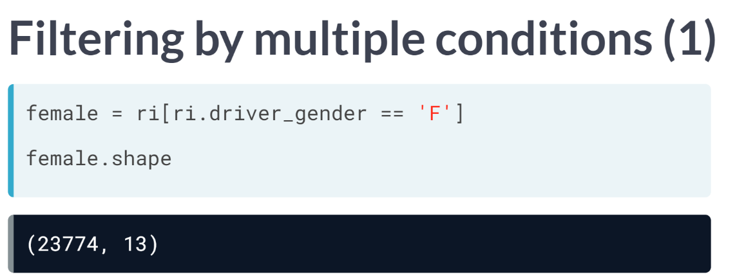  
We need to use one additional technique for this analysis, namely filtering a DataFrame by multiple conditions. In the last exercise, you used a single condition, ***driver_gender == 'F'*** to create a DataFrame of female drivers.

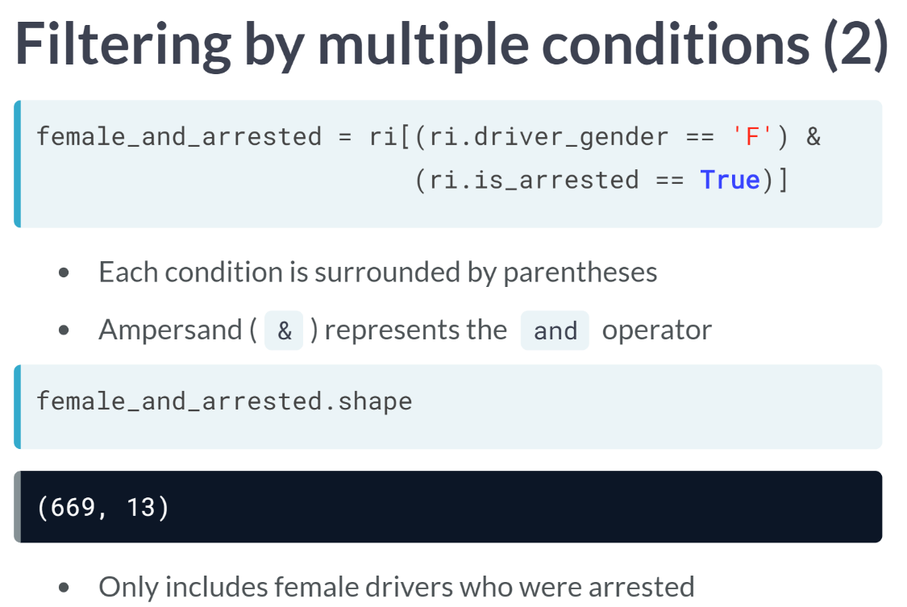  
What if we wanted to create a second DataFrame of female drivers, but only those who were arrested? We simply add a second condition to filter, namely that the *is_arrested* column equals *True*.

Notice that each condition is surrounded by parentheses, and there is an ampersand between the two conditions representing the logical AND operator.

The second DataFrame is much smaller because it only includes rows that satisfy both conditions, meaning that it only includes female drivers who were also arrested.

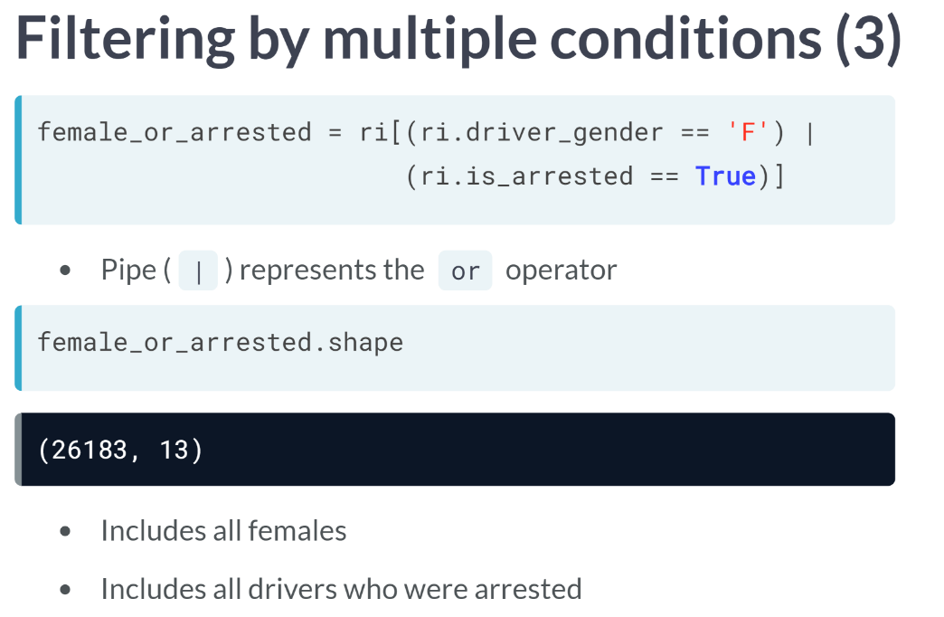  
When filtering a DataFrame by multiple conditions, another option is to use the vertical pipe character between the two conditions. The pipe represents the logical OR operator, needing rows to be included in the DataFrame if it meets either condition. This DataFrame is larger than the last one.

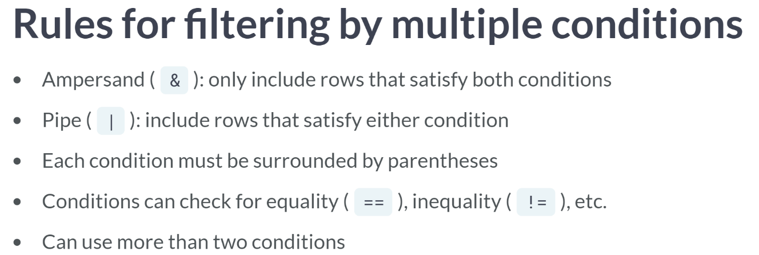  
Here's a quick summary of the rules for filtering DataFrames by multiple conditions.

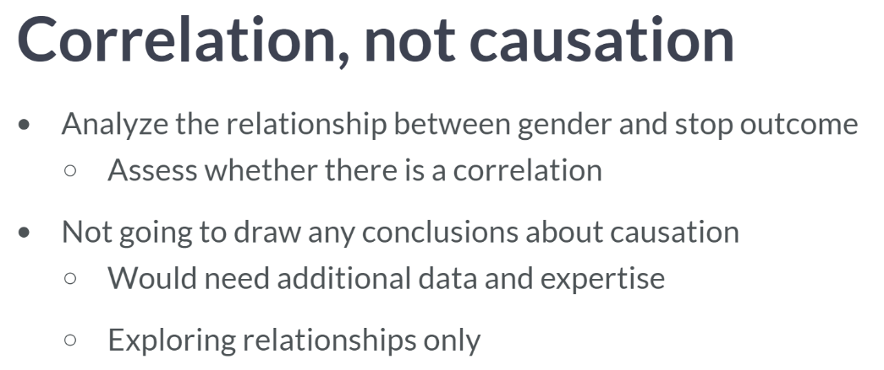  
In the upcoming exercises, you will analyze the relationship between gender and stop outcome when a driver is pulled over for a speeding. In other words, you are examining the data to access whether there is a correlation between these two attributes. Since we don't have necessary expertise on this subject, we are not going to draw causation during this course. Simply, we are exploring the relationship between different attributes in the dataset.

# Filtering by multiple conditions

Which one of these commands would filter the ri DataFrame to only include female drivers who were stopped for a speeding violation?

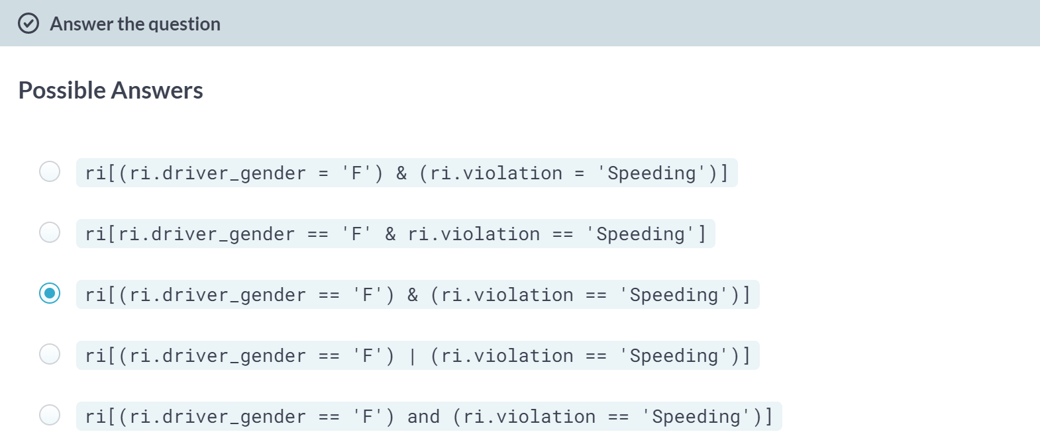

Correct! We'll use this code to filter the DataFrame in the next exercise.

# Comparing speeding outcomes by gender

When a driver is pulled over for speeding, many people believe that gender has an impact on whether the driver will receive a ticket or a warning. Can you find evidence of this in the dataset?

First, you'll create two DataFrames of drivers who were stopped for speeding: one containing females and the other containing males.

Then, for each gender, you'll use the stop_outcome column to calculate what percentage of stops resulted in a "Citation" (meaning a ticket) versus a "Warning".

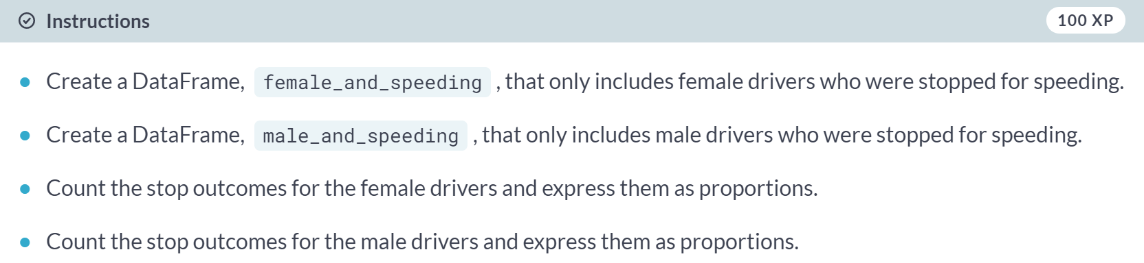

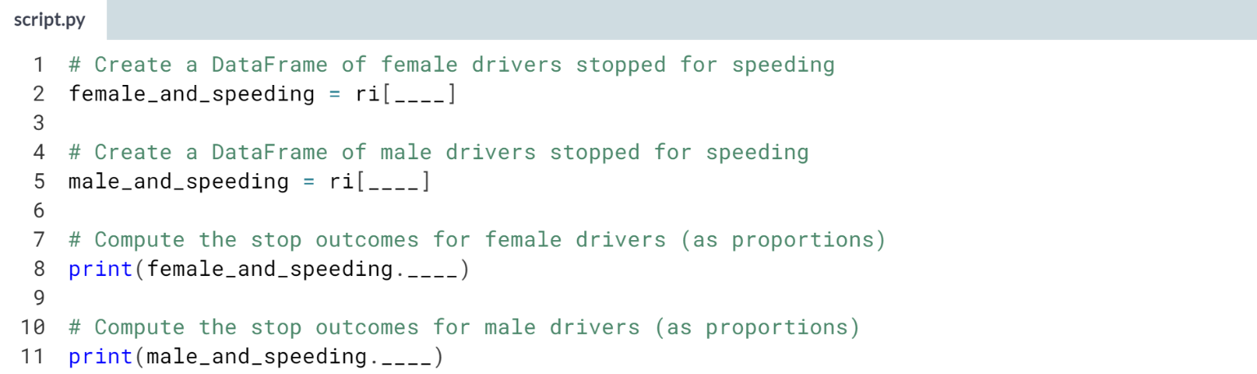

1. Make sure you're filtering the female and male drivers as *'F'* and *'M'*, respectively.
2. Check for drivers that are speeding by filtering **ri.violation**.
3. Each condition should be surrounded by parentheses with an **ampersand (&)** between the conditions.
4. Use the **normalize=True** argument to express the *stop_outcome* counts as proportions.

(Solution on the next page)

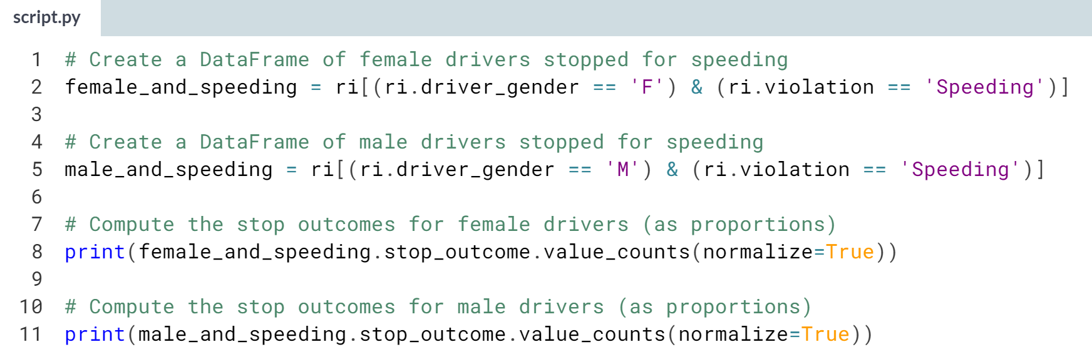

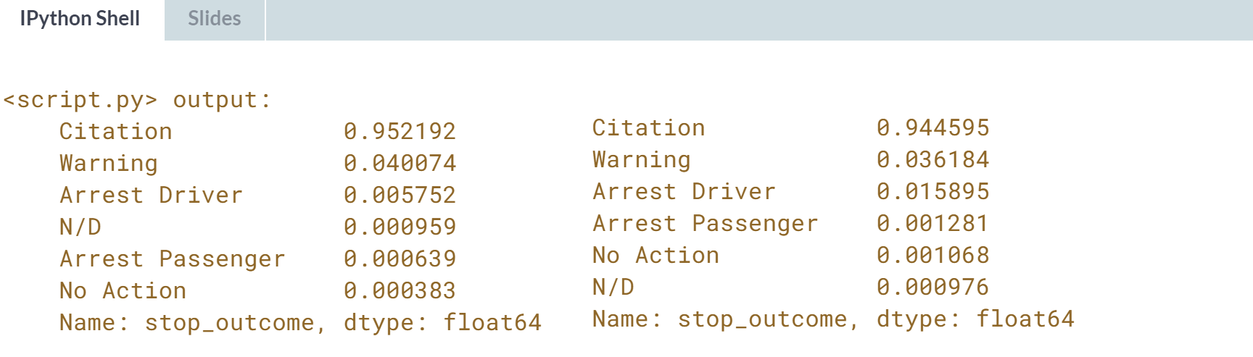

Interesting! The numbers are similar for males and females: about 95% of stops for speeding result in a ticket. Thus, the data fails to show that gender has an impact on who gets a ticket for speeding.



During a traffic stop, the police officer sometimes conducts a search of the vehicle. Does the driver's gender affect whether their vehicle is searched? Let's review a few pandas technique that will help us to answer this question.

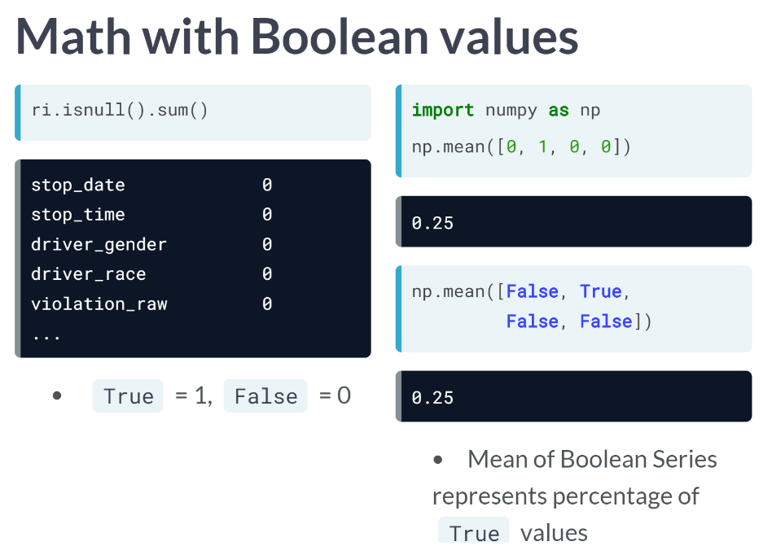  
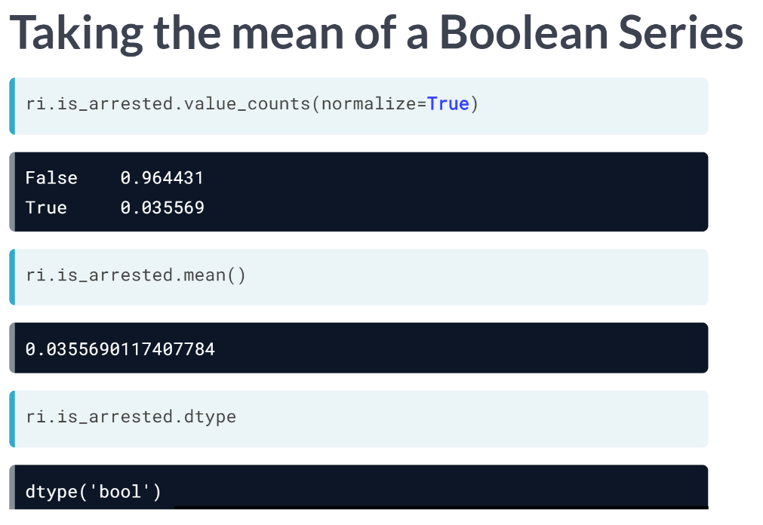  
Let's see a real example of why it's useful to be able to take the mean of a Boolean Series. We will first calculate the percentage of stops that result in an arrest using the ***value_counts()*** method. The arrest rate is around 3.6 percent since that is the percentage of True values. This method works either on object column or a Boolean column.

But we can get the same result more easily by taking the ***mean()*** of the *is_arrested* Series. This method only works because the data type is Boolean. This is exactly why you changed the data type of this Series from object to Boolean in the first place.

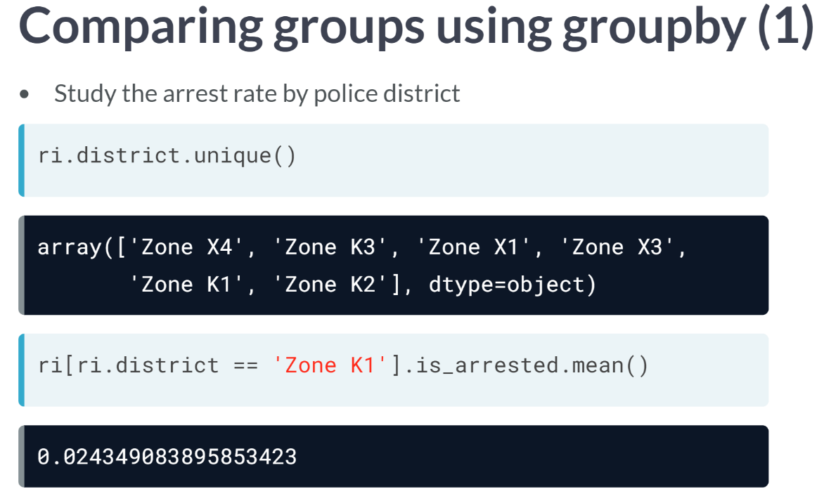  
The second technique we will review is ***groupby()***, which you've used in previous course. Let's pretend that you wanted to study the arrest rate by police district. You can see that there are six districts by using the Series method ***unique()***.

One approach we've used to compare groups is to filter the DataFrame by each group, and then perform a calculation on each subset. So to calculate the arrest rate in Zone K1, we would filter by that district, select the *is_arrested* column, and then take the ***mean()***. The arrest rate is about 2.4 percent, which is lower than the overall arrest rate of 3.6 percent.

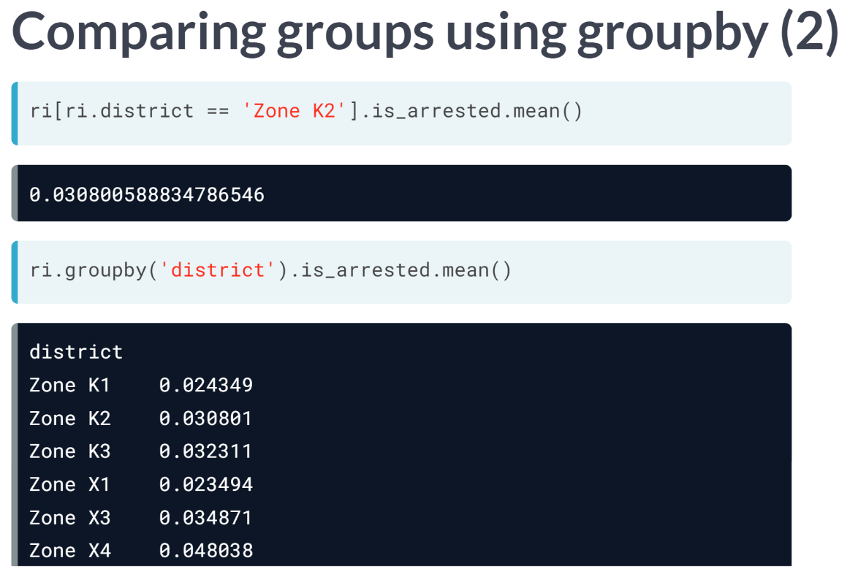  
Next, we calculate the arrest rate in Zone K2, which is about 3.1 percent. But rather than repeating this process for all six districts, we can instead group by the district column, which will perform the same calculation for all districts at once. You can see a noticeably higher arrest rate in Zone X4.

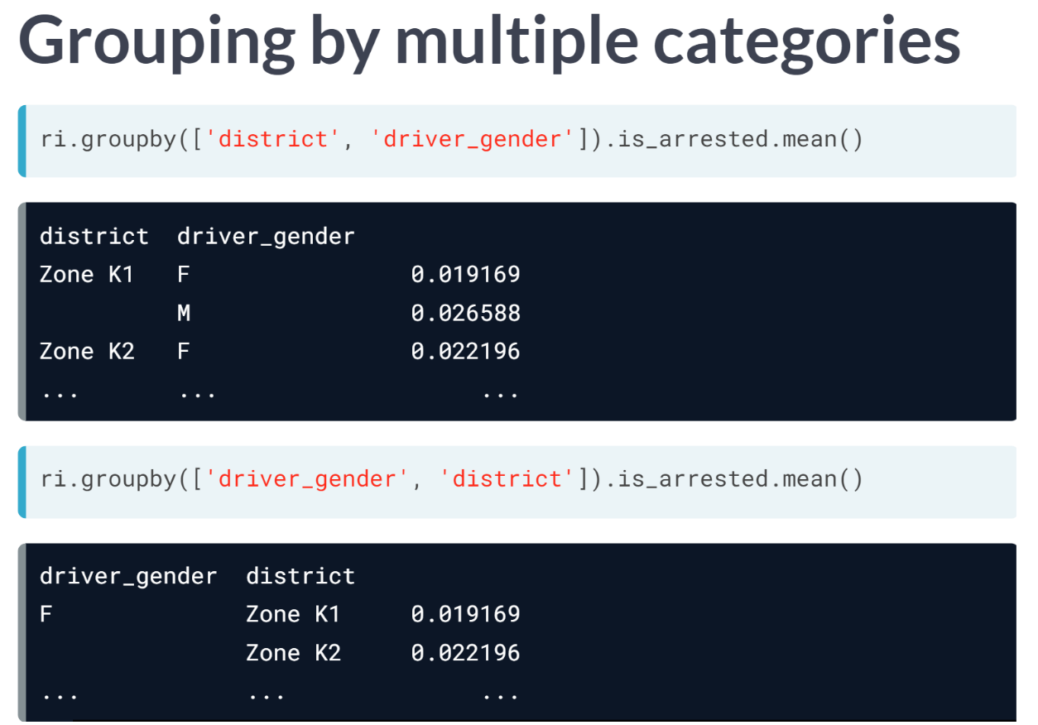  
Grouping by multiple categories is possible. For example, you can group by district and gender by passing it as a list of strings. This computes the arrest rate for every combination of district and gender. In other words, you can see the arrest rate for males and females in each district separately.

Note that if you reverse the ordering of the items in the list, grouping first by gender and then by district, the calculation will be the same, but the presentation of the results will be different. You can use the whichever option makes it easier for you to understand the results.

# Calculating the search rate

During a traffic stop, the police officer sometimes conducts a search of the vehicle. In this exercise, you'll calculate the percentage of all stops in the ri DataFrame that result in a vehicle search, also known as the search rate.

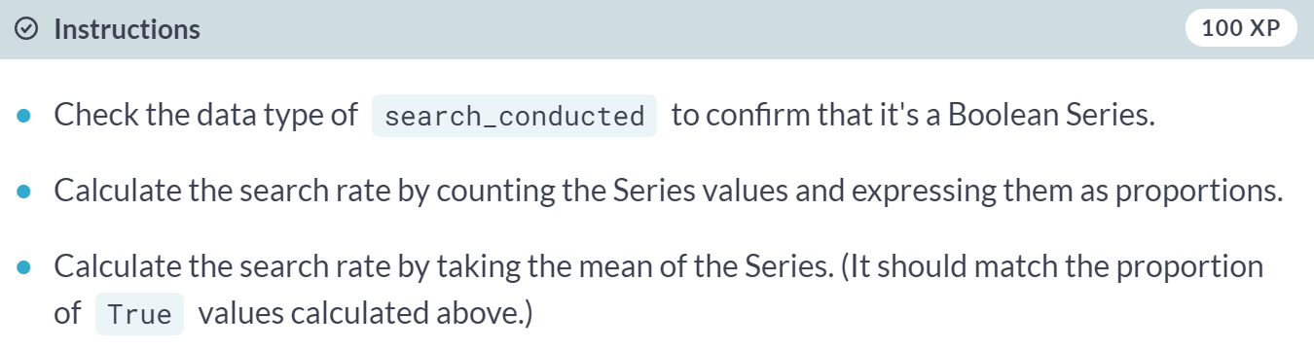

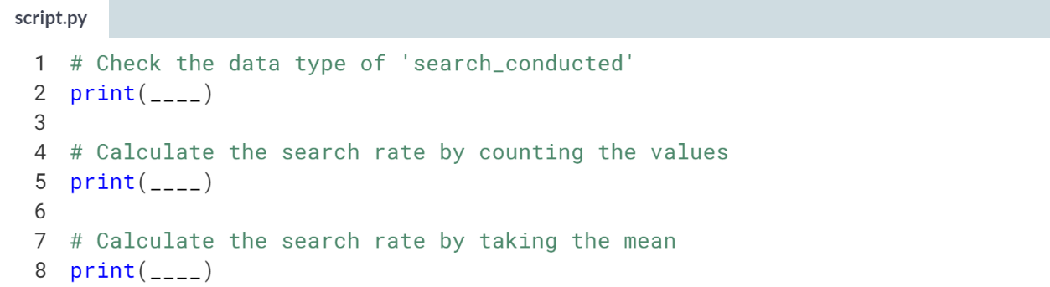

Hint

1. Examine the **.dtype** attribute to check the data type of a Series.
2. Use the **normalize=True** argument to express the *search_conducted* counts as proportions.
3. Use the ***.mean()*** method on the *search_conducted* Series.

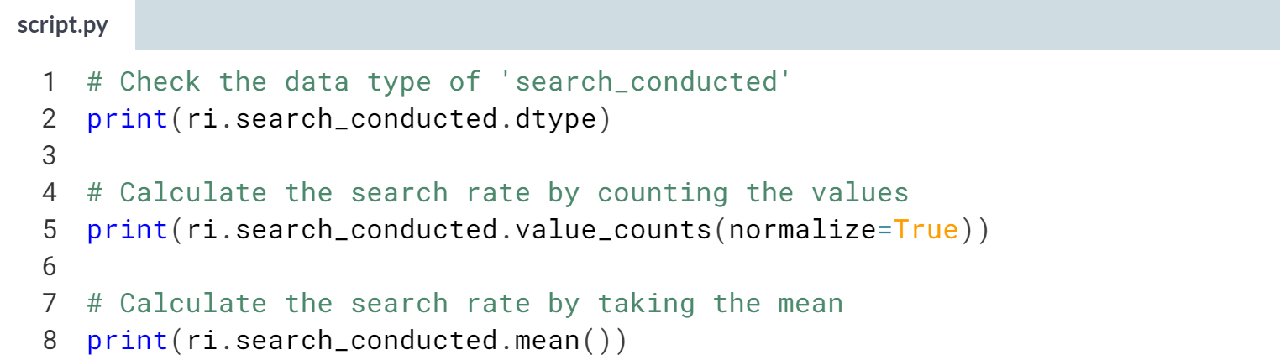  
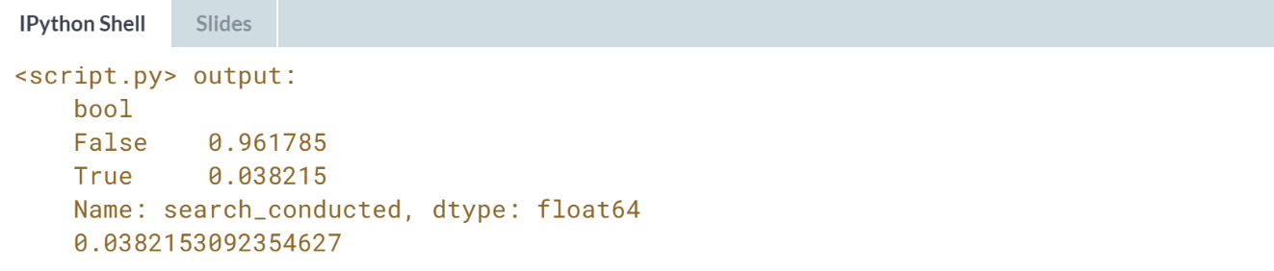

Great! It looks like the search rate is about 3.8%. Next, you'll examine whether the search rate varies by driver gender.

# Comparing search rates by gender

In this exercise, you'll compare the rates at which female and male drivers are searched during a traffic stop. Remember that the vehicle search rate across all stops is about 3.8%.

First, you'll filter the DataFrame by gender and calculate the search rate for each group separately. Then, you'll perform the same calculation for both genders at once using a .groupby().

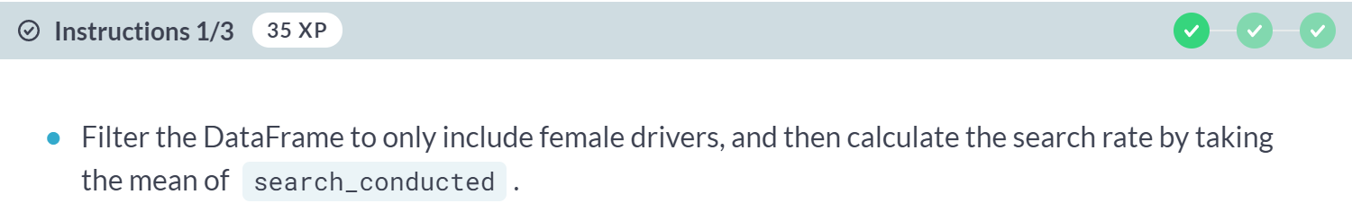

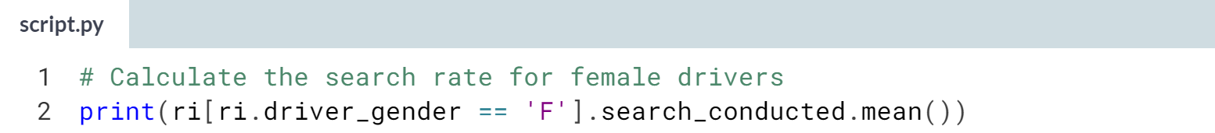

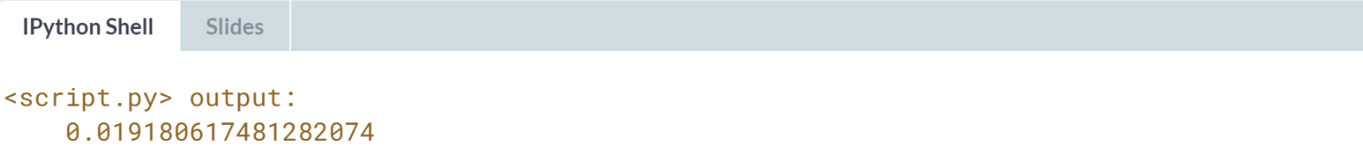



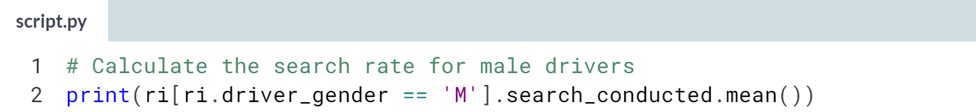

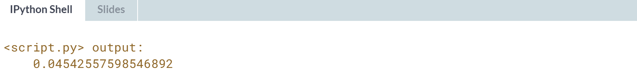

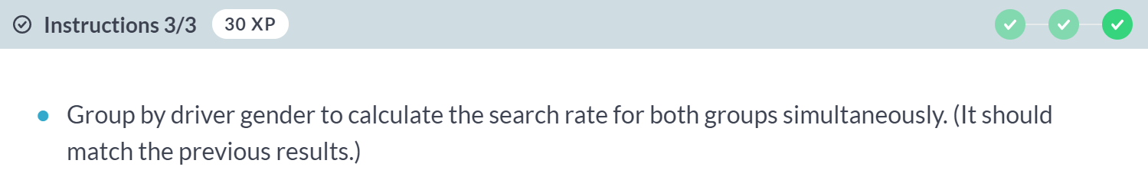

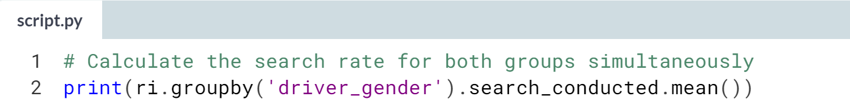

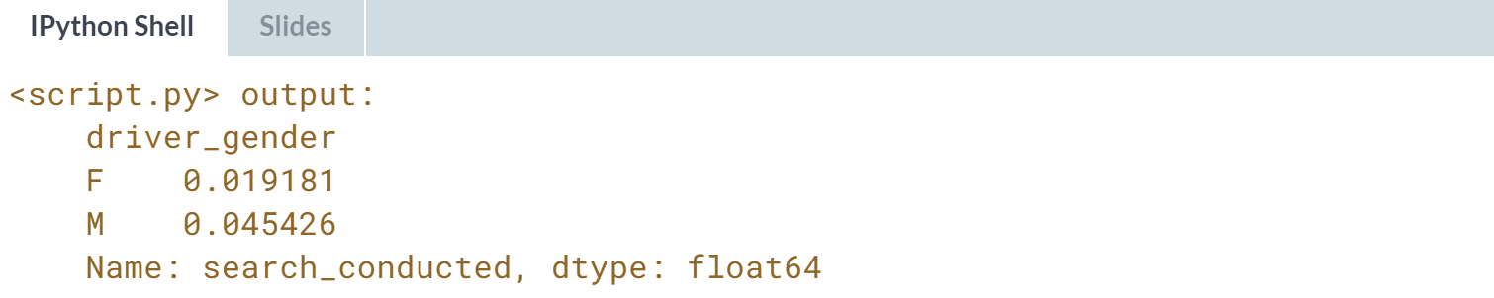

Wow! Male drivers are searched more than twice as often as female drivers. Why might this be?

# Adding a second factor to the analysis

Even though the search rate for males is much higher than for females, it's possible that the difference is mostly due to a second factor.

For example, you might hypothesize that the search rate varies by violation type, and the difference in search rate between males and females is because they tend to commit different violations.

You can test this hypothesis by examining the search rate for each combination of gender and violation. If the hypothesis was true, you would find that males and females are searched at about the same rate for each violation. Find out below if that's the case!

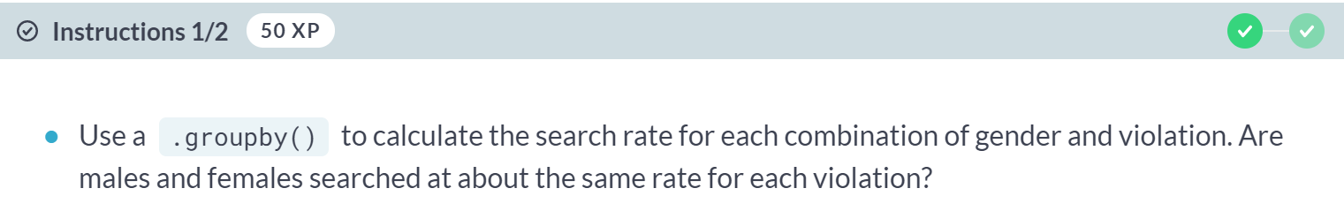



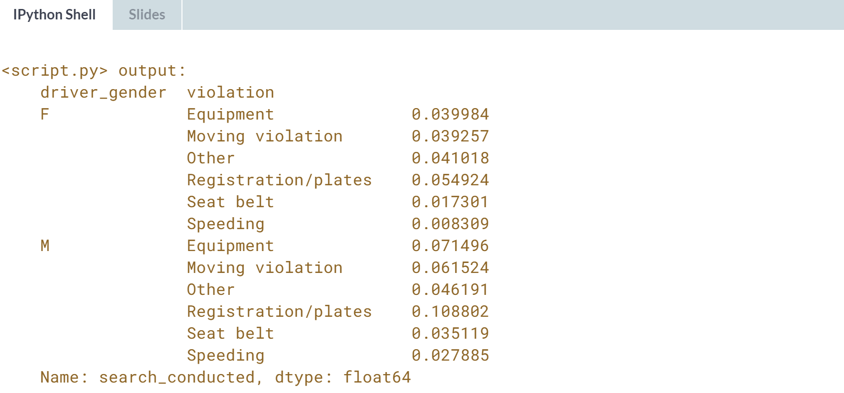

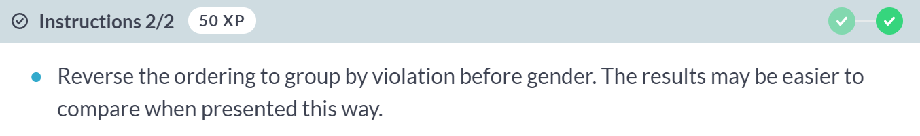



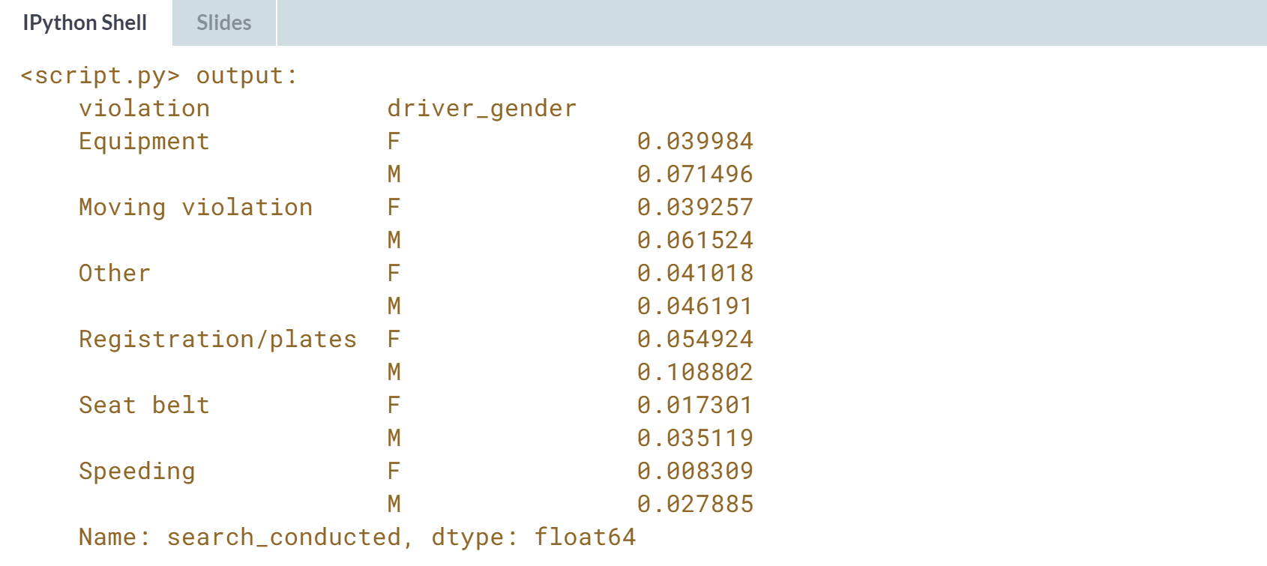

Great work! For all types of violations, the search rate is higher for males than for females, disproving our hypothesis.



In this section, we'll take a look at what happens during a search.

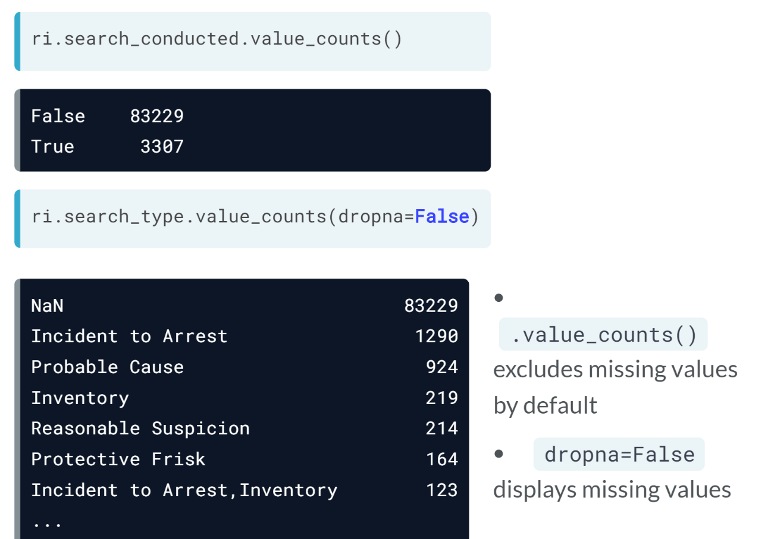  
  
The *search_conducted* field is True if there's a search during a traffic stop, and False otherwise. There's also a related field, *search_type*, that contains additional information about the search.

Notice that the *search_type* field has 83,229 missing values, which is identical to the number of False values in the *search_conducted* field.

That's because any time a search is not conducted, there's no information to record about a search, and thus the *search_type* will be missing.

Note that the ***value_count()*** method excludes missing values by default. And so we specified *dropna=False* to see the missing values.

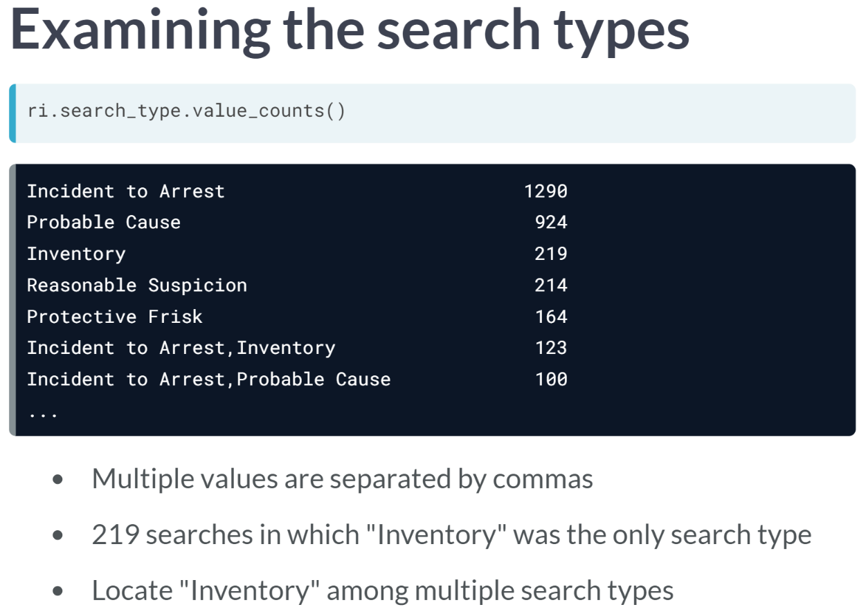  
  
There are only five possible values for *search_type*, which you can see at the top of the ***value_counts()*** output: Incident to Arrest, Probably Cause, Inventory, Reasonable Suspicion, and Protective Frisk.

But sometimes, multiple values are relevant for a single traffic stop, in which case they are separated by commas.

Let's focus on Inventory, meaning searches in which the police took an inventory of the vehicle.

Looking at the third line of the output, we see 219, which is the number of searches in which Inventory was the only search type.

But what if we wanted to know the total number of times in which an inventory was done during a search?

We'd also have to include any stops in which inventory was one of multiple search types. To do this, we will use a string method.

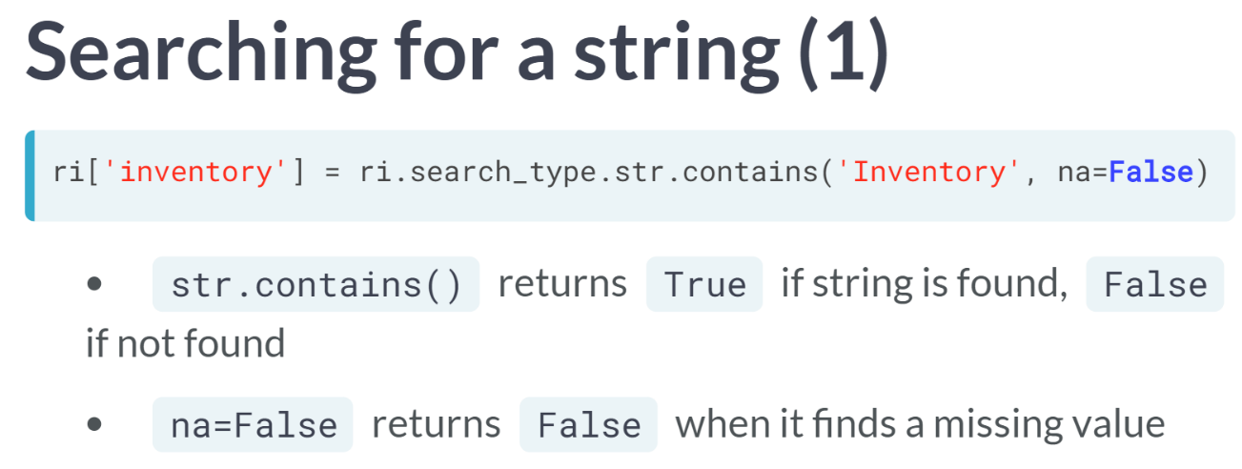

Back in chapter 1, we used a string method to concatenate two columns. This time, we will use a string method called ***contains()*** that checks whether a string is present in each element of a given column.

It returns True if the string is found, False otherwise. Specifying *na=False* tells ***contains()*** method to return False when it finds a missing value in the *search_type* column. We will save the result in a new column called inventory.

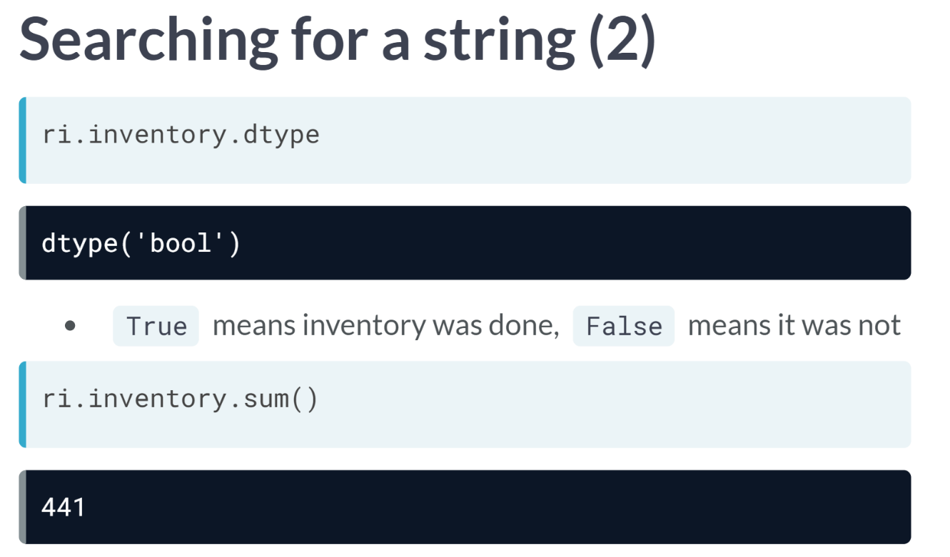  
As expected, the data type of the column is Boolean. To be clear, a *True* value in this column means that an inventory was done during a search, and a *False* value means it was not.

We can take the ***sum()*** of the inventory column to see that an inventory was done during 441 searches. This includes the 219 stops in which Inventory was the only search type, plus additional stops in which Inventory was one of multiple search types.

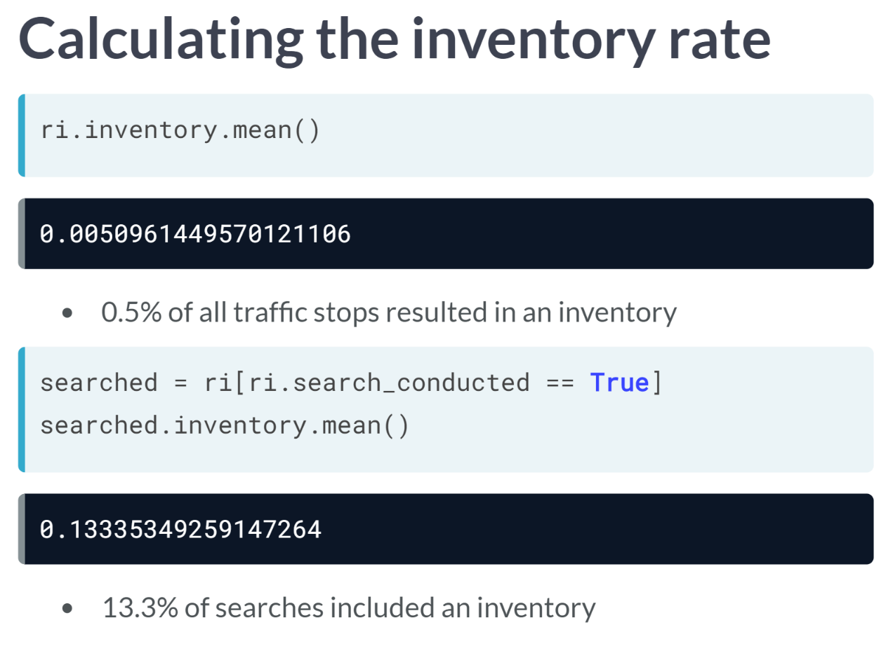  
What if we wanted to calculate the percentage of searches that included an inventory? You might think this would be as simple as taking the ***mean()*** of the inventory column, and the answer would be about 0.5 percent.

But what is wrong with this calculation? This percentage includes all traffic stops which resulted in an inventory including those stops in which a search was not even done.

Instead, we first need to filter the DataFrame to only include those rows in which a search was done, and then take the ***mean()*** of the inventory column.

The correct percentage is 13.34 percent. This is a vastly different result, and it highlights the importance of carefully choosing which rows are relevant before doing a calculation.

# Counting protective frisks

During a vehicle search, the police officer may pat down the driver to check if they have a weapon. This is known as a "protective frisk."

In this exercise, you'll first check to see how many times "Protective Frisk" was the only search type. Then, you'll use a string method to locate all instances in which the driver was frisked.

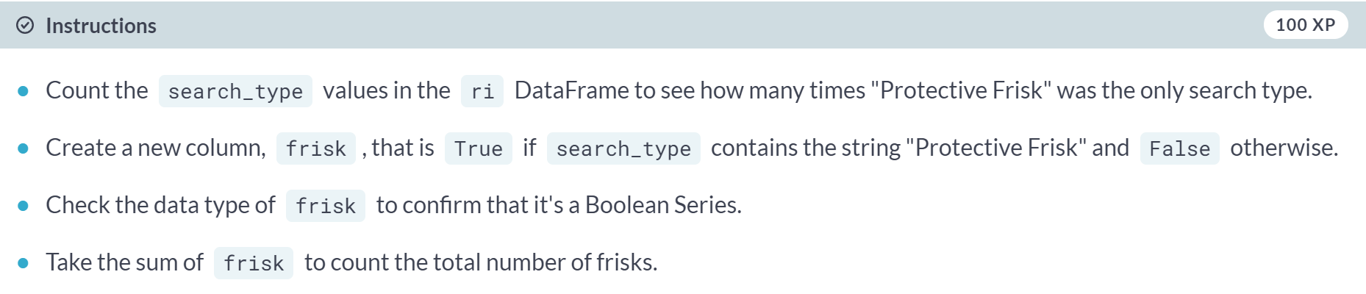

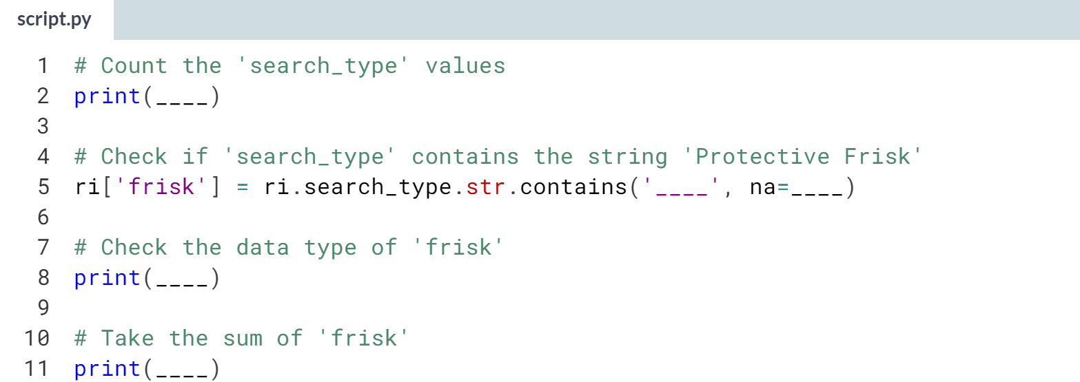

Hint

1. Use the ***.str.contains()*** method on the *search_type* column to search for **'Protective Frisk'**, and make sure to include the **na=False** argument.
2. If you're not finding any matches, keep in mind that string methods are case sensitive.

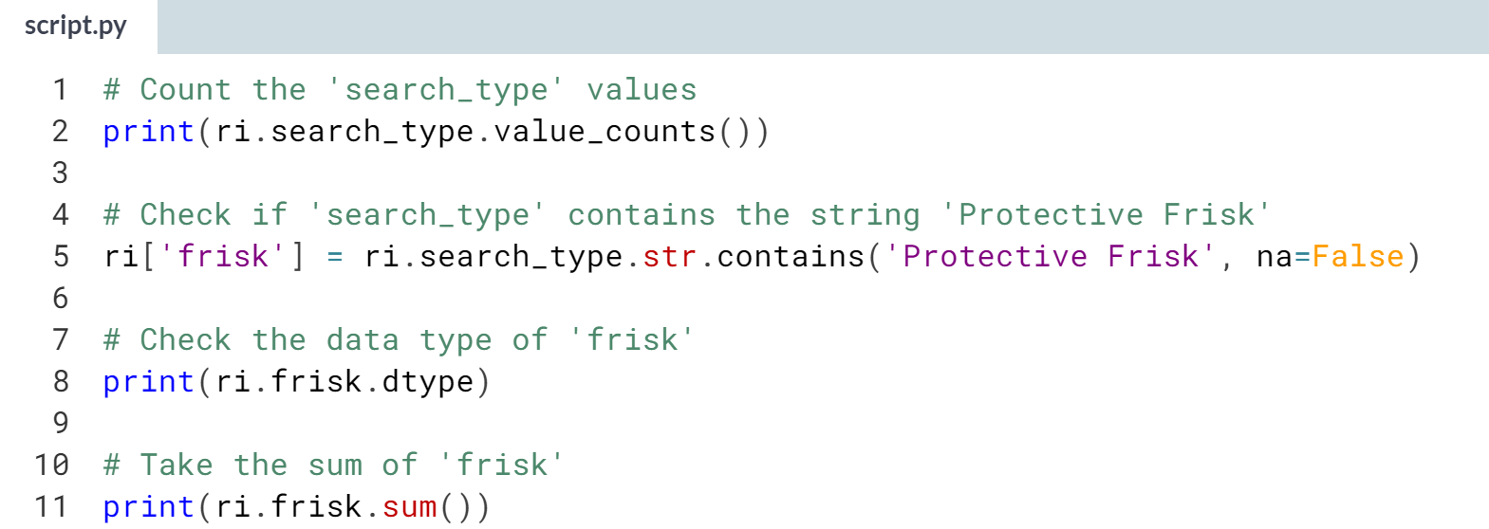

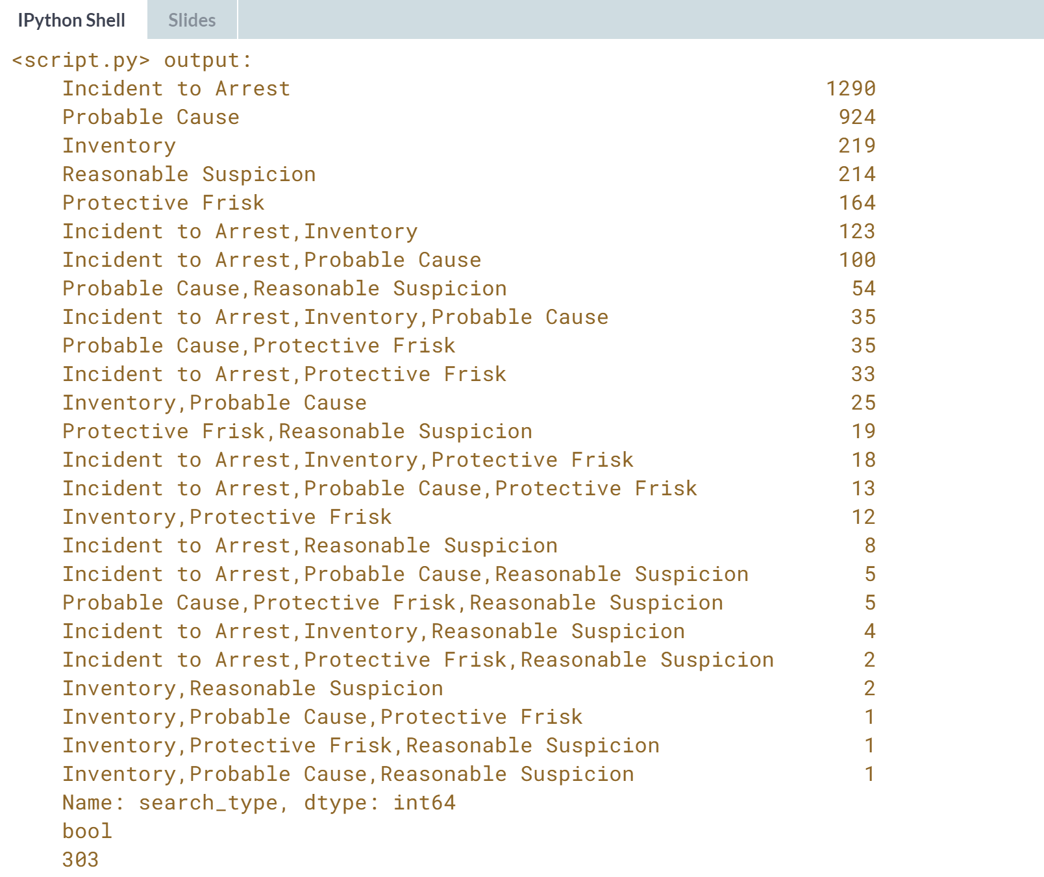

Nice job! It looks like there were 303 drivers who were frisked. Next, you'll examine whether gender affects who is frisked.

# Comparing frisk rates by gender

In this exercise, you'll compare the rates at which female and male drivers are frisked during a search. Are males frisked more often than females, perhaps because police officers consider them to be higher risk?

Before doing any calculations, it's important to filter the DataFrame to only include the relevant subset of data, namely stops in which a search was conducted.

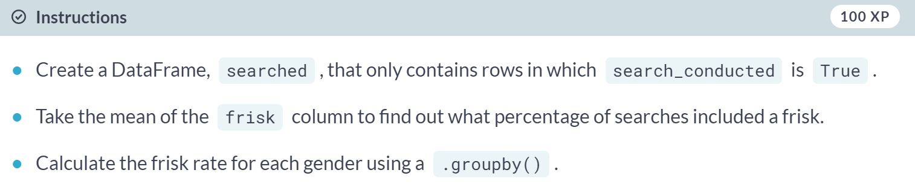

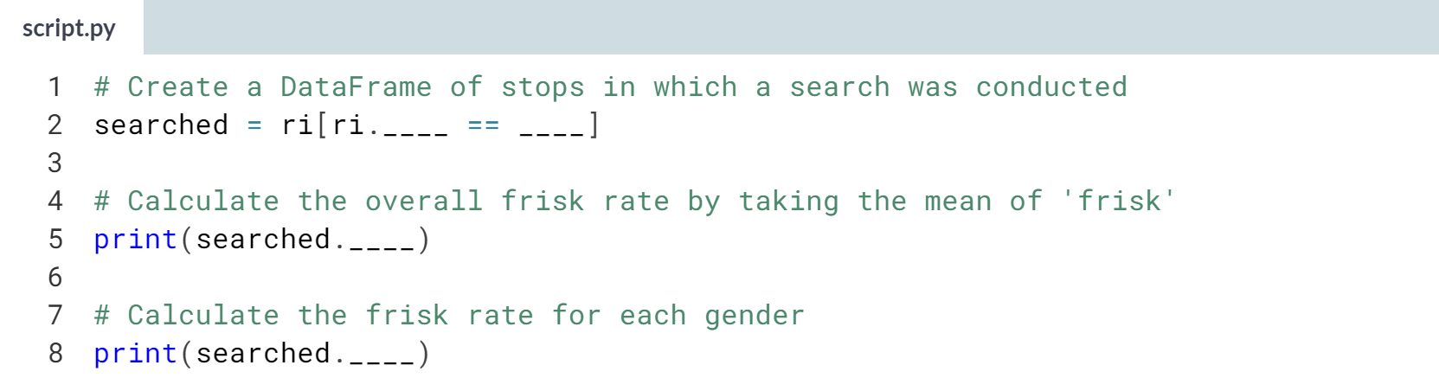

Hint

1. Filter the *ri* DataFrame using the condition **ri.search_conducted == True**.
2. To calculate the frisk rate by gender, group by *'driver_gender'* and then take the **.mean()** of the frisk column.

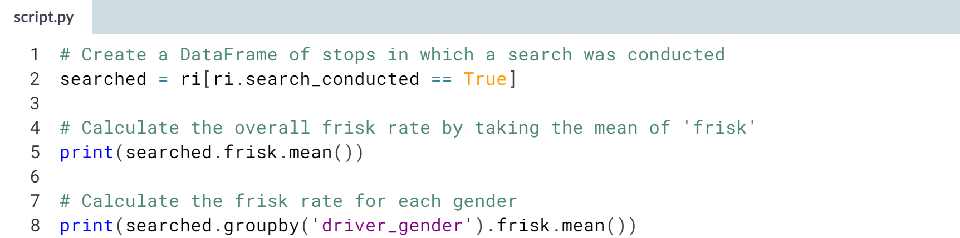

(Result on the next page)

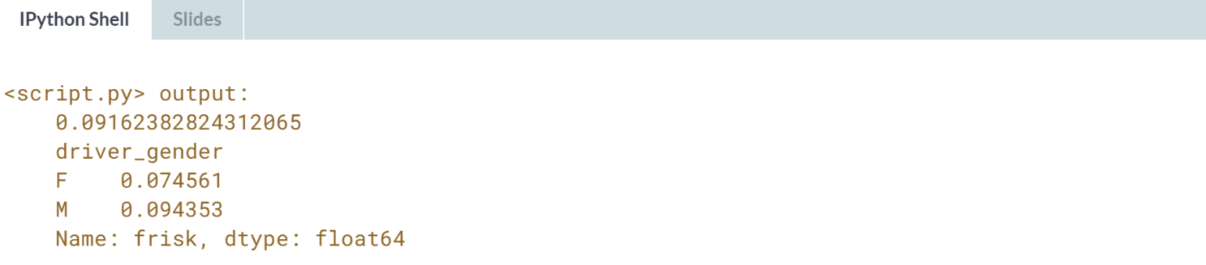

Interesting! The frisk rate is higher for males than for females, though we can't conclude that this difference is caused by the driver's gender.

**3. Visual exploratory data analysis**

Are you more likely to get arrested at a certain time of day? Are drug-related stops on the rise? In this chapter, you will answer these and other questions by analyzing the dataset visually, since plots can help you to understand trends in a way that examining the raw data cannot.



In this chapter, we will explore and analyze the dataset visually using plots.

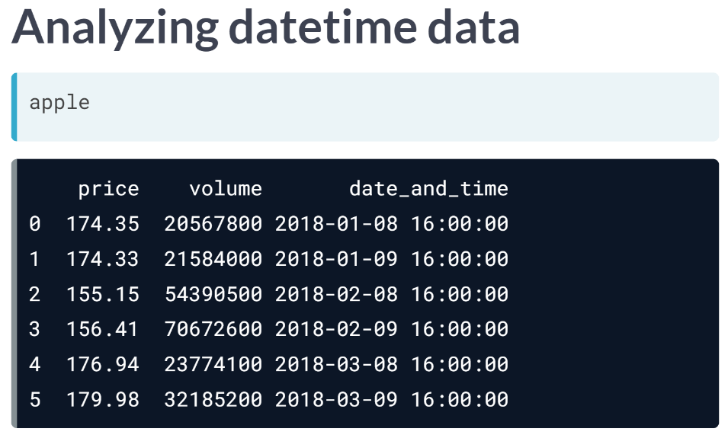  
Back in chapter 1, we worked with a small DataFrame of Apple stock prices. We are going to use it here again, but this time it includes two days each from the first three months of 2018. There is also a new column, volume, that displays the number of Apple shares traded that day.

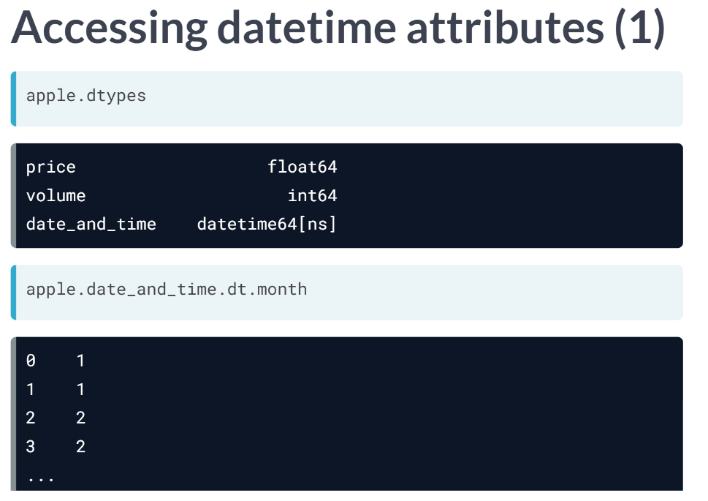  
You might recall that we converted the *date_and_time* column to pandas *datetime* format. Because of datetime format, you actually have access to special date-based attributes via the dt accessor. For example, you can access the month as an integer by using the *dt.month* attribute. There are many other similar attributes, such as week, dayofweek, hour, minute, so on.

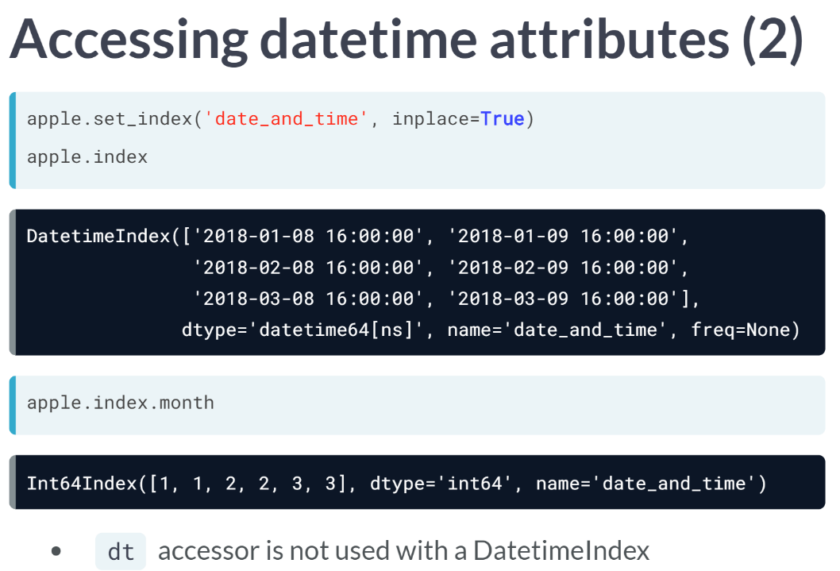  
Similar to our traffic stops dataset, we can set the date_and_time column as the DataFrame index. Because of its data type, it is not a DatetimeIndex. We can still access the same datetime attributes, such as month, and we get the same result as before, but we no longer have to use the dt accessor.

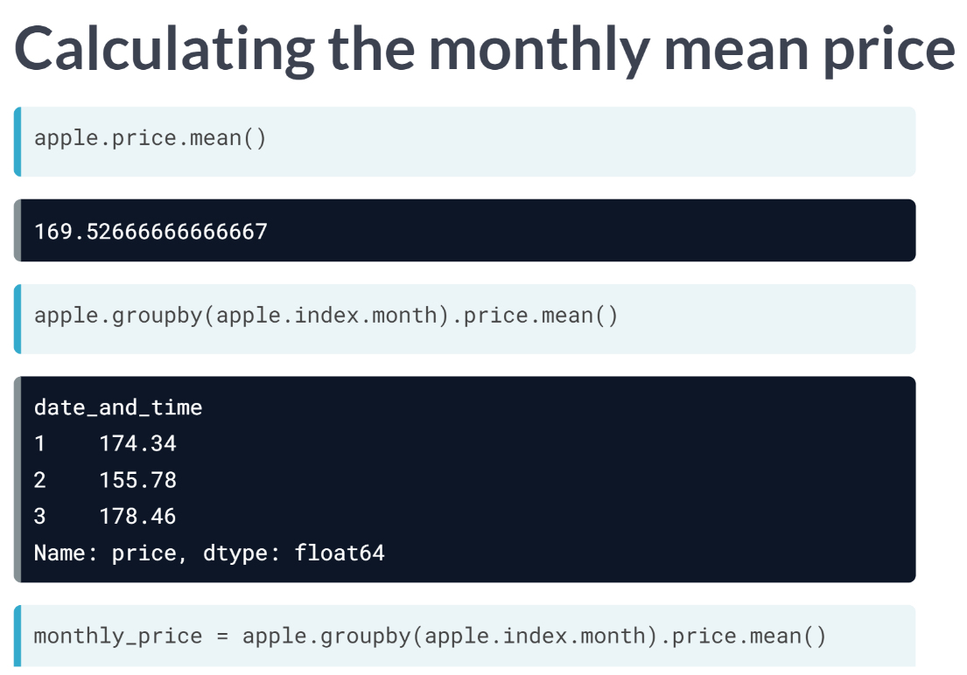  
Let's examine the price column of the apple DataFrame. If we wanted to calculate the mean price for all rows, we would simply use the ***mean()*** method.

But what if we wanted to calculate the mean price for each month? One idea would be to use a ***groupby()*** operation, but we can't group by month as a string since it's not a column in the DataFrame.

Instead, we would group by *apple.index.month* and then take the ***mean()*** of the price column. This operation outputs a Series, in which the index is the month number and the values are the mean prices. We will go ahead and save this Series as an object called *monthly_price*.

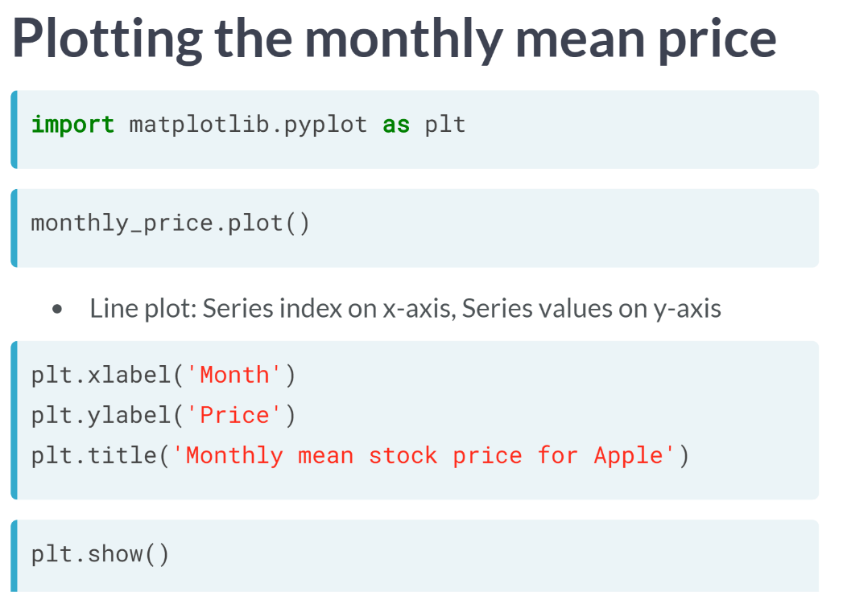  
Let's say that we wanted to plot this data to visually examine the monthly price trends. The following is how you can execute the code to generate the plot.

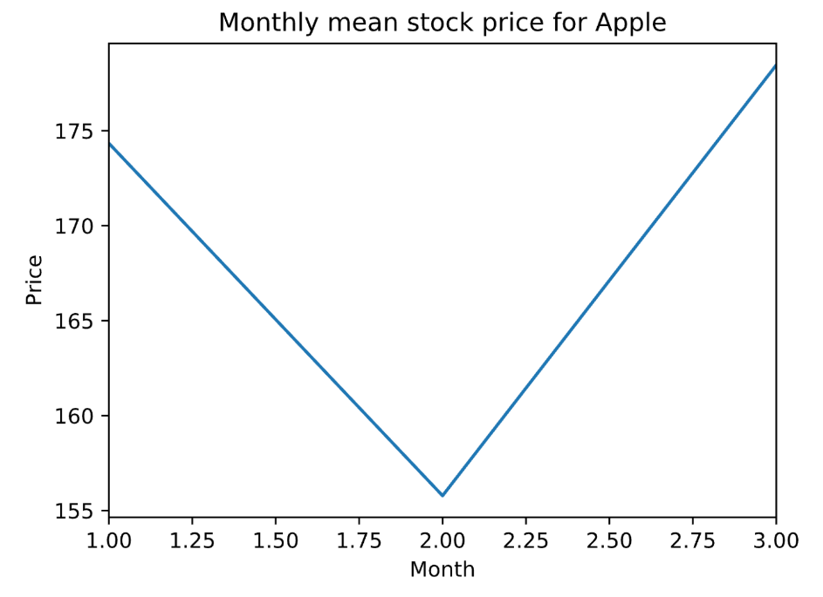  
It is a very simple plot in this case, but you can imagine that with a much larger dataset, this plot could help you to understand the price trends in a way that examining the raw data could not.

# Calculating the hourly arrest rate

When a police officer stops a driver, a small percentage of those stops ends in an arrest. This is known as the arrest rate. In this exercise, you'll find out whether the arrest rate varies by time of day.

First, you'll calculate the arrest rate across all stops in the ri DataFrame. Then, you'll calculate the hourly arrest rate by using the hour attribute of the index. The hour ranges from 0 to 23, in which:

* 0 = midnight
* 12 = noon
* 23 = 11 PM

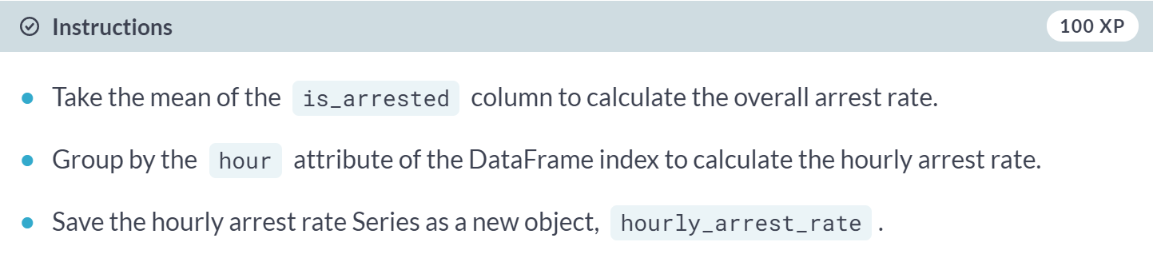

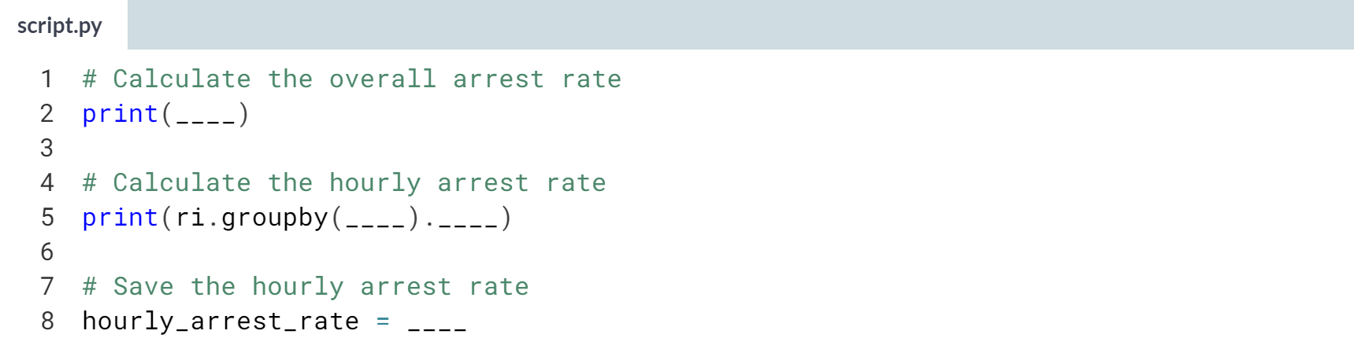

Hint

1. To calculate the overall arrest rate, use the ***.mean()*** method on the *is_arrested* column.
2. To calculate the hourly arrest rate, group by **ri.index.hour** and then take the ***.mean()*** of the *is_arrested* column.

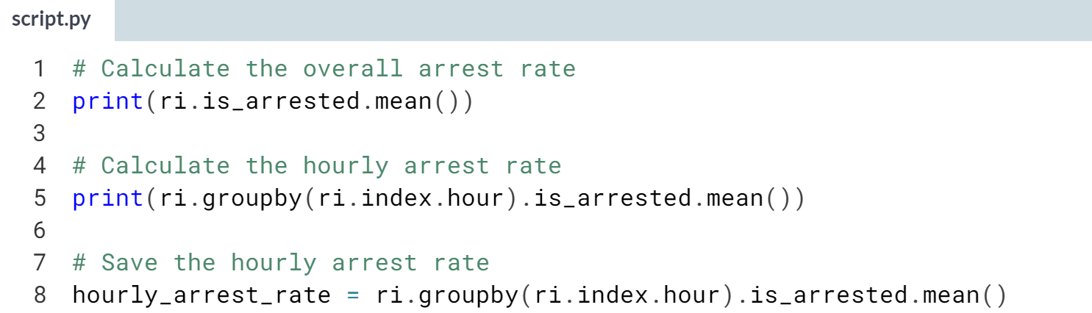

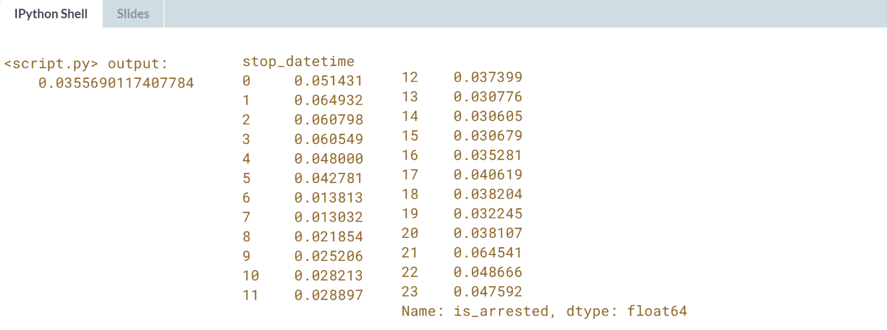

Great work! Next you'll plot the data so that you can visually examine the arrest rate trends.

# Plotting the hourly arrest rate

In this exercise, you'll create a line plot from the hourly_arrest_rate object. A line plot is appropriate in this case because you're showing how a quantity changes over time.

This plot should help you to spot some trends that may not have been obvious when examining the raw numbers!

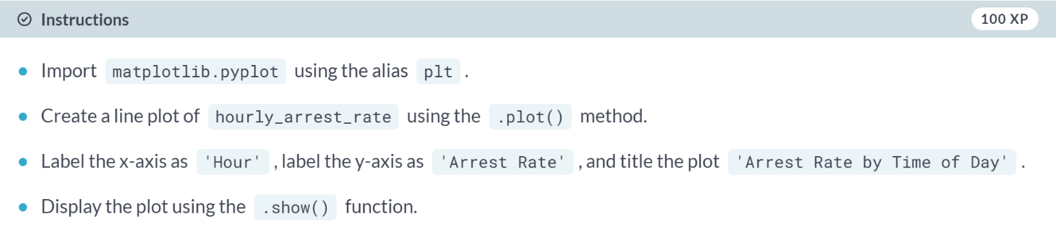

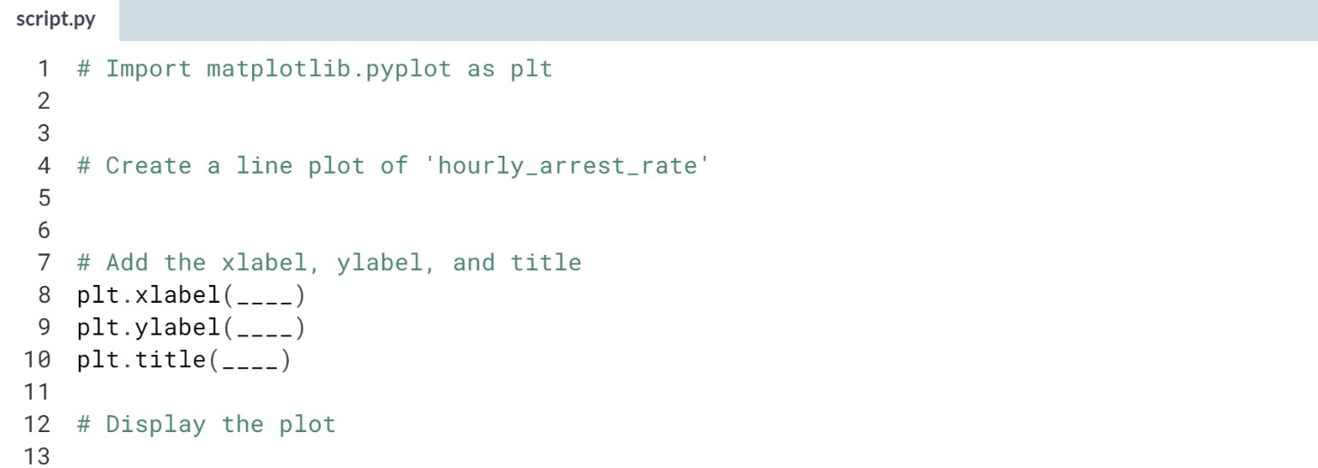

Hint

1. The **hourly_arrest_rate** object already exists in your workspace and is not part of the *ri* DataFrame.
2. Make sure to pass the labels as strings to the *plt* functions.
3. The plot will not appear until ***plt.show()*** has been run.

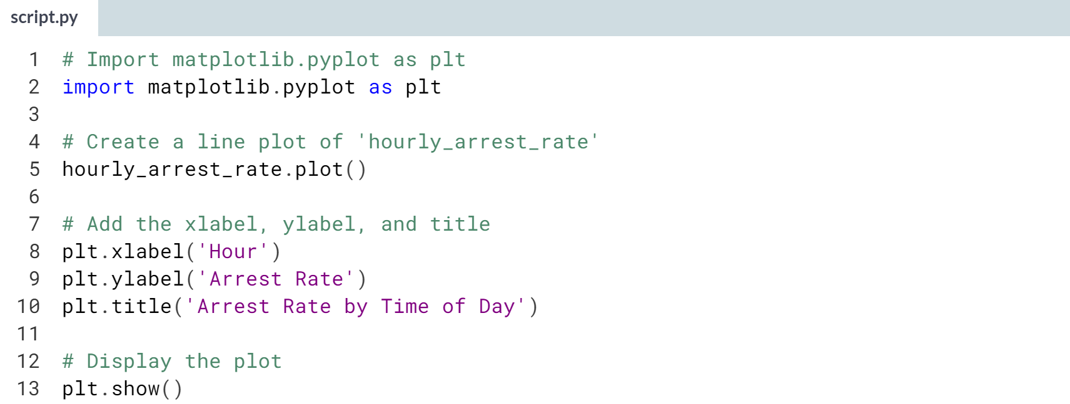

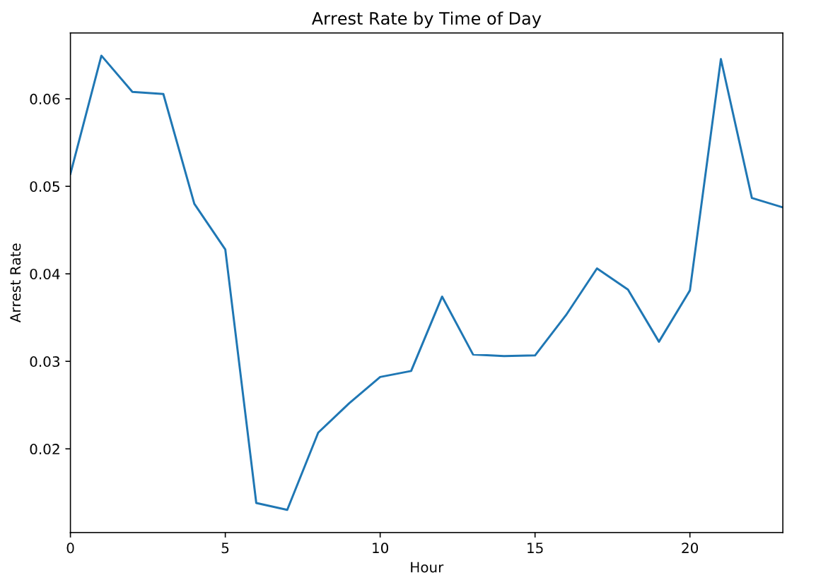

Wow! The arrest rate has a significant spike overnight, and then dips in the early morning hours.



In this section, we will use subplots to help us examine the relationship between two variables over time.

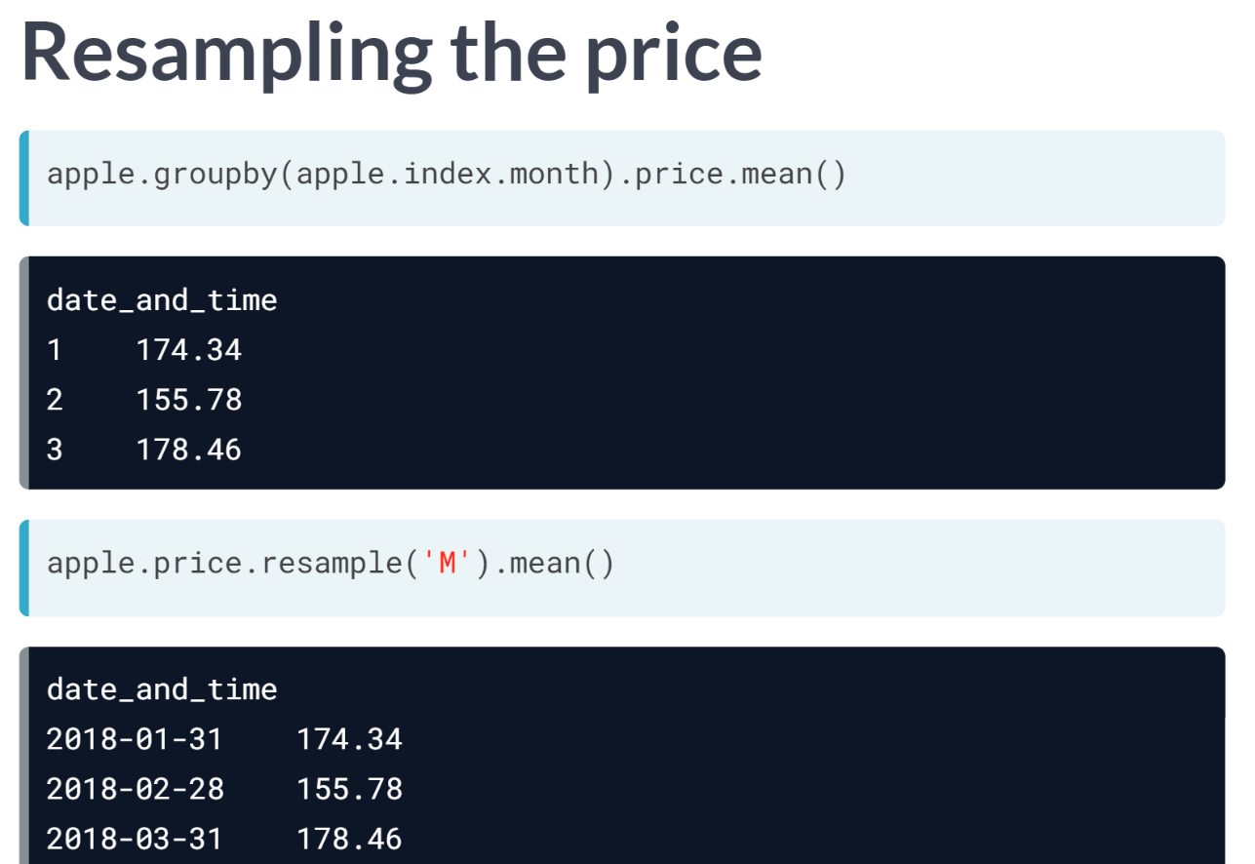  
In the last section, we calculated the mean price for each month using a ***groupby()*** operation. There's actually an alternative method, known as resampling, that we can use to accomplish the same task.

As you might remember from previous courses, resampling is when you change the frequency of your time series observations.

In this case, we will resample the price column by month, represented by the capital letter M, and then chain the ***mean()*** method onto the end.

The output is identical to the ***groupby()*** operation, except that the index consists of the last day of each month, rather than just the integers 1,2, and 3.

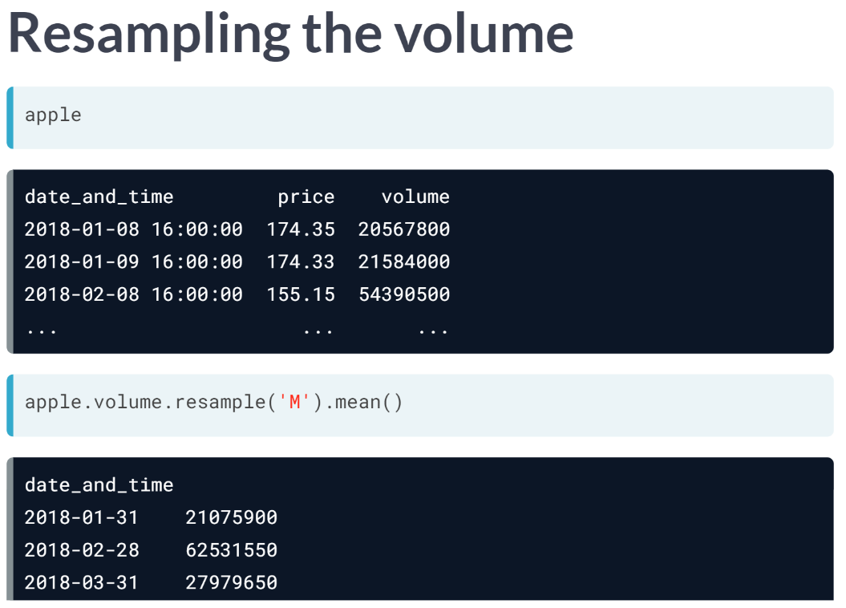  
Let's resample the volume column to calculate the mean daily volume for each month. One thing worth noticing is that the output has the same index as the last resampling operation, since both price and volume were resampled at the same frequency.

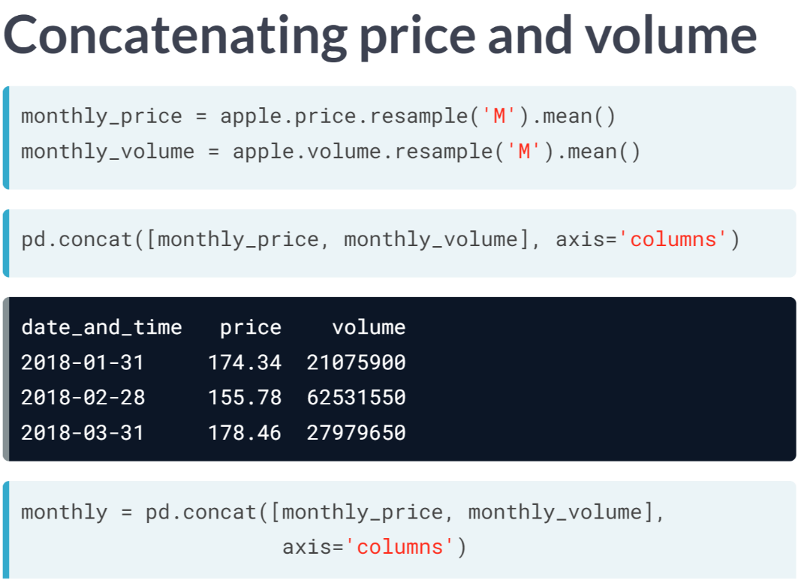  
Now that we've resampled both the price and volume data, we are going to combine the result into a single DataFrame so that we can study the relationship between price and volume.

First, we will save the two resampled Series as separate objects. One is called *monthly_price* and the other is called *monthly_volume*. Then, we will use ***concat()*** to combine these two objects along a specified axis. We want to combine along the column axis in this case, meaning we want them side by side. Notice that they aligned along their shared index. We will save this new DataFrame as an object called *monthly*.

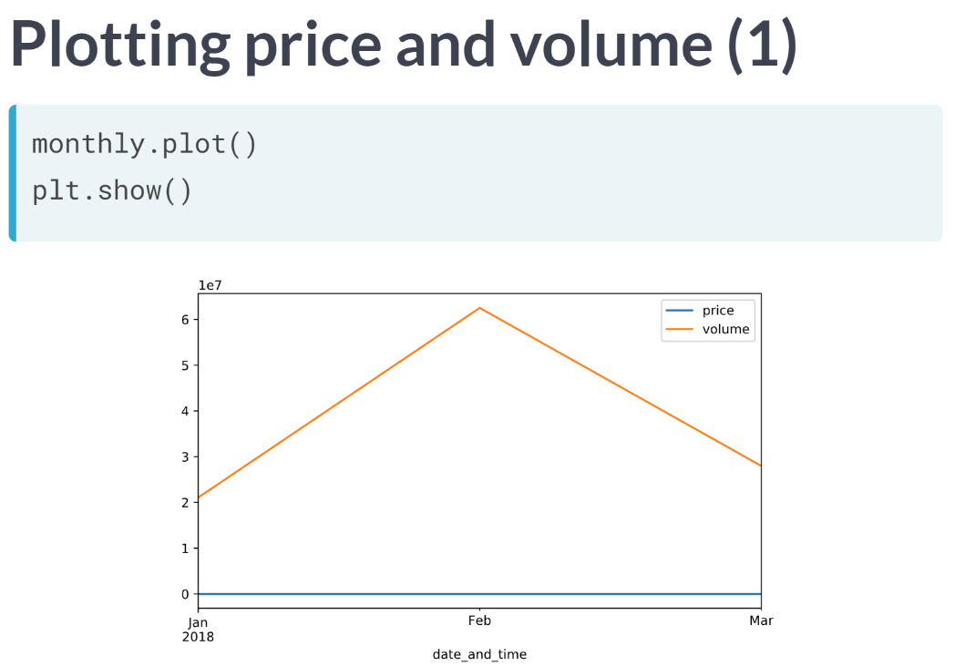  
To visualize the relationship between price and volume, we simply call the ***plot()*** method on the monthly DataFrame. pandas outputs a single line plot in which each line represents one of the two columns. Because it is a single plot, the two lines are sharing both the x and y axes.

It makes sense for the x-axis to be shared, since we want to compare price and volume by month. But sharing the y-axis is problematic, because the price and volume are on such different scales: price is in the hundreds, and volume is in the tens of millions, represented by the *1e7* notation at the top of the y-axis. Because of the different scales, we can't actually see the price trend.

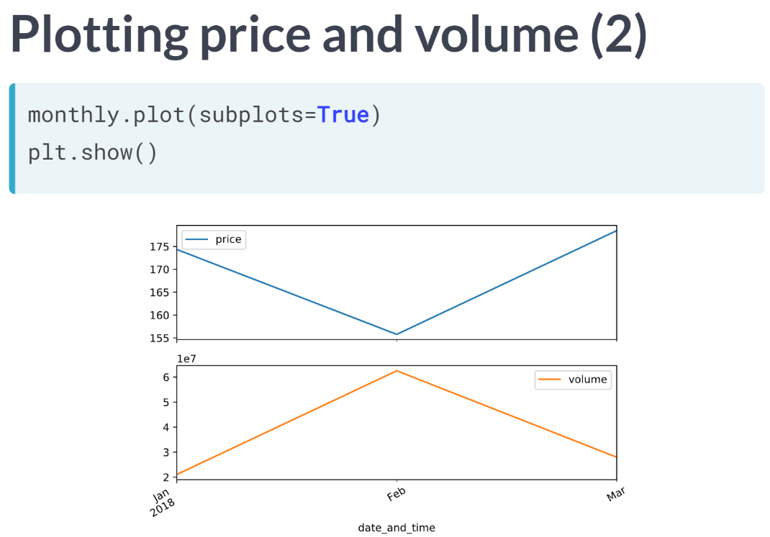  
To solve this issue, we can set the subplots parameter to True, which results in two separate plots with independent y axes. Now, we can clearly see the monthly trends for both price and volume.

# Plotting drug-related stops

In a small portion of traffic stops, drugs are found in the vehicle during a search. In this exercise, you'll assess whether these drug-related stops are becoming more common over time.

The Boolean column drugs_related_stop indicates whether drugs were found during a given stop. You'll calculate the annual drug rate by resampling this column, and then you'll use a line plot to visualize how the rate has changed over time.

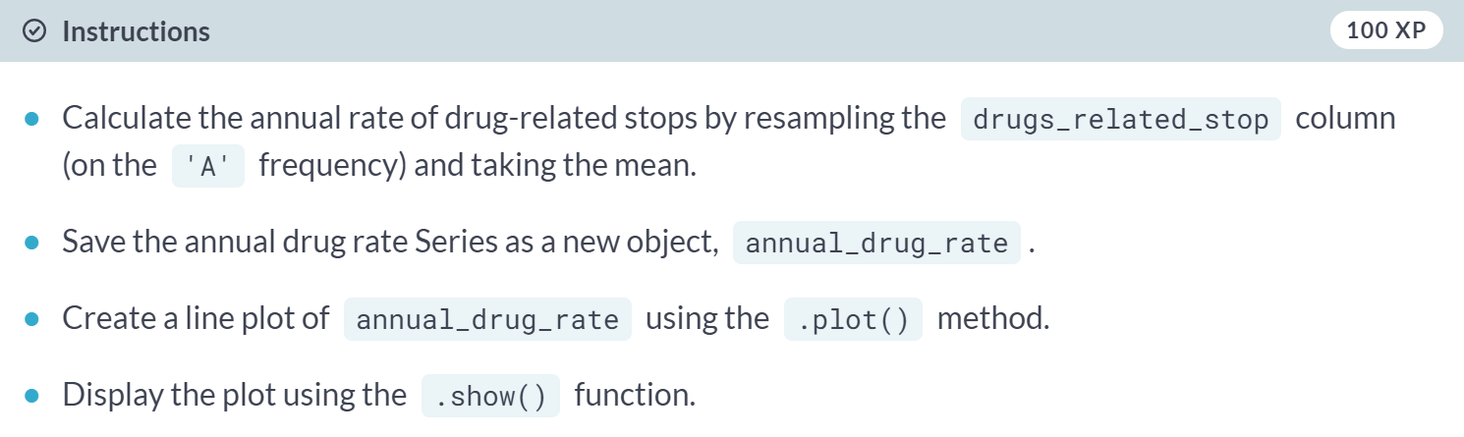

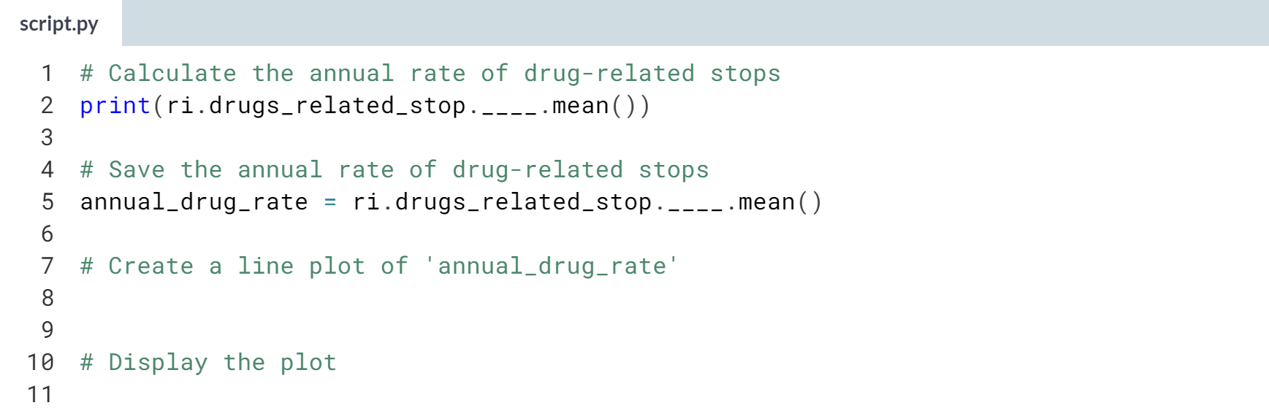

To calculate the annual drug rate, use the **.resample('A')** method on **ri.drugs_related_stop** and then chain the ***.mean()*** method on the end.

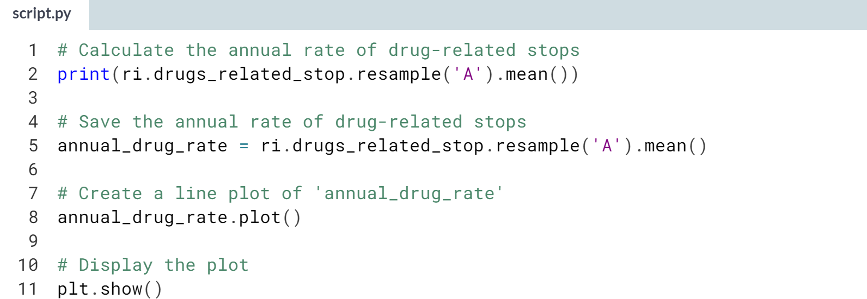

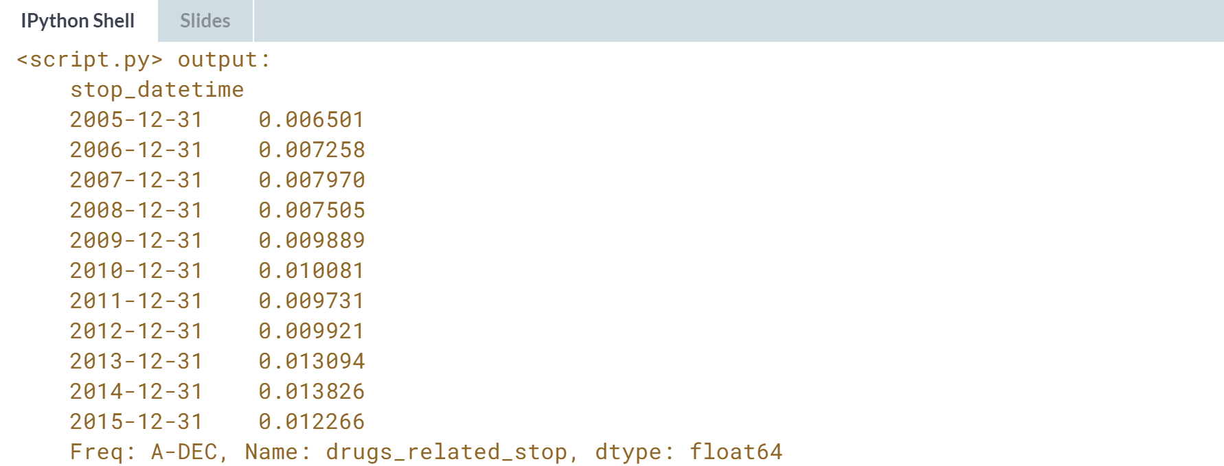

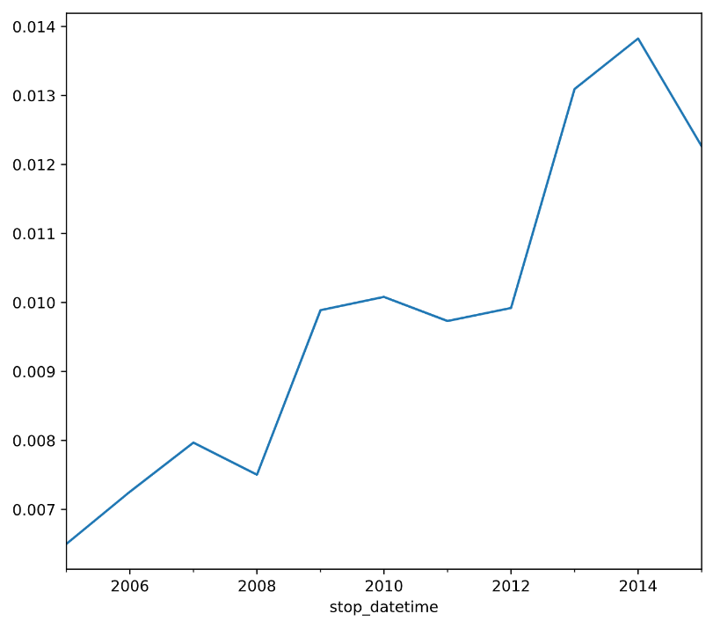  
Interesting! The rate of drug-related stops nearly doubled over the course of 10 years. Why might that be the case?

# Comparing drug and search rates

As you saw in the last exercise, the rate of drug-related stops increased significantly between 2005 and 2015. You might hypothesize that the rate of vehicle searches was also increasing, which would have led to an increase in drug-related stops even if more drivers were not carrying drugs.

You can test this hypothesis by calculating the annual search rate, and then plotting it against the annual drug rate. If the hypothesis is true, then you'll see both rates increasing over time.

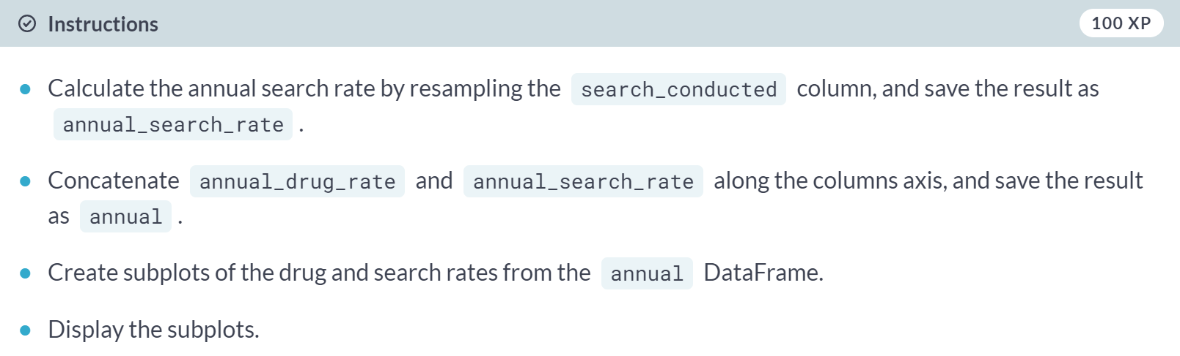

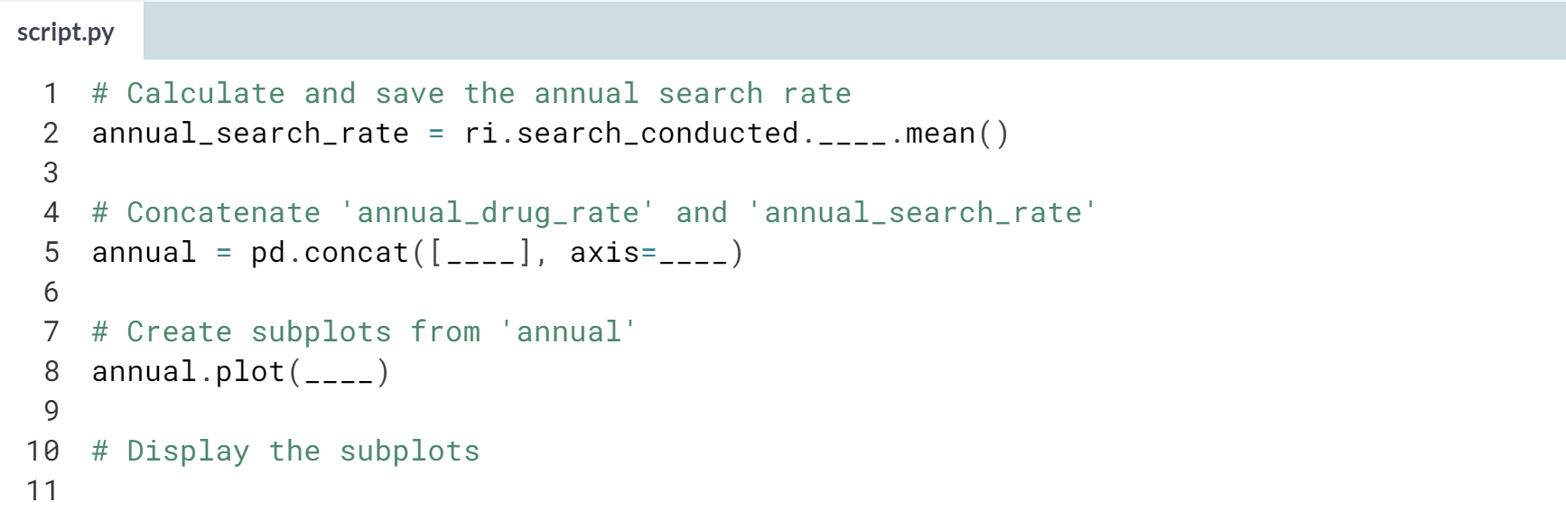

Hint

1. To calculate the annual search rate, use the **.resample('A')** method on **ri.search_conducted** and then chain the ***.mean()*** method on the end.
2. To concatenate objects side-by-side, pass a list of those objects to ***pd.concat()*** and set the axis parameter to **'columns'**.
3. To create subplots from a DataFrame, include the **subplots=True** argument.

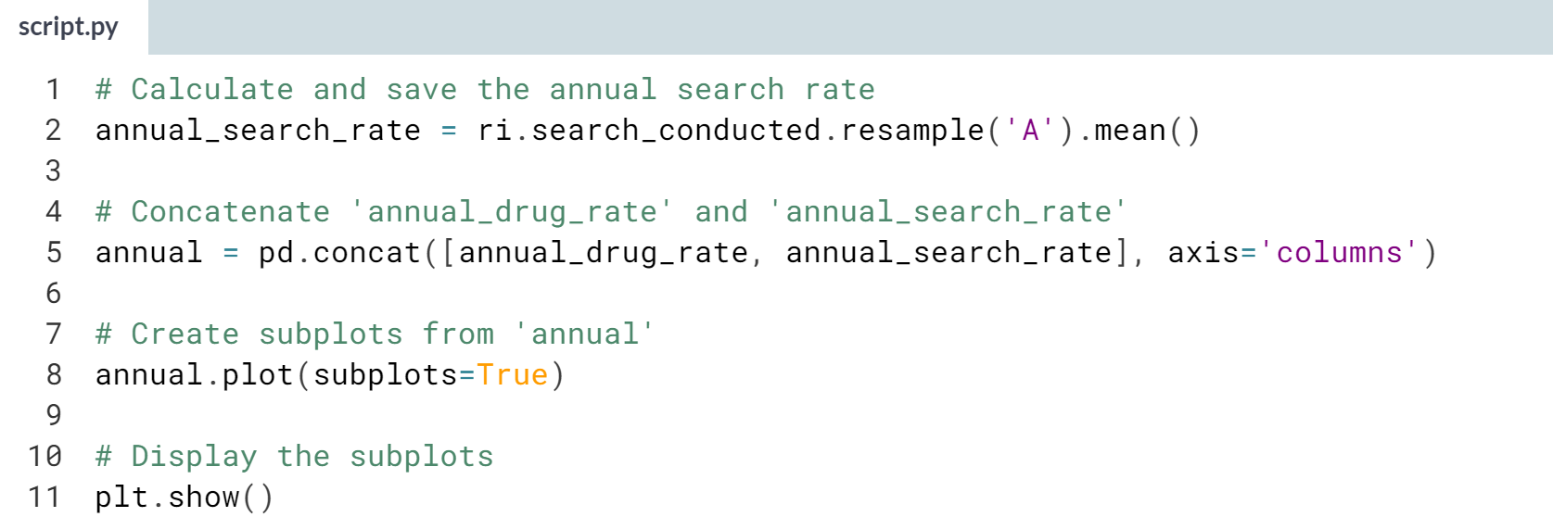

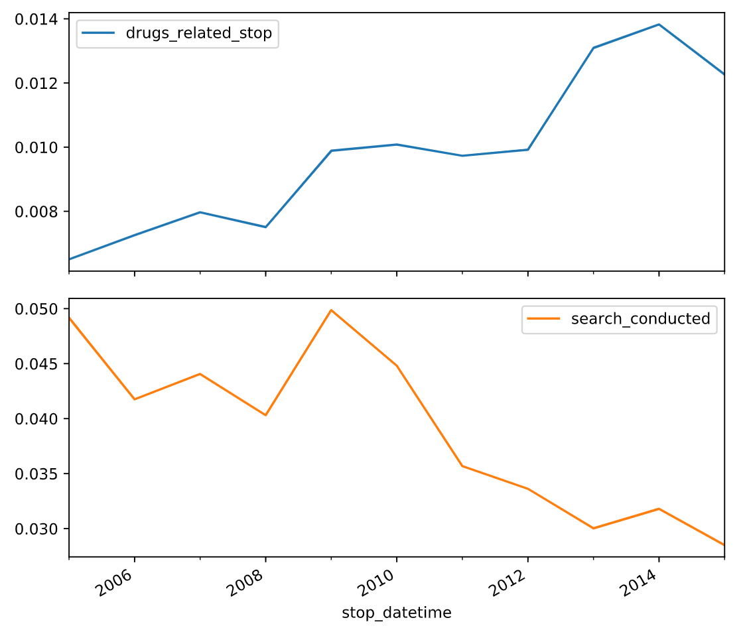

Wow! The rate of drug-related stops increased even though the search rate decreased, disproving our hypothesis.



Let's learn about making different types of plots from DataFrames.

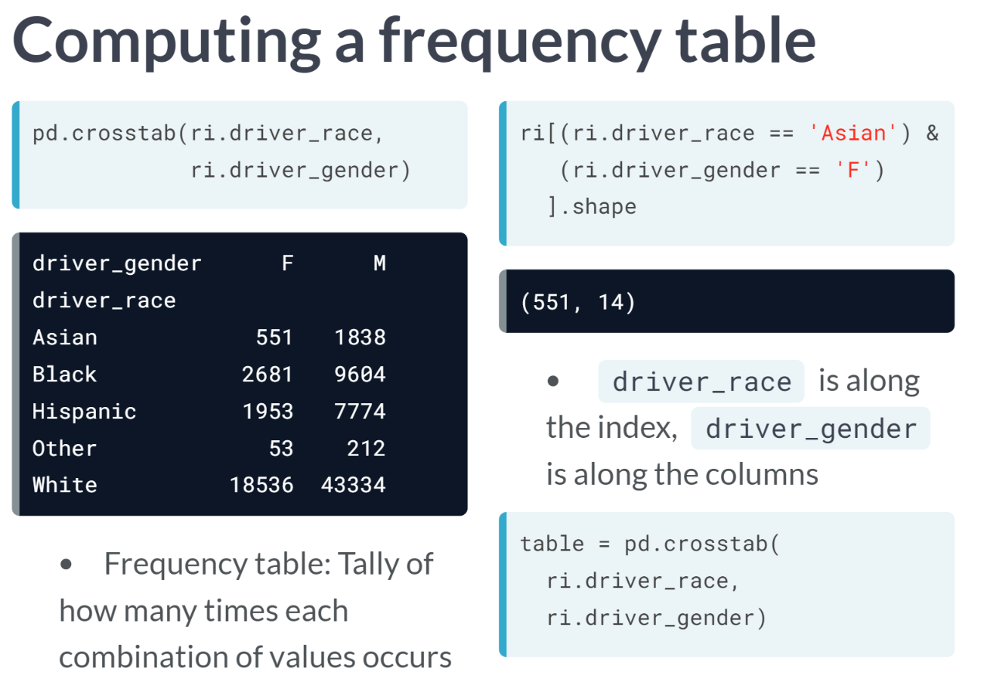  
One Pandas function that might be new to you is ***crosstab()***, short for cross-tabulation. To use ***crosstab()***, you pass it two pandas Series that represent categories, and it outputs a frequency table in the form of a DataFrame. You can think of a *frequency* table as a tally of how many times each combination of values occurs in the dataset.

In this case, we passed *driver_race* and *driver_gender* to ***crosstab()***, and it tells us how many rows contain each combination of race and gender. For example, 551 female Asian drivers were stopped, which you can verify by filtering the DataFrame.

Notice that race is along the index of the DataFrame and gender is along the columns, though you could transpose the DataFrame by reversing the order in which race and gender are passed to ***crosstab()***. Let's go ahead and save the frequency table as an object called *table*.

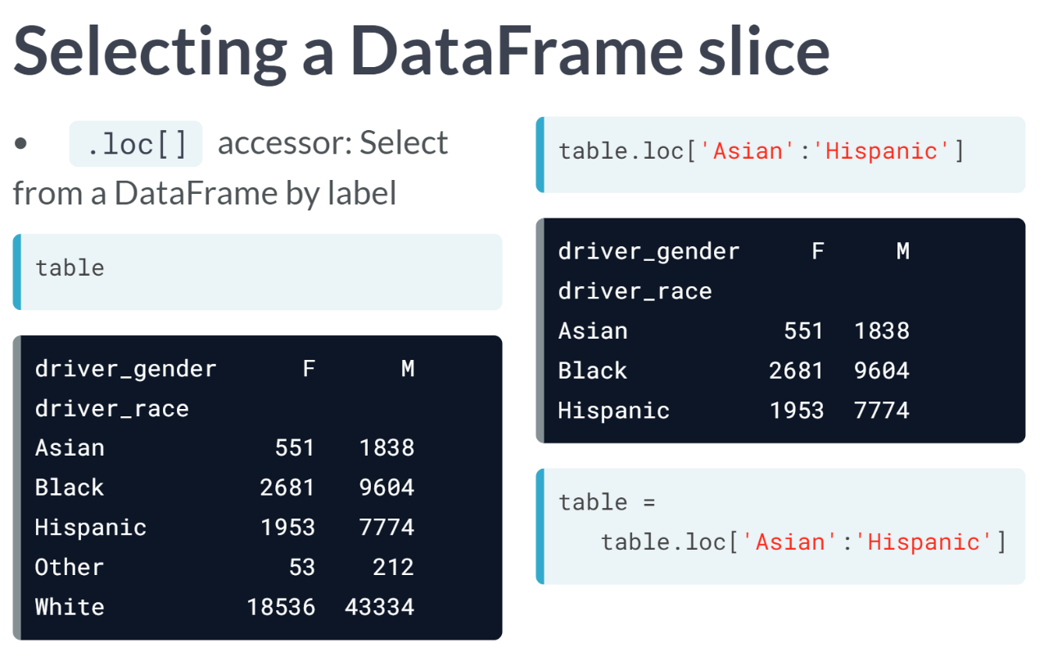As you might recall from previous courses, the loc accessor allows you to select portions of a DataFrame by label. Given our frequency table, let's pretend that we wanted to select the Asian through Hispanic rows only. Using loc, we can extract this slice of the DataFrame as shown above. Let's overwrite our existing table object with this smaller DataFrame**.**

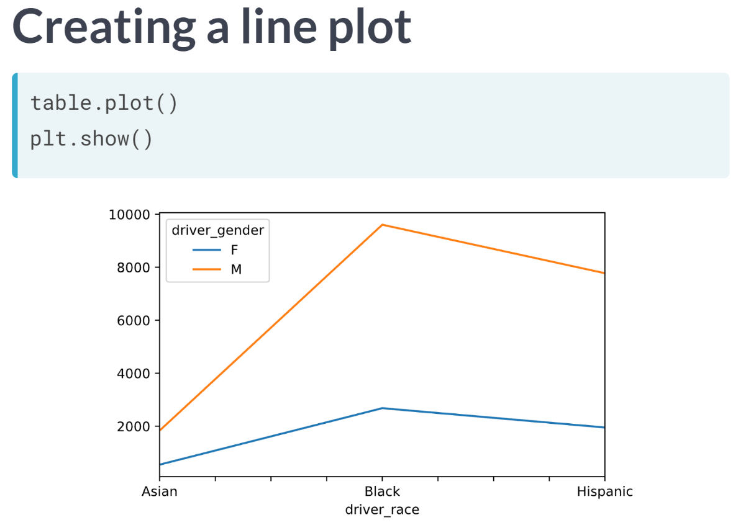Running the basic code above generates a line graphs by default, as shown above. It is inappropriate to use the line graph in this case because it implies a change in time along the x-axis; whereas, the x-axis actually represents three distinct categories.

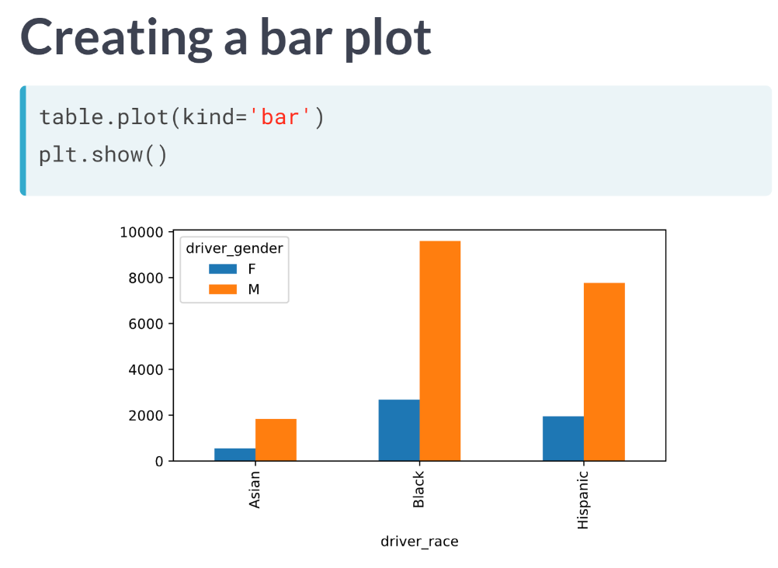By specifying *kind=’bar’*, you can create a bar plot, which is more appropriate than a line plot for comparing categorical data. With this plot, the numbers in our frequency table have been converted to bars for which the height represents the magnitude.

Each gender has been assigned a color, and the two gender bars for each race are placed next to one another. The bar plot makes it especially easy to see the gender difference within each race. For all three races, we see that the number of males stopped is far greater than the number of females stopped.

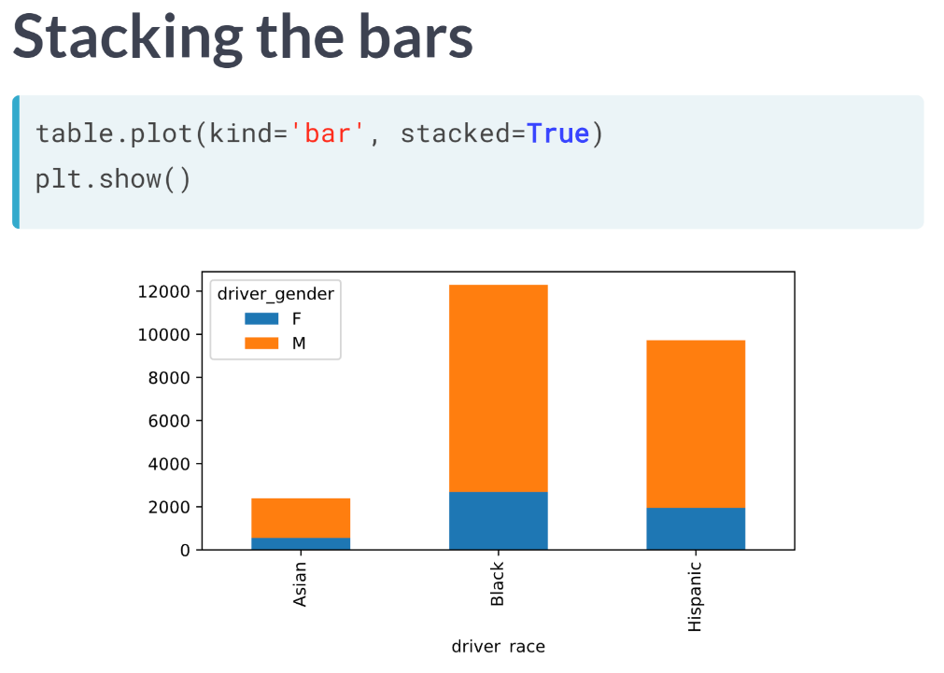  
The variation of bar plot is a stacked bar plot, which you can generate by adding the argument *stacked = True*. For each race, the two gender bars are now stacked on top of one another. This plot is great for the reason that it helps you to see the total stops for each race, which was not obvious when the bars were side by side.

By emphasizing the totals, however, this plot slightly deemphasizes the individual components of each bar and makes those components harder to compare against one another. Neither type of bar plot is right nor wrong, rather you should choose the plot that best helps to answer the question you are asking.

# Tallying violations by district

The state of Rhode Island is broken into six police districts, also known as zones. How do the zones compare in terms of what violations are caught by police?

In this exercise, you'll create a frequency table to determine how many violations of each type took place in each of the six zones. Then, you'll filter the table to focus on the "K" zones, which you'll examine further in the next exercise.

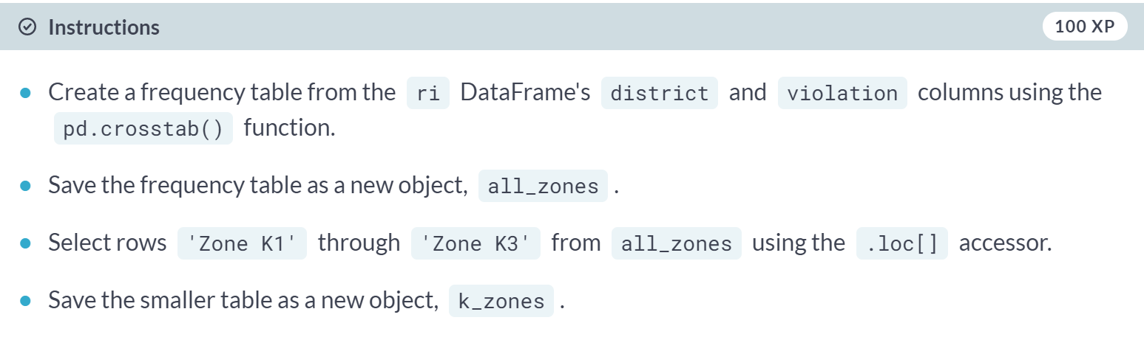

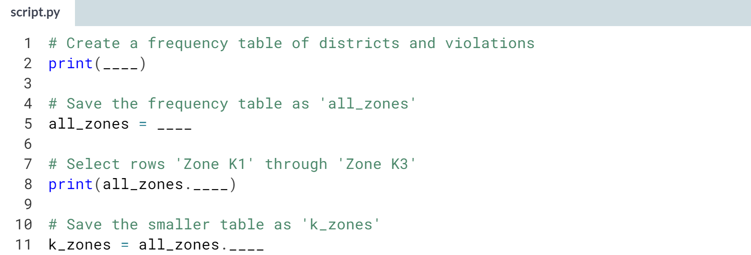

Hint

1. Specify the columns as *ri.district* and *ri.violation* when passing them to ***pd.crosstab()***.
2. Use brackets rather than parentheses with the **.loc[]** accessor.
3. To select a DataFrame slice using **.loc[]**, specify the starting and ending labels as strings and separate them with a colon.

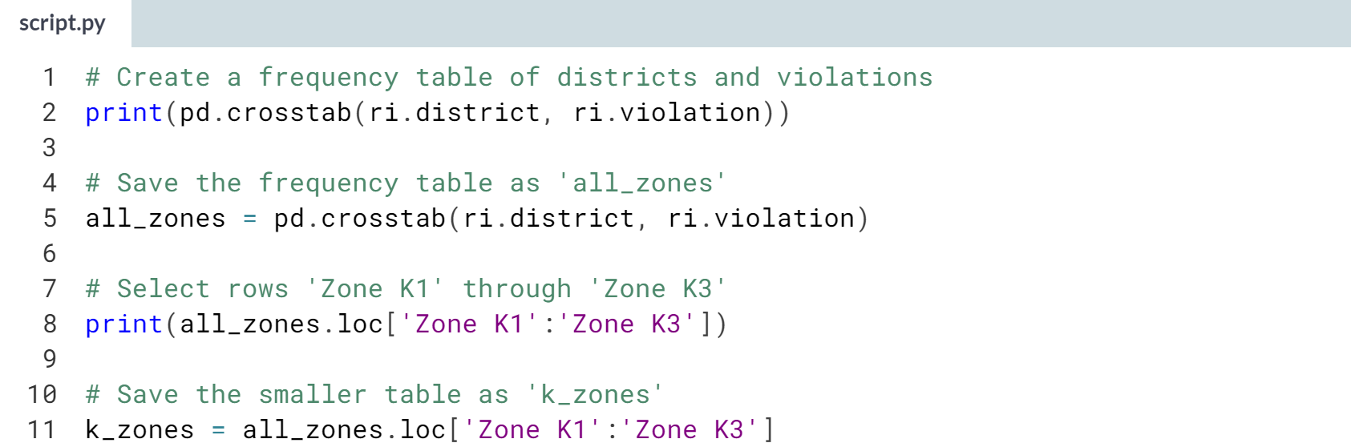

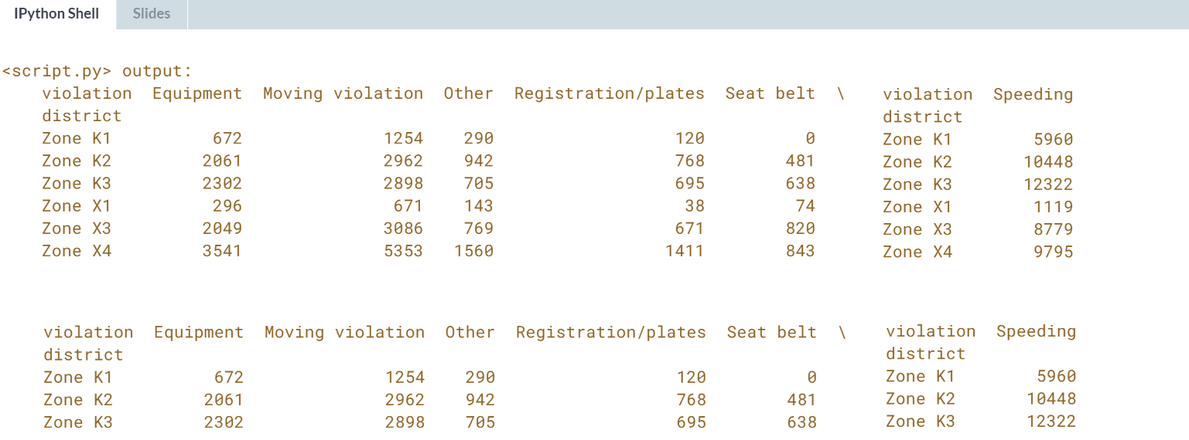

Great job! Next you'll plot the violations so that you can compare these districts.

# Plotting violations by district

Now that you've created a frequency table focused on the "K" zones, you'll visualize the data to help you compare what violations are being caught in each zone.

First you'll create a bar plot, which is an appropriate plot type since you're comparing categorical data. Then you'll create a stacked bar plot in order to get a slightly different look at the data. Which plot do you find to be more insightful?



To create a bar plot, use the ***.plot()*** method and include the argument **kind='bar'**.

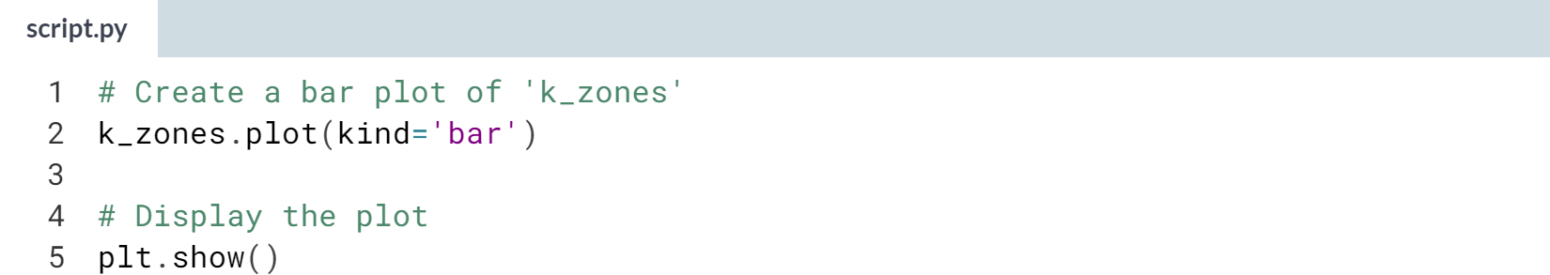

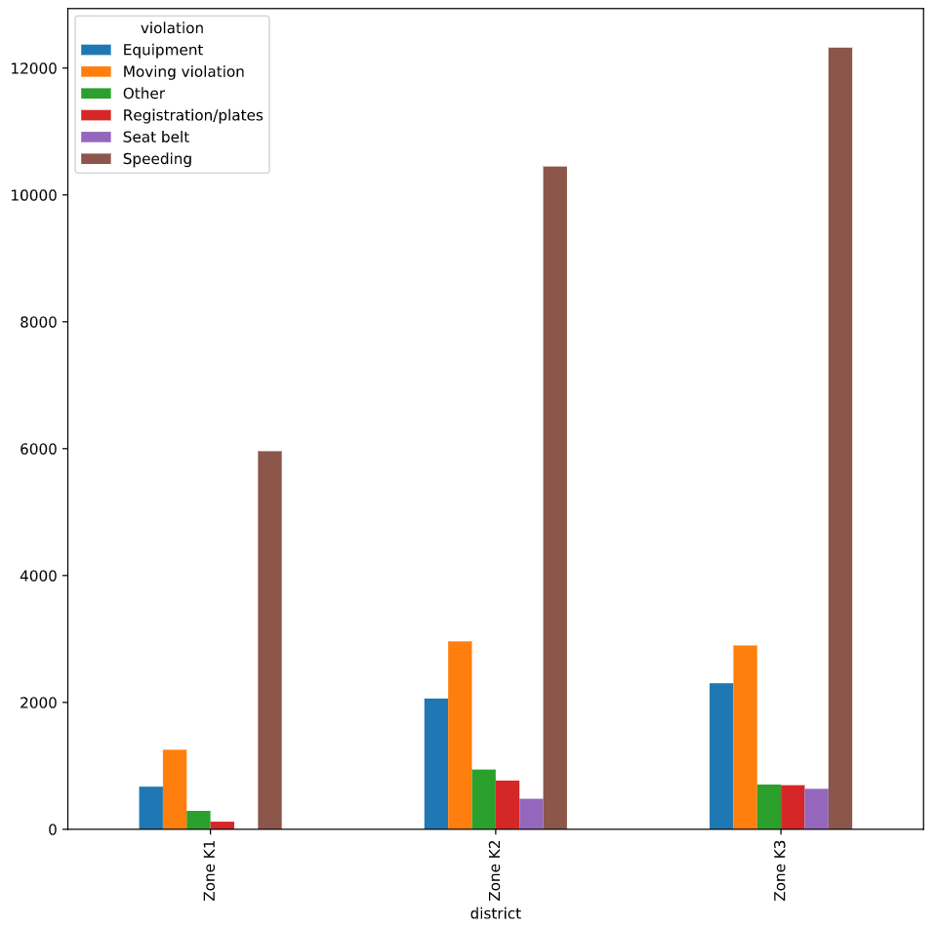



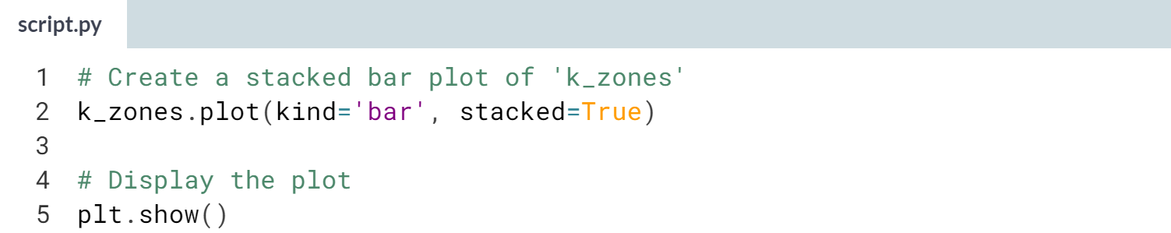

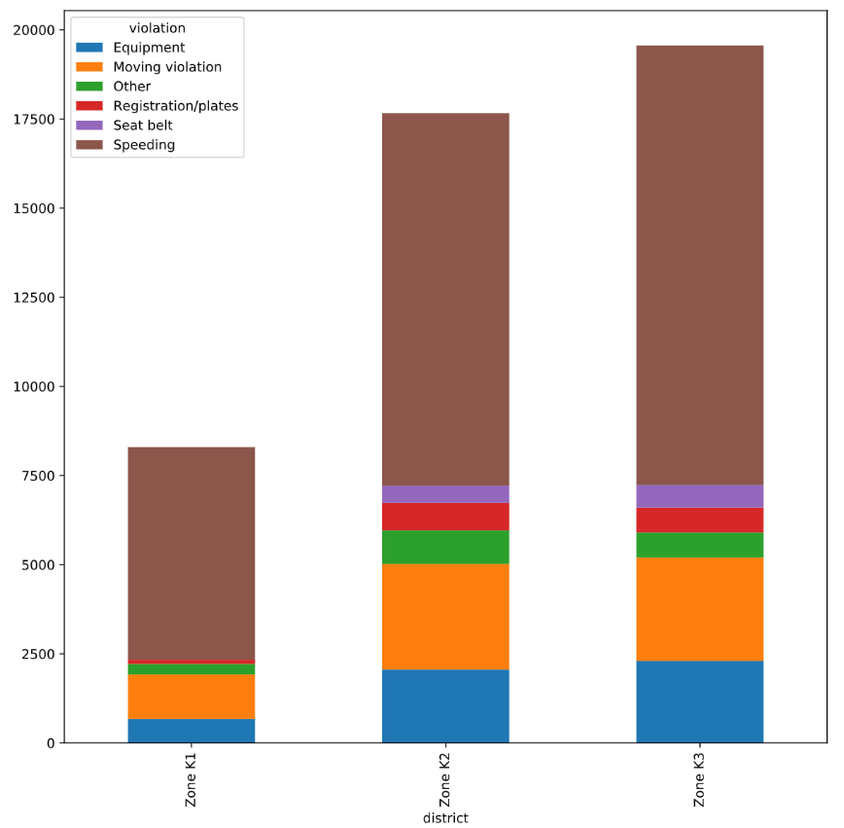

Interesting! The vast majority of traffic stops in Zone K1 are for speeding, and Zones K2 and K3 are remarkably similar to one another in terms of violations.



In this section, we will start by learning how to translate strings into data that can be analyzed numerically, and then we will learn a few easy ways to improve our plots.

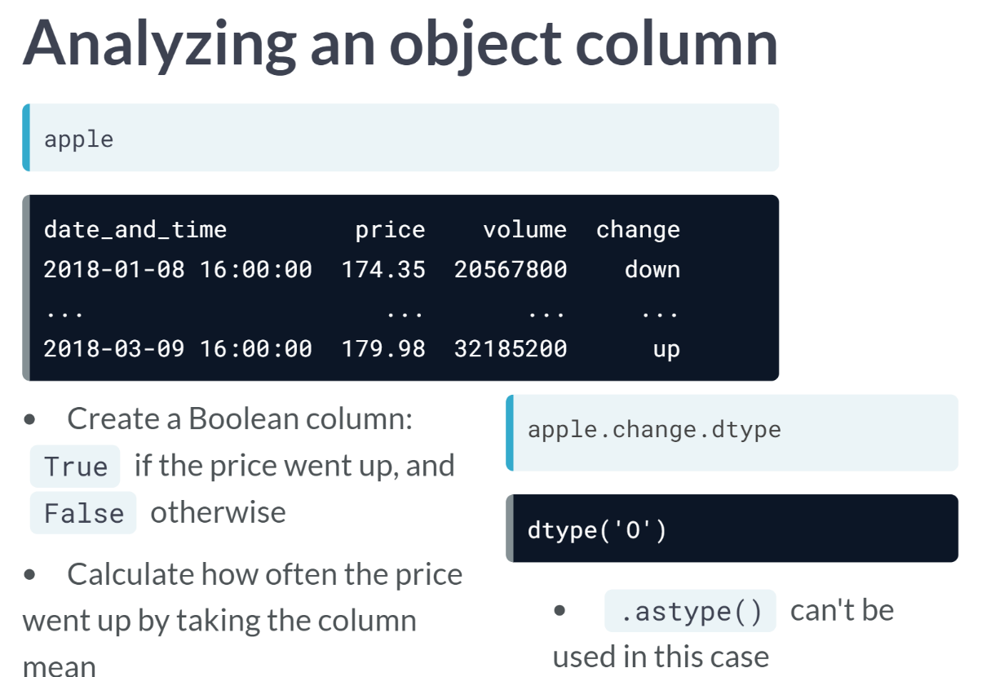  
The new column called change has been added to the apple DataFrame. It indicates whether the stock price went up or down compared to the previous trading day.

Let's pretend we wanted to calculate how often the price went up. One way to do this would be to create a Boolean column that is *True* if the price went up and *False* otherwise.

Then, we could easily calculate how often the price went up by taking the mean of the Boolean column.

But how would we create this column? The change column has the object data type because it contains strings, and we've previously used ***astype()*** method to convert strings to numbers or Booleans.

However, ***astype()*** only works when pandas can infer how the conversion should be done, and that is not the case here. We will need to find a different technique.

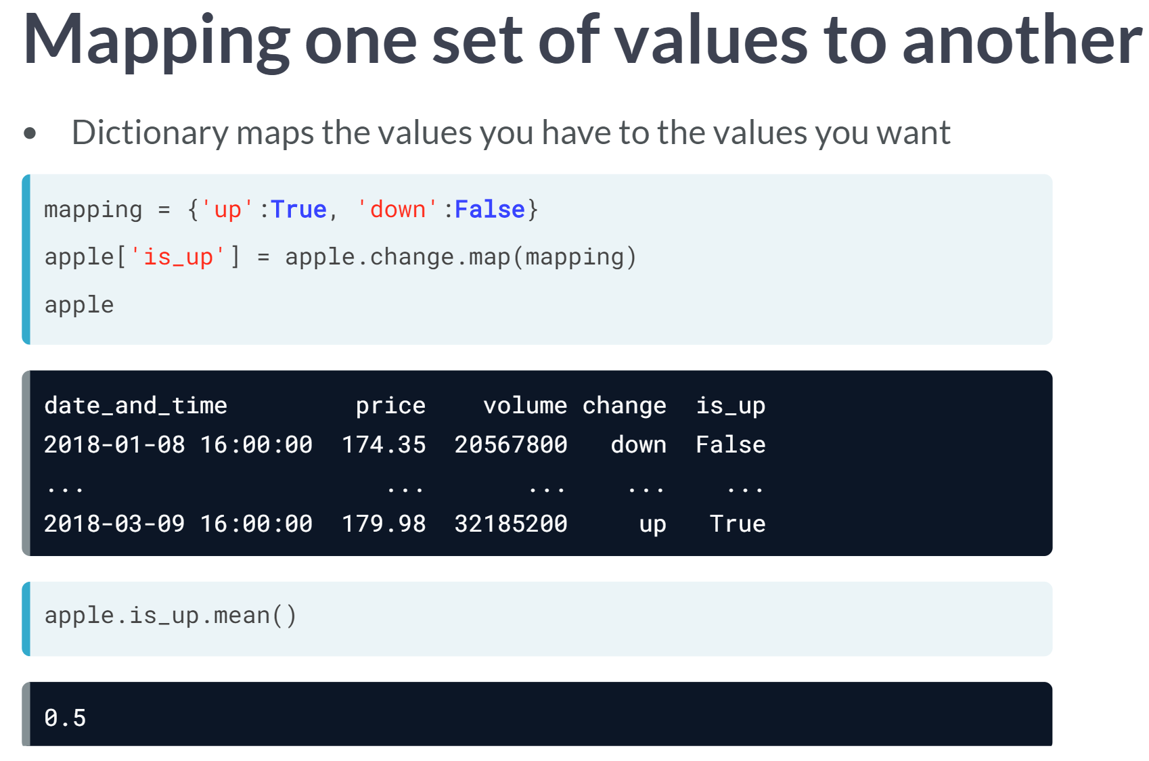When you need to map one set of values to another, you can sue the Series ***map()*** method. You provide it with a dictionary that maps the values you currently have to the values that you want.

In this case, we want to map *"up"* to *True* and *"down"* to *False*, so we will create a dictionary called mapping that specifies this.

Then, we will use the ***map()*** method on the change column, pass it the mapping object, and store the result in a new column called *is_up*.

When we print the DataFrame, you will see that the *is_up* column contains True when the change column says up, and False when the change column says down.

Now that we have a Boolean column, we can calculate how often the price went up by taking the ***mean()*** of that column. The answer is that it went up 50 percent of the time.

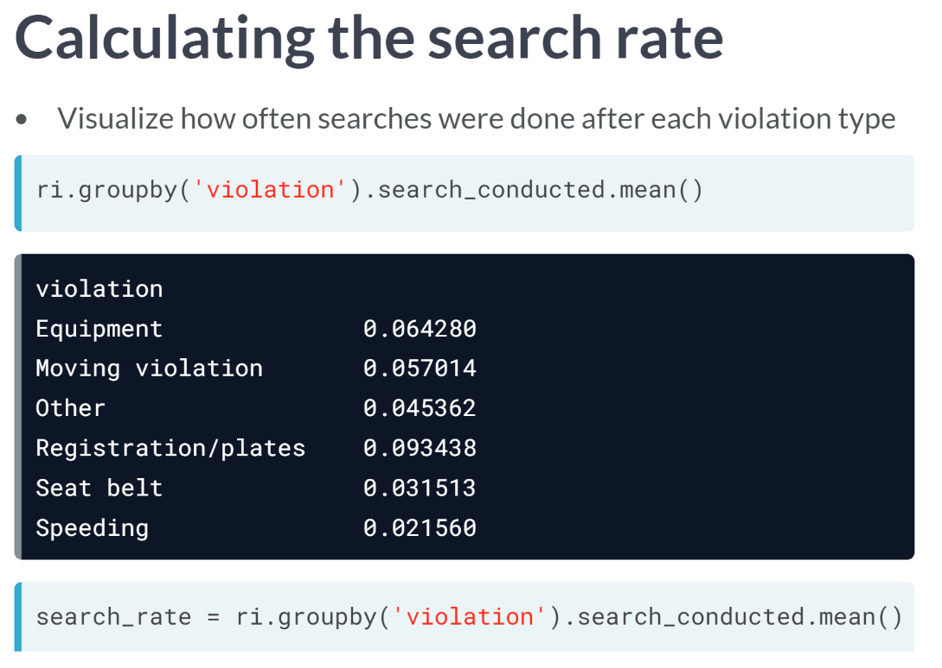Now we are going to return to our DataFrame of traffic stops, and shift to a completely separate topic.

Let's say that we want to visualize how often searches were performed after each type of violation. We would group by violation and then take the ***mean()*** of *search_conducted*. This calculates the *search_rate* for each of the six violation types and returns a Series that is sorted in alphabetical order by violation. We will save this an object named search_rate.

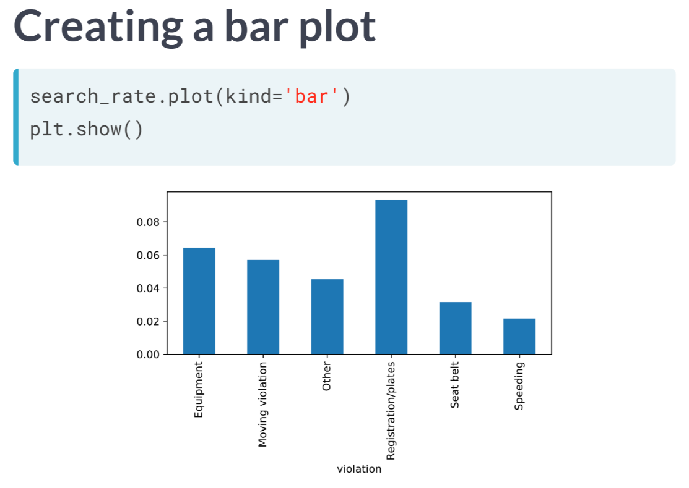To visualize the search rate, we will create a bar plot since we are comparing the search rate across categories. The violations are displayed on the x-axis, and the search rate is on the y-axis. This plot looks okay, but there are two simple changes we can make that will make this plot more effective.

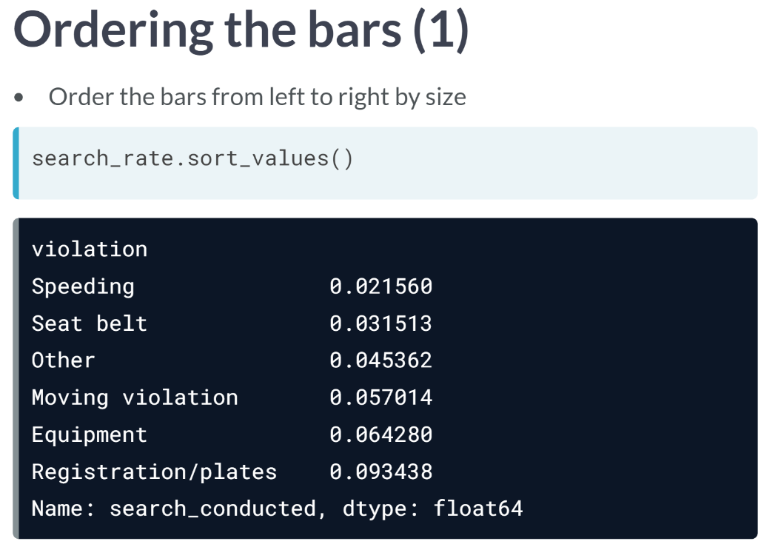  
The first improvement we can make is to order the bars from the left to right by size, which will make the plot easier to understand.

All we need to do is to use the ***sort_values()*** method to sort the search_rate Series in ascending order.

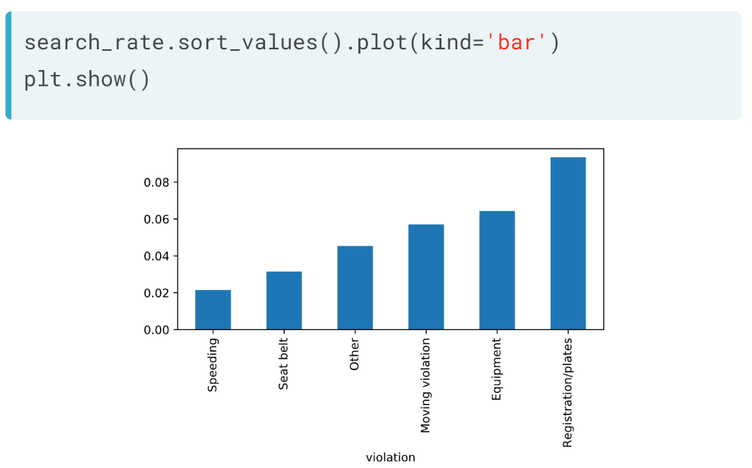

Then, when we call the plot method on the sorted data, the bars are now ordered.

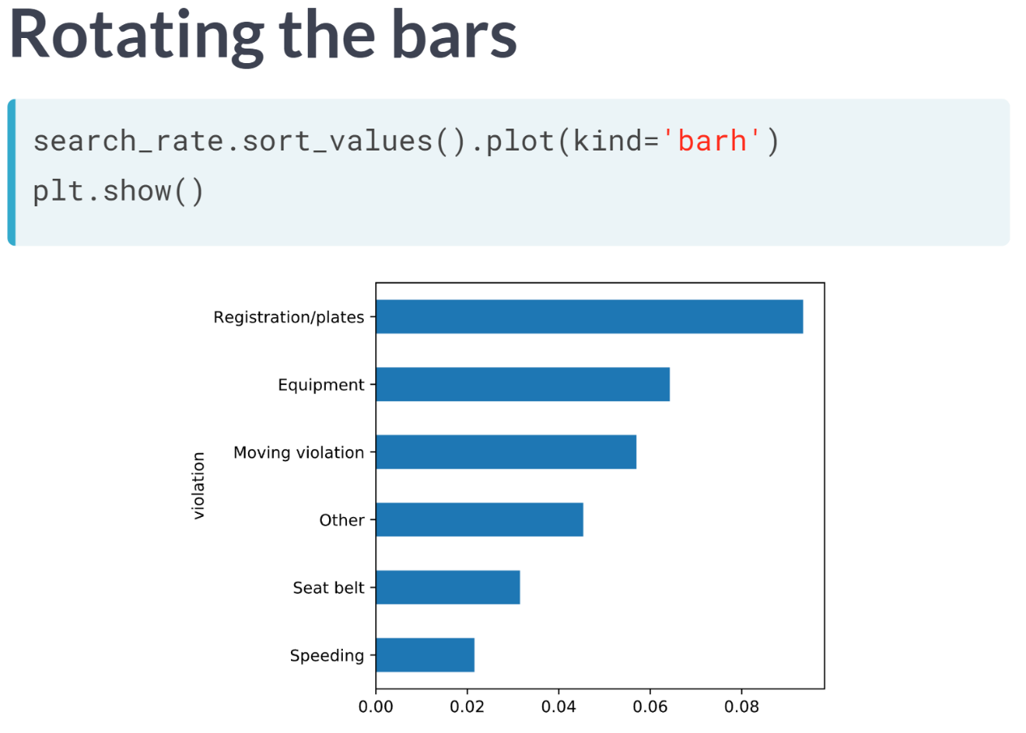The second improvement we can make is to change the kind argument kind from *'bar'* to '*barh'*, which will rotate the bars so that they are horizontal. This makes it much easier to read the labels for each bar.

# Converting stop durations to numbers

In the traffic stops dataset, the stop_duration column tells you approximately how long the driver was detained by the officer.

Unfortunately, the durations are stored as strings, such as '0-15 Min'. How can you make this data easier to analyze?

In this exercise, you'll convert the stop durations to integers. Because the precise durations are not available, you'll have to estimate the numbers using reasonable values:

* Convert '0-15 Min' to 8
* Convert '16-30 Min' to 23
* Convert '30+ Min' to 45

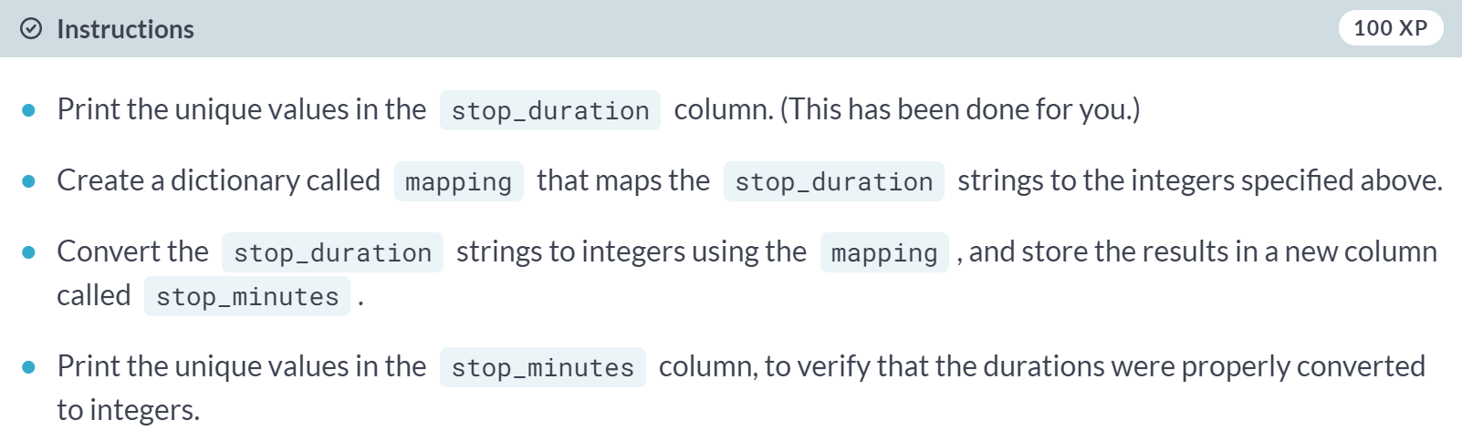

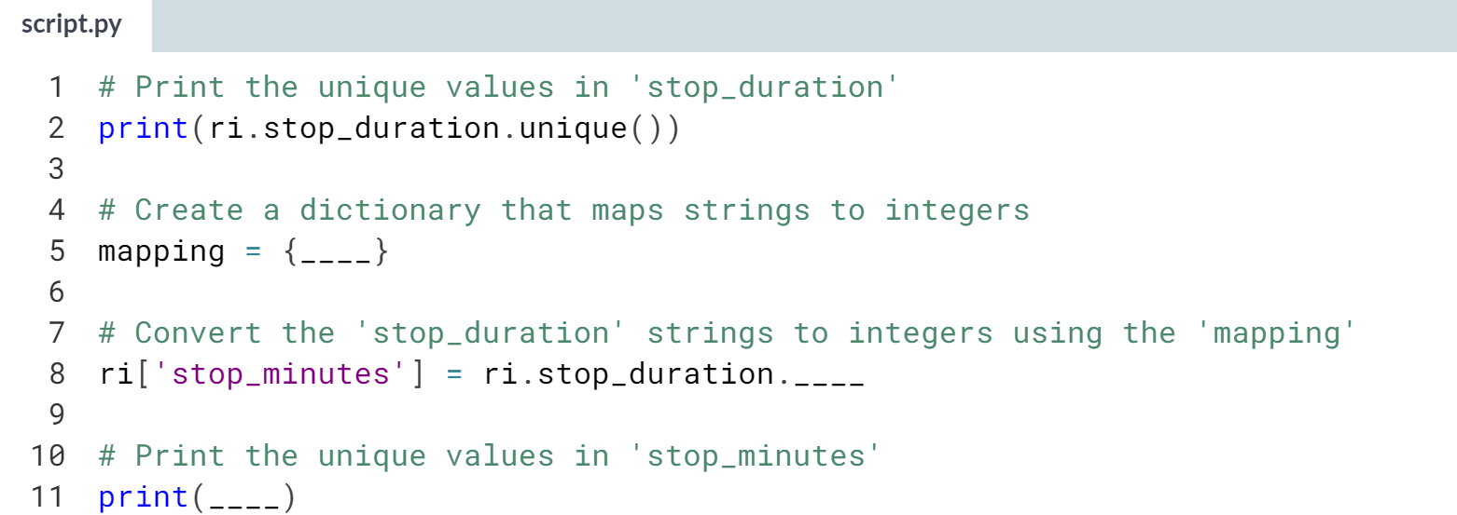

Hint

1. The mapping dictionary should consist of three key-value pairs, such as **'0-15 Min':8**.
2. Make sure that each dictionary key is a string, and each dictionary value is an integer.
3. To convert the **stop_duration** strings to integers, pass the mapping object to the ***.map()*** method.

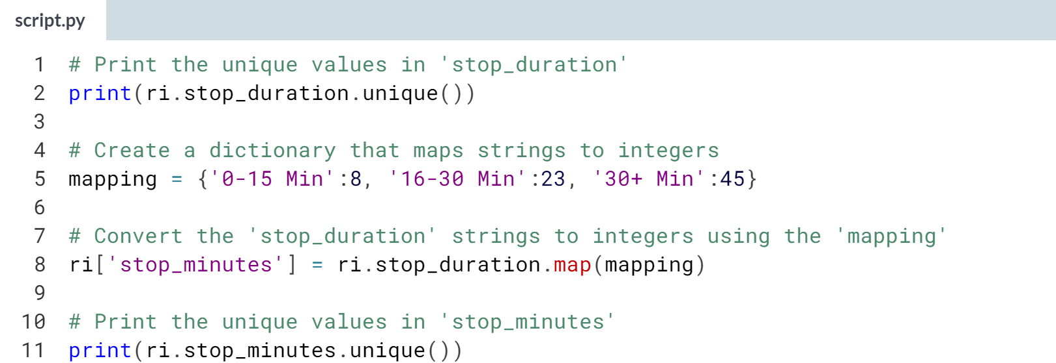

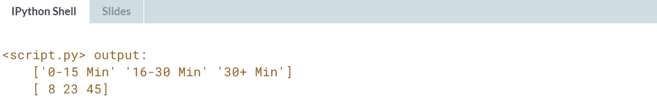

Excellent! Next you'll analyze the stop length for each type of violation.

# Plotting stop length

If you were stopped for a particular violation, how long might you expect to be detained?

In this exercise, you'll visualize the average length of time drivers are stopped for each type of violation. Rather than using the violation column in this exercise, you'll use violation_raw since it contains more detailed descriptions of the violations.

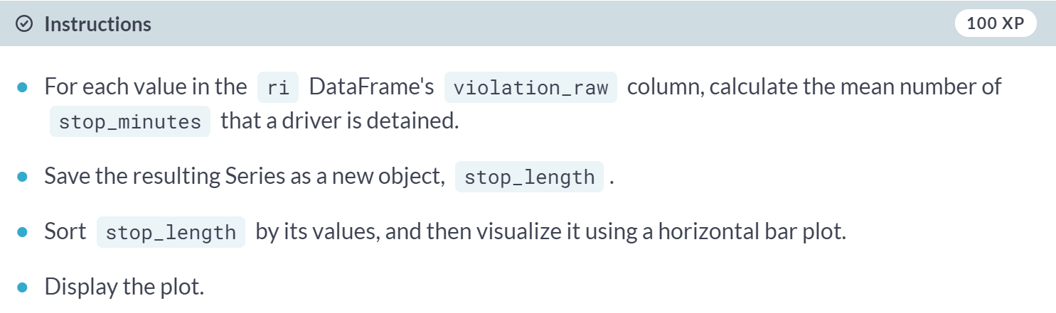

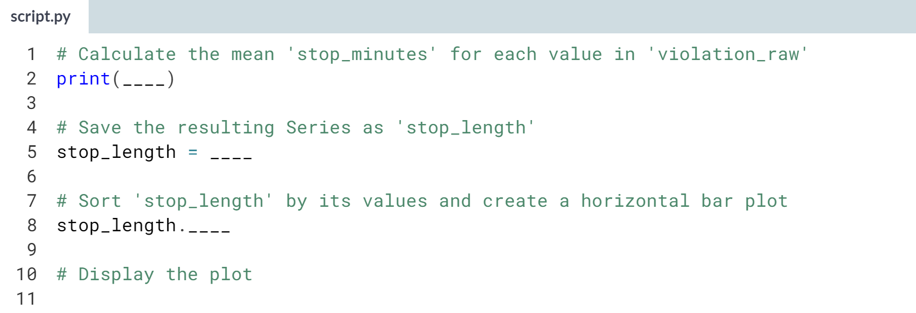

Hint

1. To calculate the mean stop length by violation, group by **'violation_raw'** and then take the ***.mean()*** of the **stop_minutes** column.
2. To sort **stop_length** by its values, use the ***.sort_values()*** method.
3. To create a horizontal bar plot, use the argument **kind='barh'** with the ***.plot()*** method.

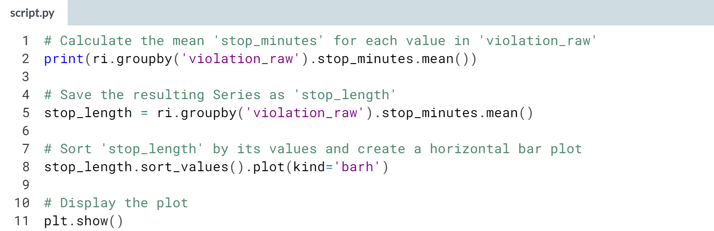

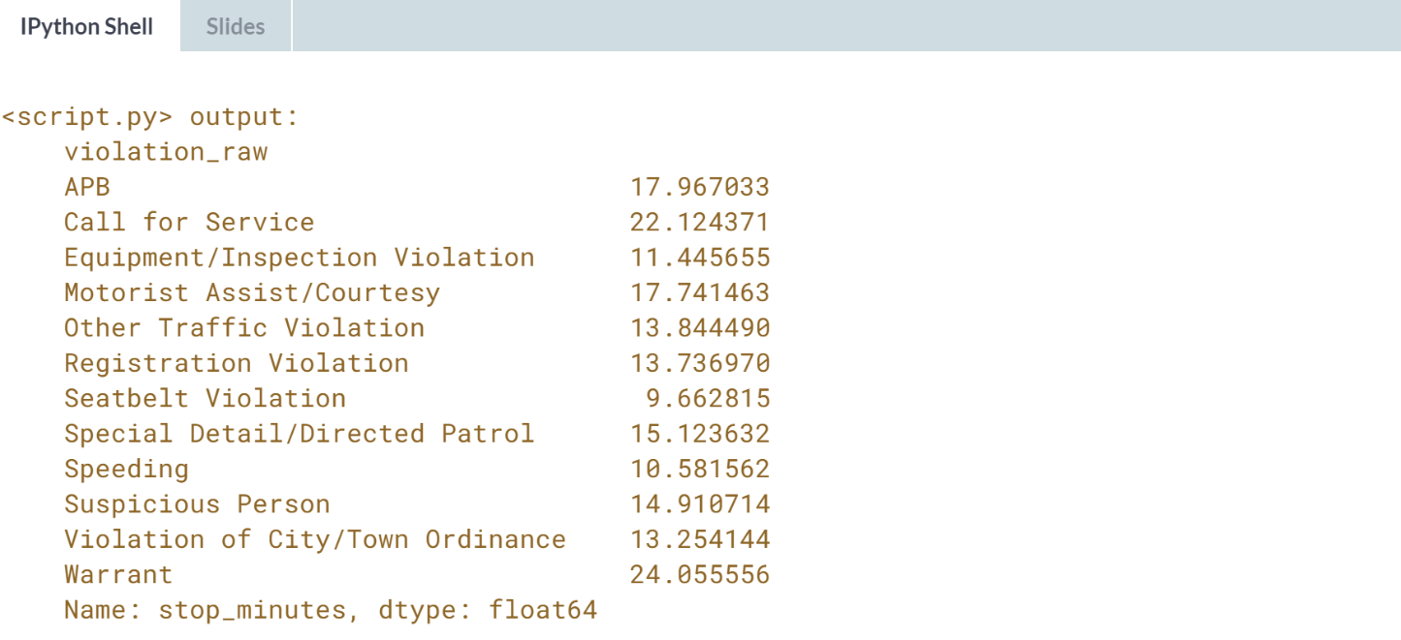

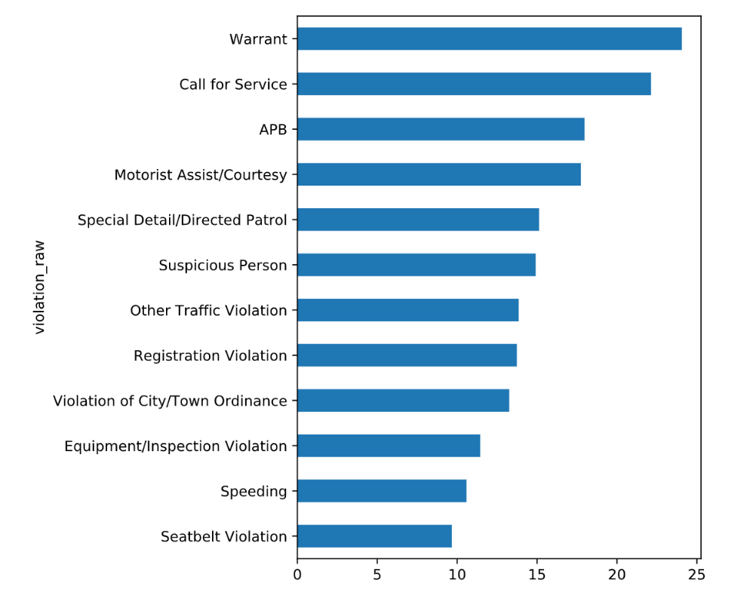

**4. Analyzing the effect of weather on policing**

In this chapter, you will use a second dataset to explore the impact of weather conditions on police behavior during traffic stops. You will practice merging and reshaping datasets, assessing whether a data source is trustworthy, working with categorical data, and other advanced skills.



"In this chapter, we will be working with a new dataset to help us determine if weather conditions have an impact on police behavior."

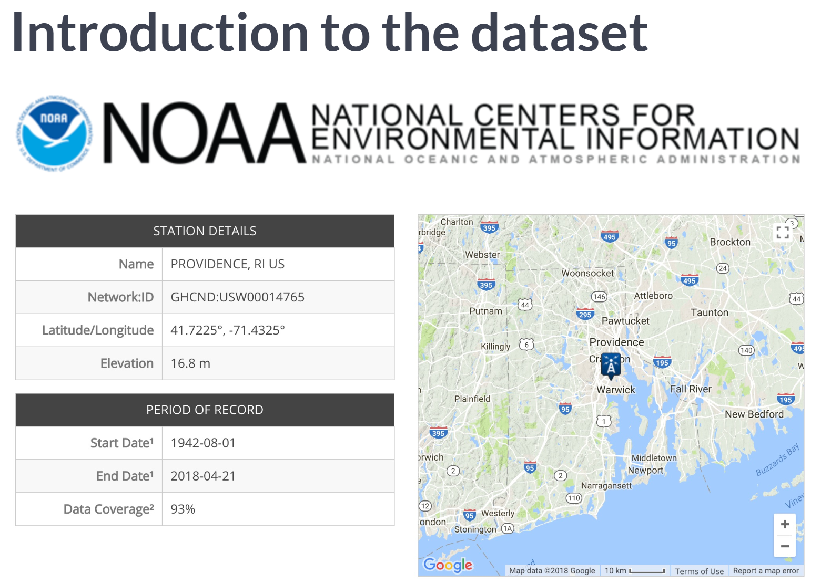  
The weather data you'll be using was collected by the National Centers for Environmental Information. Our hypothesis is that weather conditions impact police behavior during traffic stops, so ideally we look up the historical weather at the location of each stop.

However, the traffic stops dataset does not specify stop location, so we are going to use the data from a single weather location near the center of Rhode Island. This is not ideal, but this is the smallest US state and so a single station will still give us a general idea of the weather throughout the state.

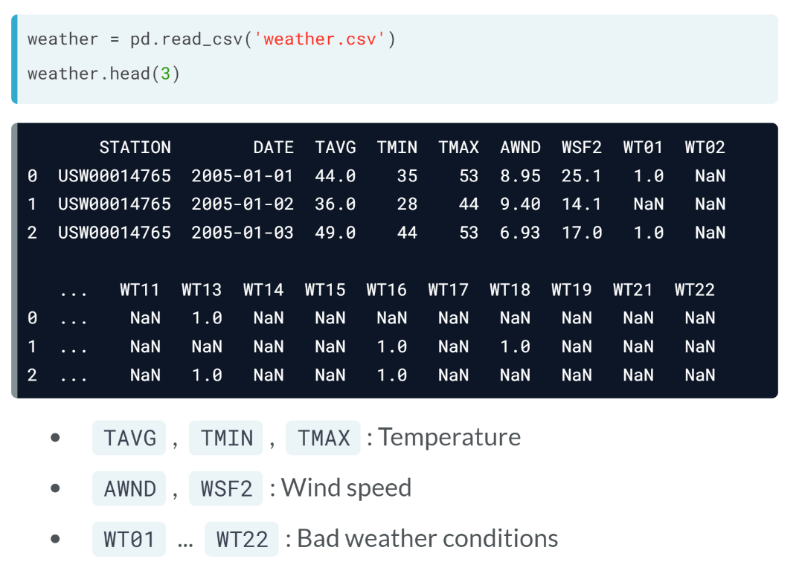  
When analyzing weather.csv file, we can see that the station column lists the station ID, and there's one row for each date.

There are three columns related to temperature, two columns related to wind speed, and 20 columns related to the presence of certain bad weather conditions.

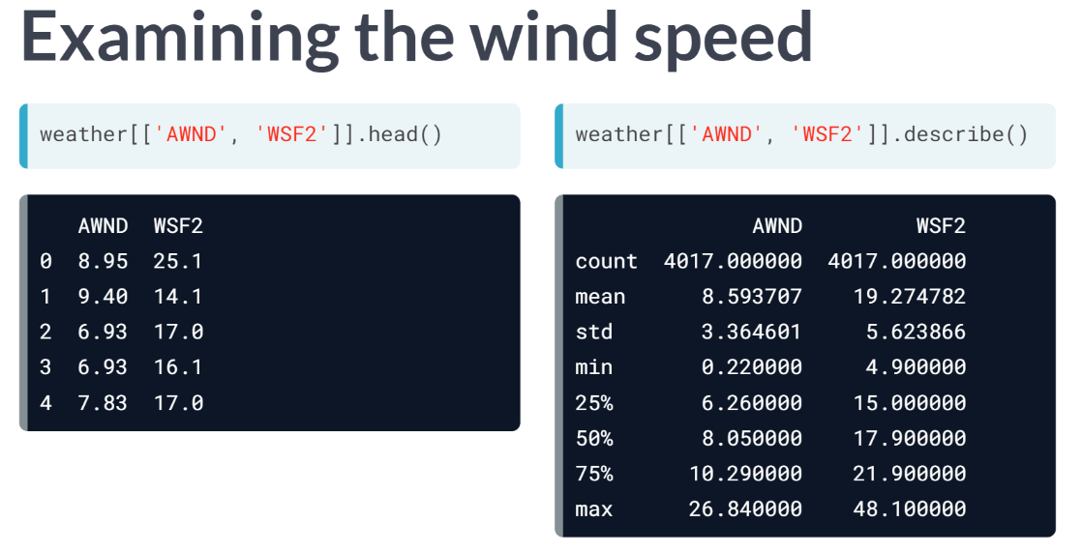  
Before using a new dataset, it's a good practice to explore the data to check that the values seem reasonable. If you don't find anything unreasonable, then you gain increased confidence that the data is trustworthy. For example, let's take a look at the two columns related to wind speed.

AWND is average wind speed in mph, and WSF3 is the fastest 2-minute wind speed, meaning the fastest wind speed during any 2-minute period. We can use the ***describe()*** method on these two columns to see a summary statistic including the minimum, maximum, and 25th through 75th percentiles.

Notice that the minimum values are above zero, and the fastest wind speed are greater than average wind speed values. Also, the number seem reasonable given that they are measured in mph. There are all simple signs that the data is trustworthy.

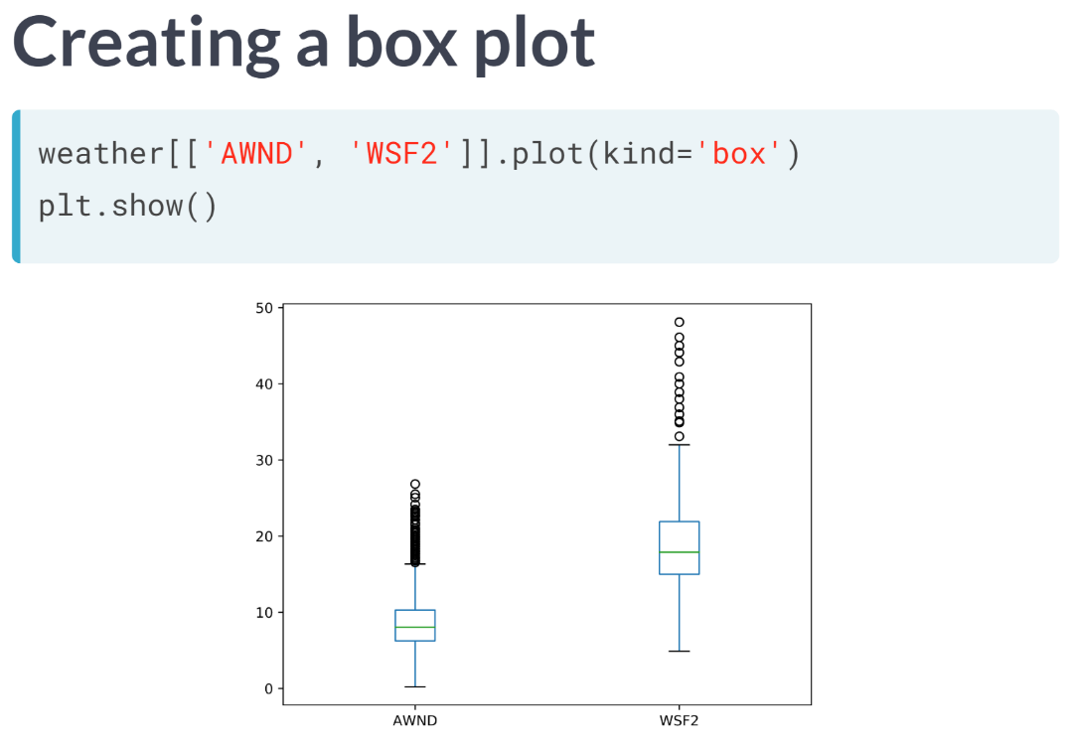  
Another way to examine these values is with a boxplot, by specifying kind = 'box' when plotting. This is essentially a visual representation of the summary statistics, in that the box represents the 25th through 75th percentiles, and the lines below and above the box represent the minimum and maximum values, excluding the outliers represented by circles. Again, our goal is simply to validate that the data looks reasonable.

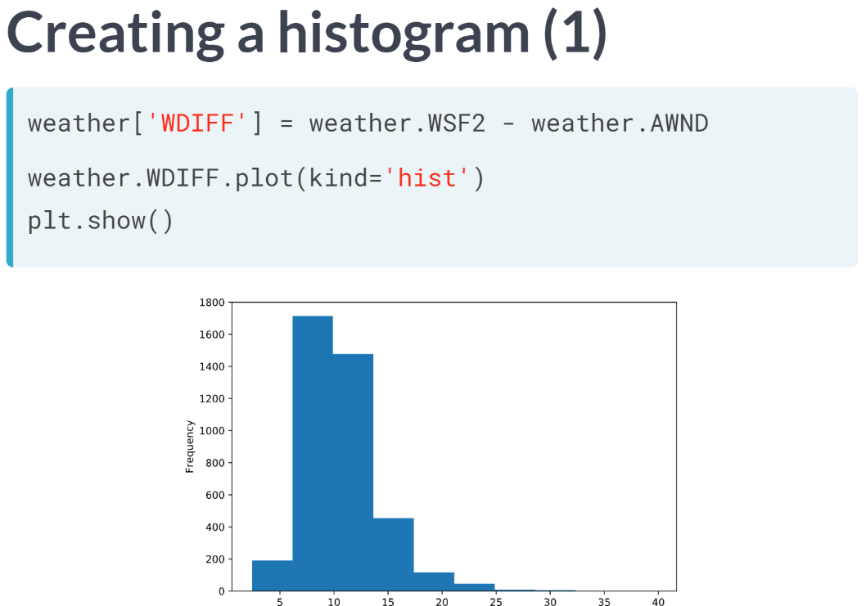  
It would also be useful to validate that the fastest wind speed values are greater than the average values for every single row. We will do this by subtracting the average speed from the fastest speed and storing the result in a new column.

We will visualize the new column using a histogram so that we can see its distribution. There are no values below zero, which is a good sign. But because there are some extreme values, it's hard to clearly see the shape of the distribution.

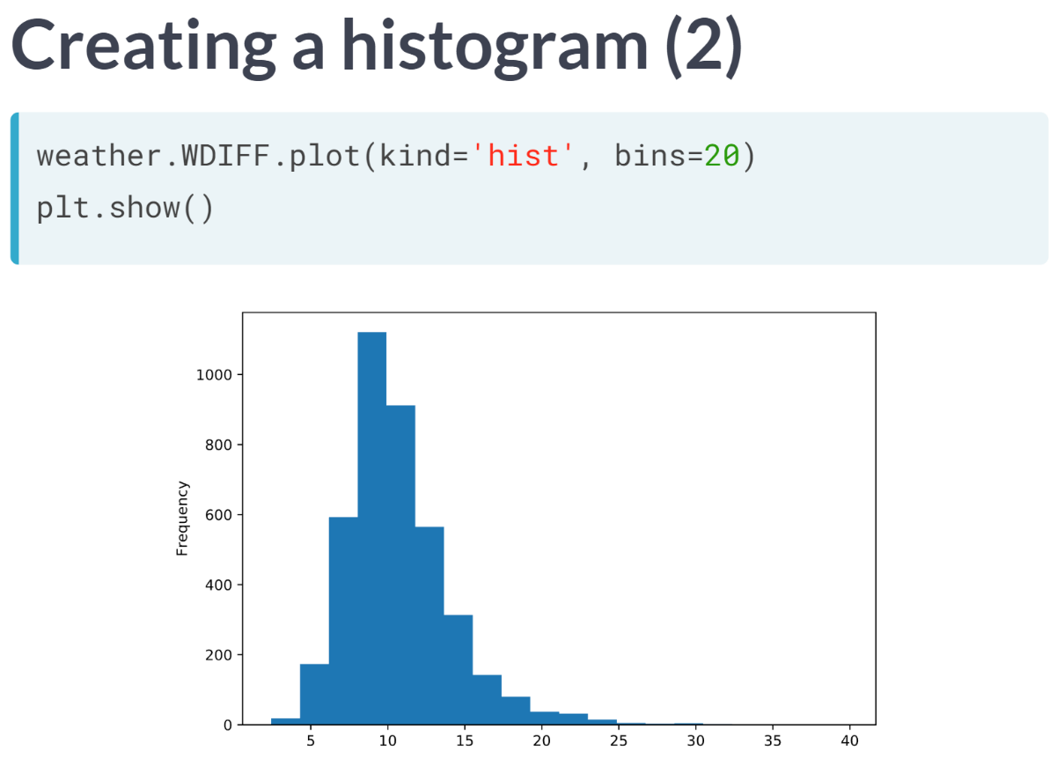We can make the shape clearer by changing the number of histogram bins to 20. We can now see that the difference between the fastest and average wind speed values has an approximately normal shape.

# Plotting the temperature

In this exercise, you'll examine the temperature columns from the weather dataset to assess whether the data seems trustworthy. First you'll print the summary statistics, and then you'll visualize the data using a box plot.

When deciding whether the values seem reasonable, keep in mind that the temperature is measured in degrees Fahrenheit, not Celsius!

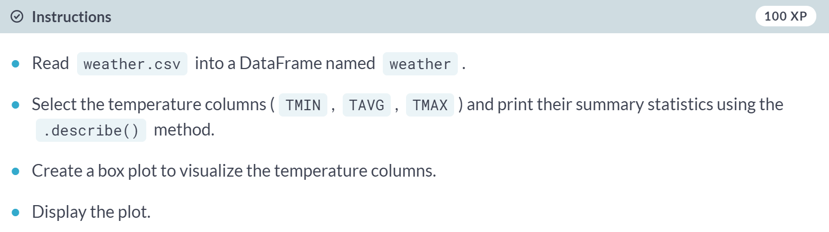

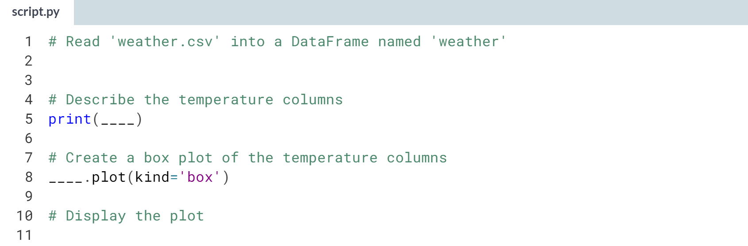

Hint

1. Read the file by passing *'weather.csv'* to the ***pd.read_csv()*** function.
2. Select the temperature columns using double brackets: **weather[['TMIN', 'TAVG', 'TMAX']]**.
3. To create a box plot, use the argument **kind='box'** with the ***.plot()*** method.

(Solution on the next page)

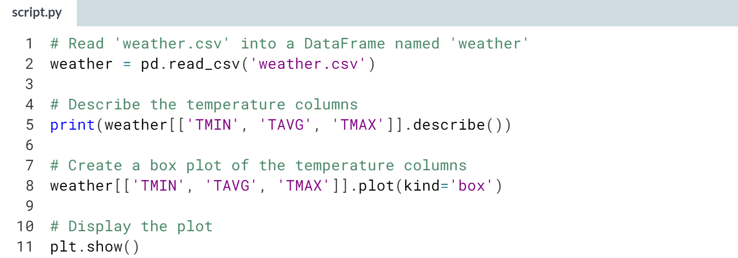

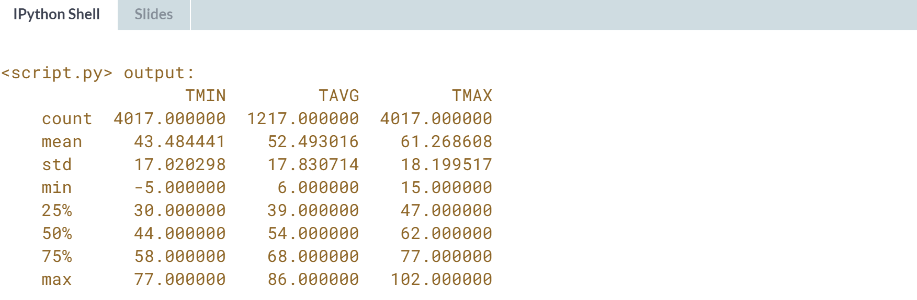

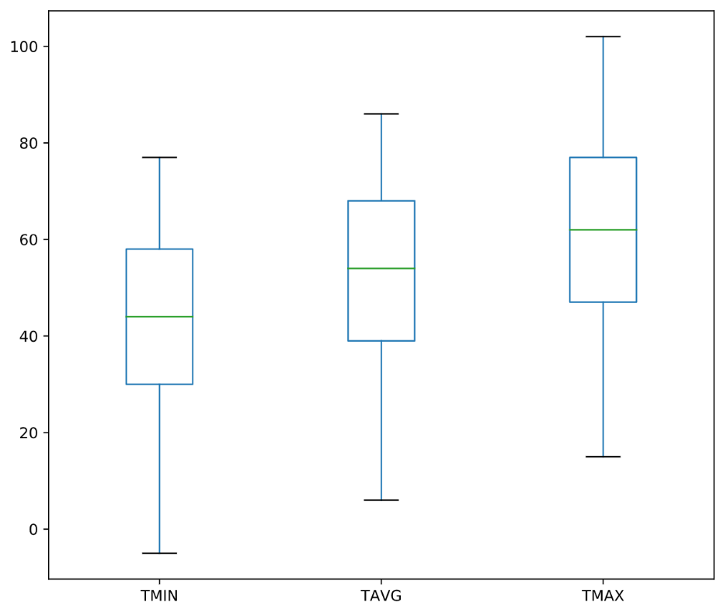  
Nice job! The temperature data looks good so far: the **TAVG** values are in between **TMIN** and **TMAX**, and the measurements and ranges seem reasonable.

# Plotting the temperature difference

In this exercise, you'll continue to assess whether the dataset seems trustworthy by plotting the difference between the maximum and minimum temperatures.

What do you notice about the resulting histogram? Does it match your expectations, or do you see anything unusual?

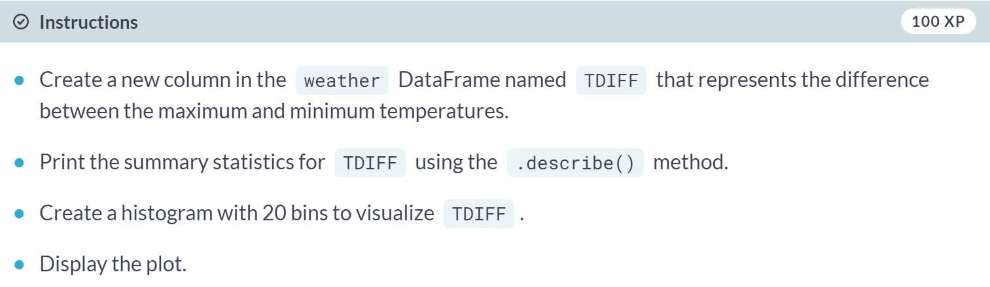

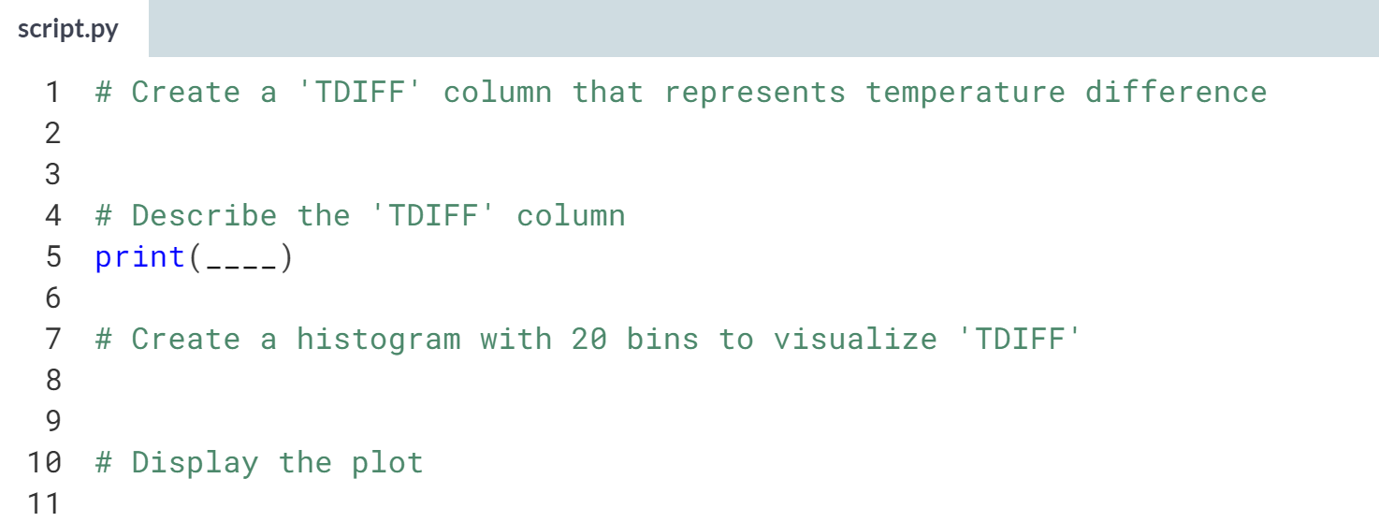

1. Create the **TDIFF** column by subtracting the **TMIN** column from the **TMAX** column.
2. To print the summary statistics for a DataFrame column, first select the column and then chain the ***.describe()*** method on the end.
3. To create a histogram with 20 bins, use the arguments **kind='hist'** and **bins=20** with the ***.plot()*** method.

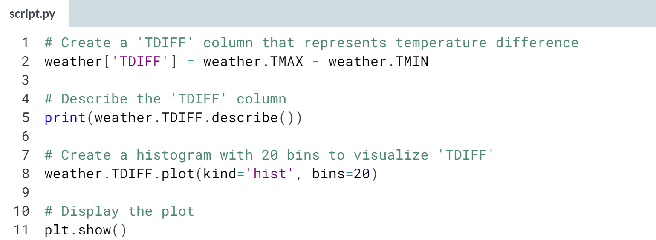  
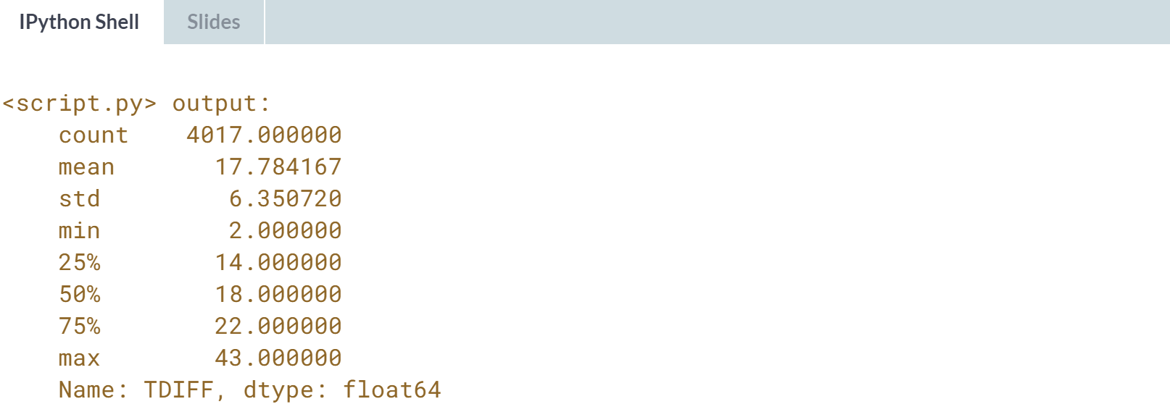  
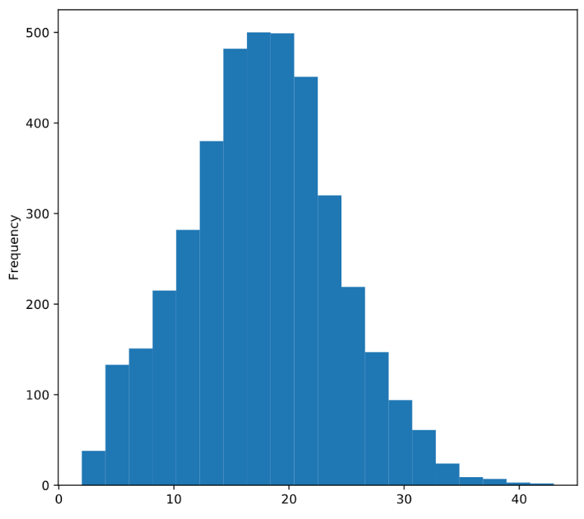  
Great work! The TDIFF column has no negative values and its distribution is approximately normal, both of which are signs that the data is trustworthy.



Since we have verified this dataset to be trustworthy, we can start preparing it for analysis. Let's review a few pandas technique we will be using.

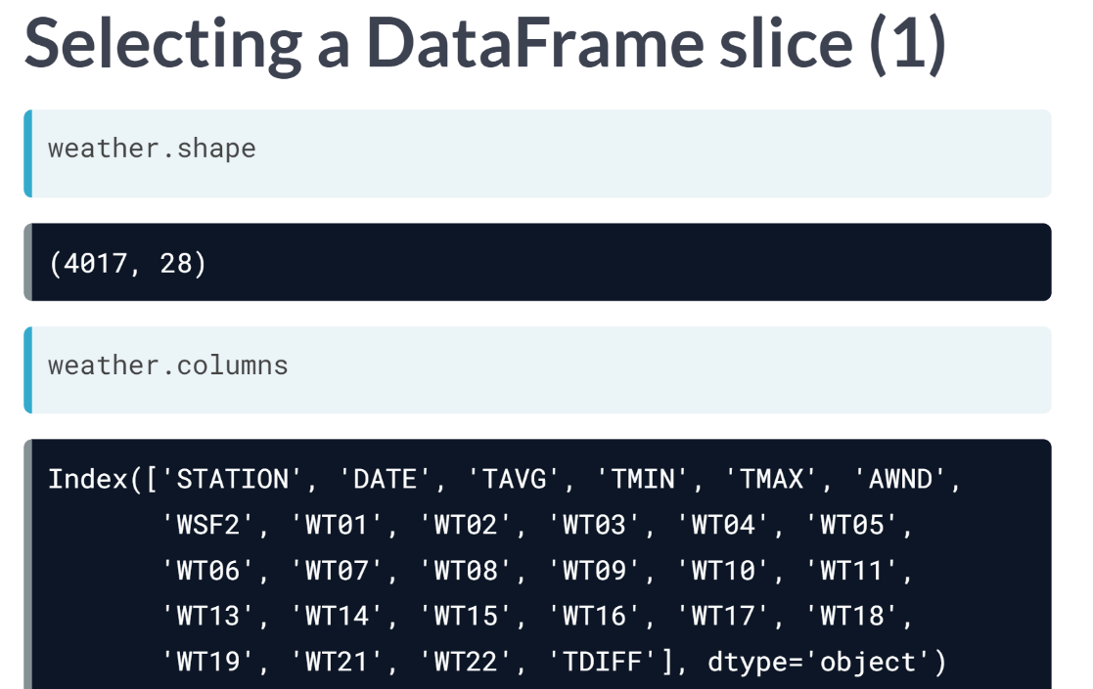  
Let's say that we wanted to copy the three temperature columns to a new DataFrame called temp. How might we do this?

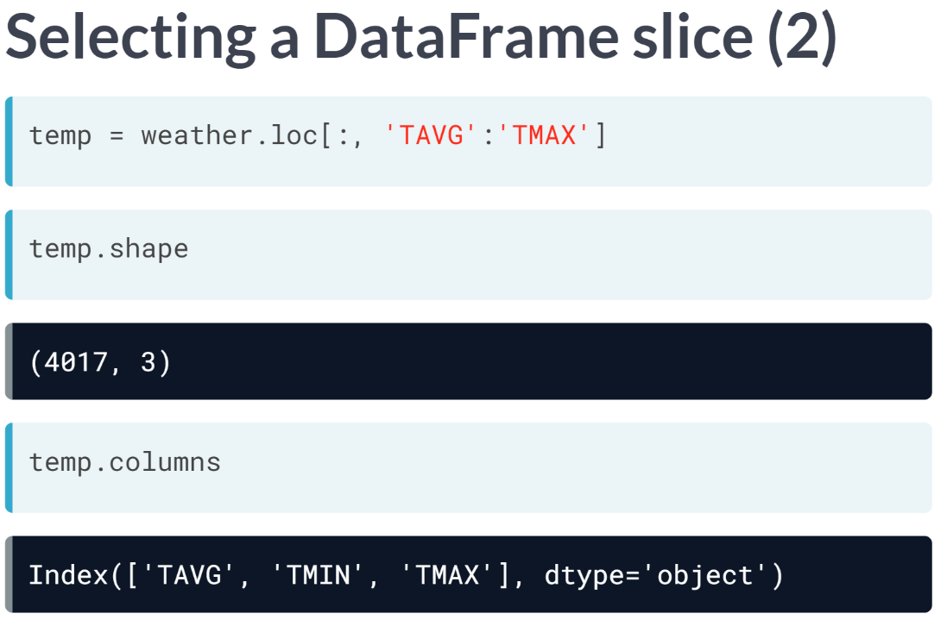

You might recall that the loc accessor allows you to extract a DataFrame. slice by specifying the starting and ending labels of your desired selection. In this case, we will select all rows (represented by the first colon) and the columns *TAVG* through *TMAX* and save them to *temp*.

You can see that the temp DataFrames contains all 4,017 rows but just 3 columns. This method is particularly useful when you need to select a large number of columns that are side-by-side.

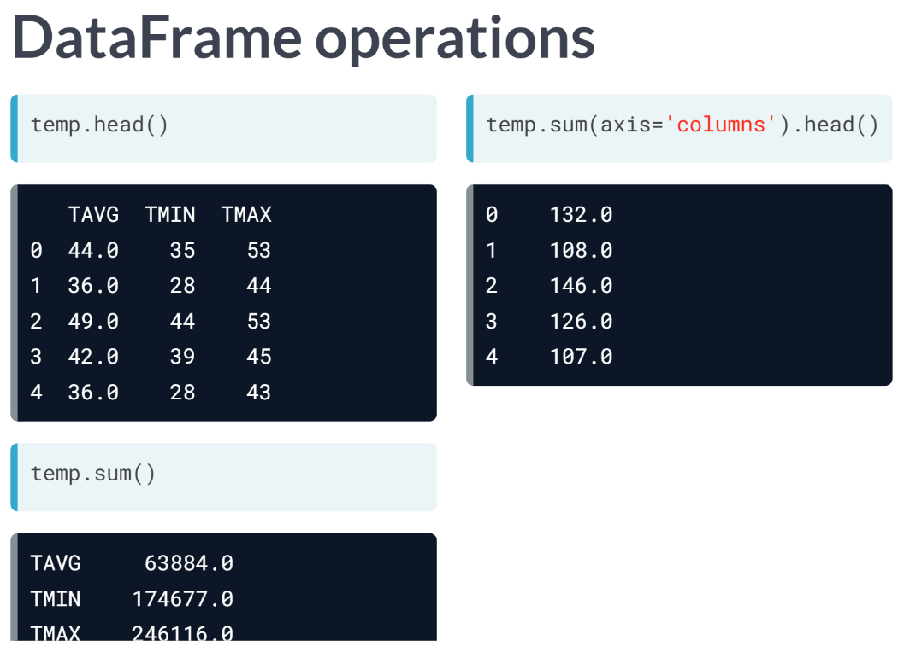What would happen if you used the sum() method on the DataFrame? pandas will actually return the sum of each of the three columns. But what if you wanted to calculate the sum of each row?

You can do this by specifying *axis = 'columns'*, and you will see that each value is the sum of the three temperature values in that row. For mathematical operations, the axis specifies the array dimension that is being aggregated, and aggregating columns is how you combine the data for each row.

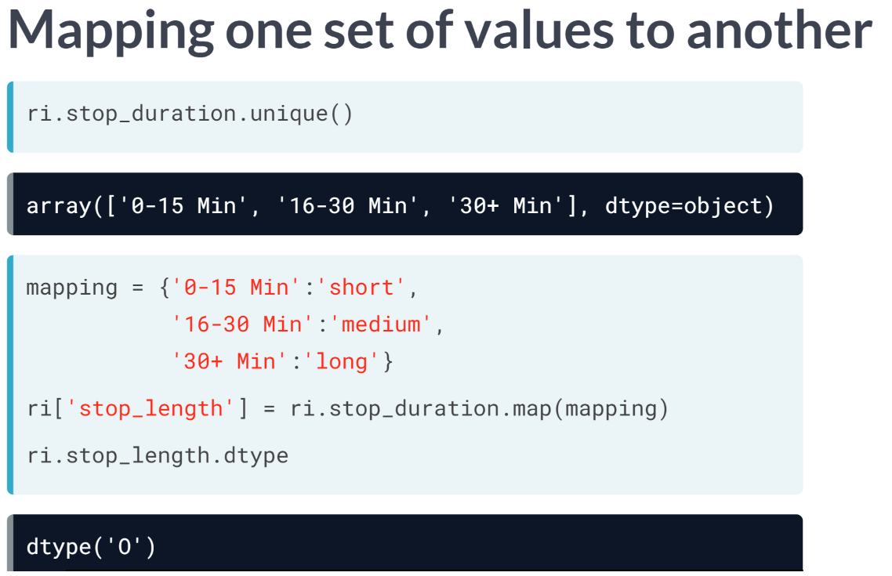  
Let's return to the traffic stops dataset and *stop_duration* column. You may remember that you can map one set of values to another using the Series ***map()*** method.

In this case, we will create a dictionary that maps the *stop_duration* values to the strings short, medium, and long. Then, we will use the ***map()*** method to create a column called *stop_length*, which has the object data type since it contains string data.

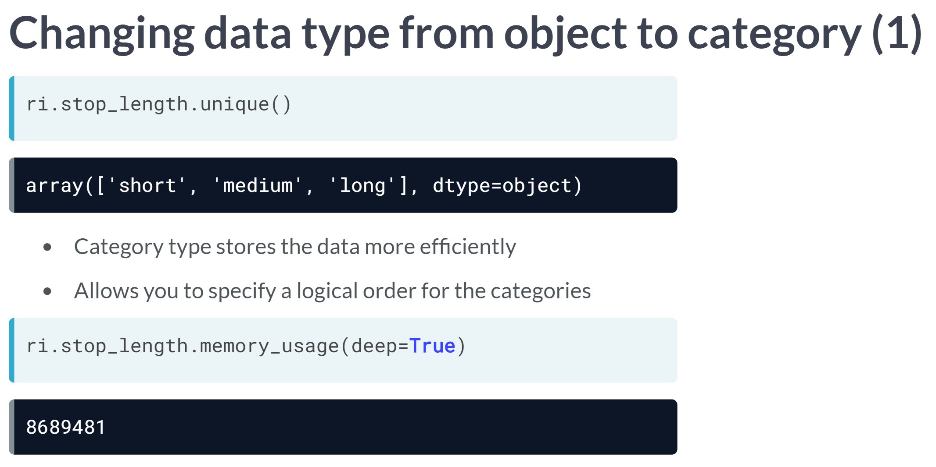Whenever you have an object column with a small number of possible values, as is the case here, you may want to change its data type to category. The main reason to use the category type is that it stores the data more efficiently than the object type.

It also allows you to specify a logical order for the categories. Before we change the data type of the *stop_length* Series, we will use a Series method to calculate its current memory usage, which is over 8 megabytes.

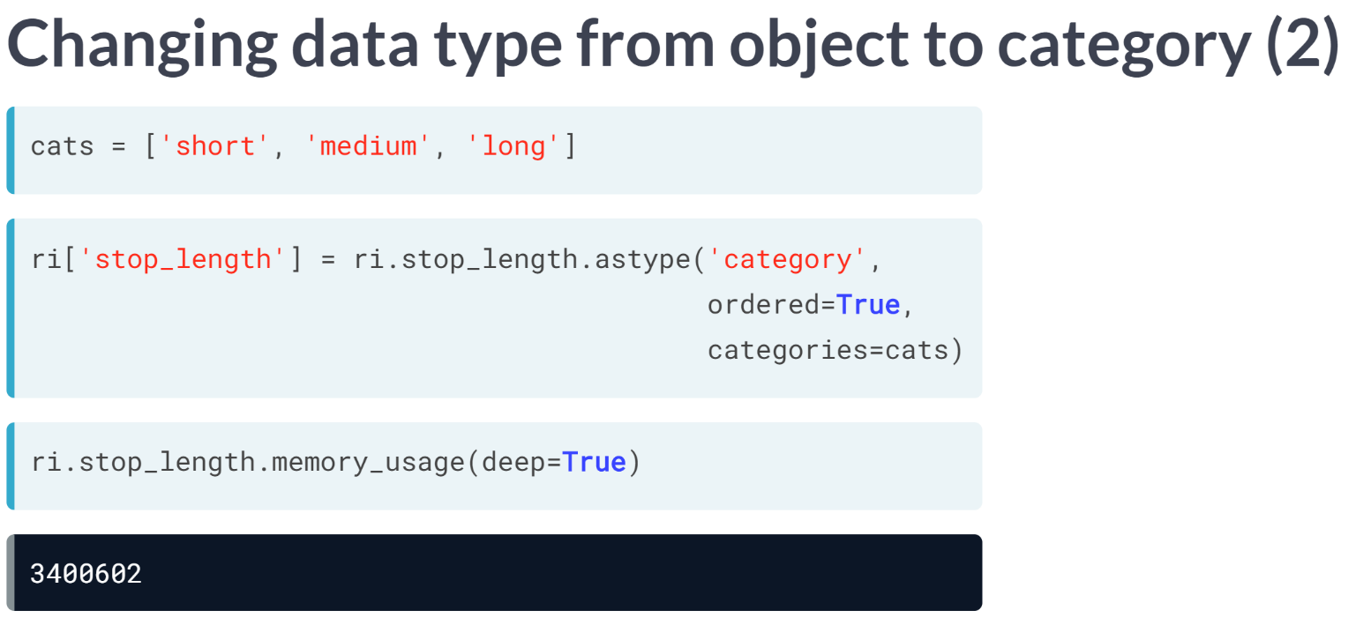To change the data type, we first create a Python list called cats that defines the logical order of the categories. Second, we use the ***astype()*** method to specify the new data type. We also specify that it should be ordered, and the cats list defines the ordering.

By changing the data type, you can see that the memory usage of this column has been reduced to around 3 megabytes.

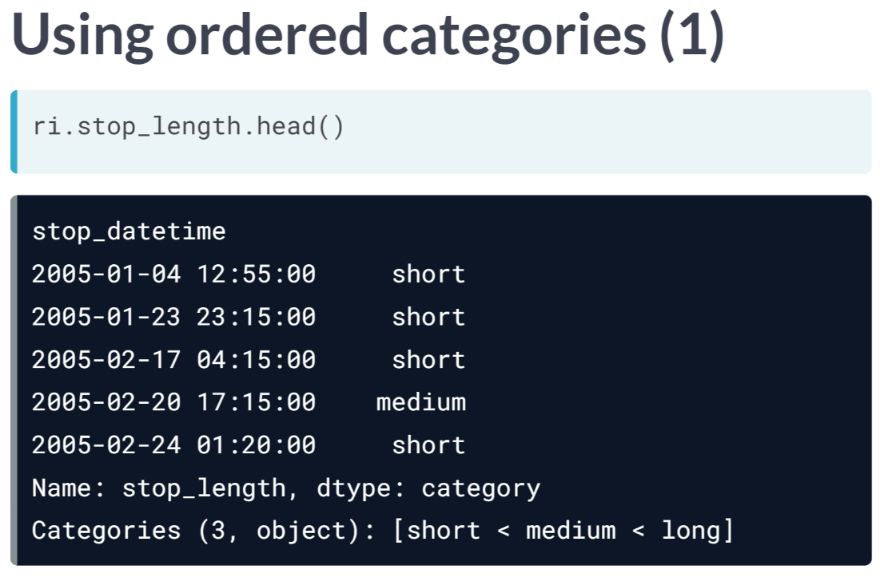Let's take a look at the head of this column. In the bottom two lines, you can see that the *dtype* is now category and the categories are ordered from short to long. Because of the ordering, you can now use comparison operators with this column.

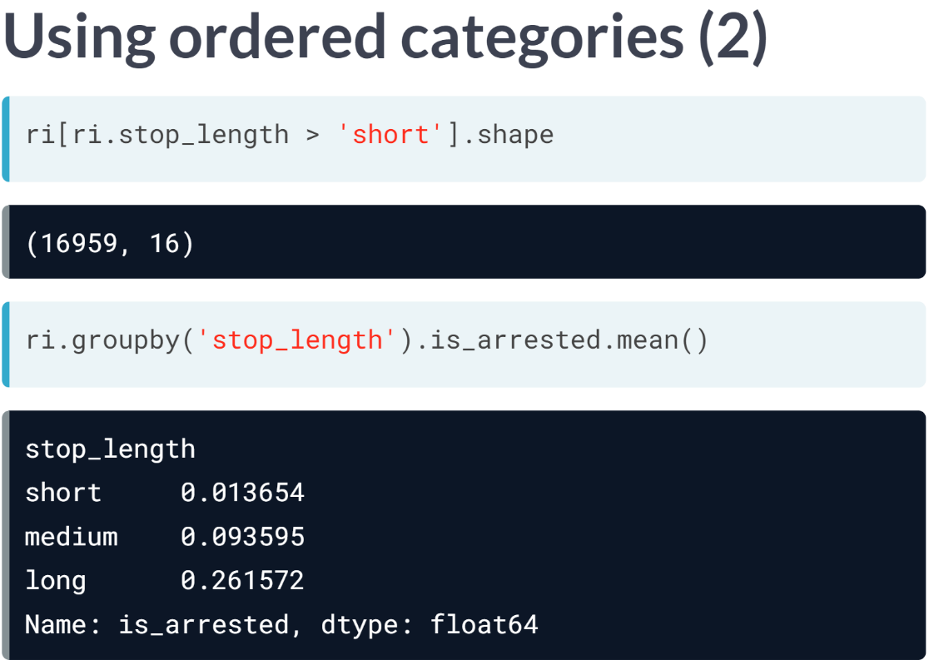For example, we can specify that *stop_length* is greater than short in order to filter the DataFrame to only include medium or long stops.

In addition, pandas will automatically sort ordered categories logically rather than alphabetically, which make the results of a calculation easier to understand.

# Counting bad weather conditions

The weather DataFrame contains 20 columns that start with 'WT', each of which represents a bad weather condition. For example:

* WT05 indicates "Hail"
* WT11 indicates "High or damaging winds"
* WT17 indicates "Freezing rain"

For every row in the dataset, each WT column contains either a 1 (meaning the condition was present that day) or NaN (meaning the condition was not present).

In this exercise, you'll quantify "how bad" the weather was each day by counting the number of 1 values in each row.

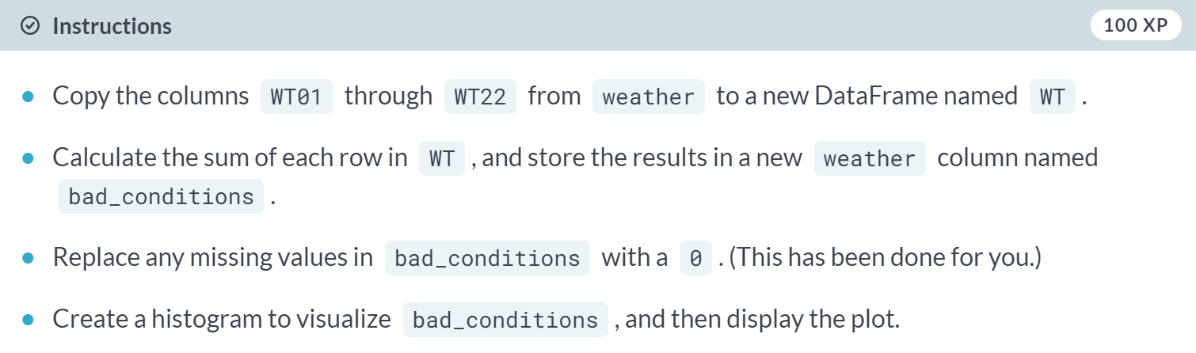

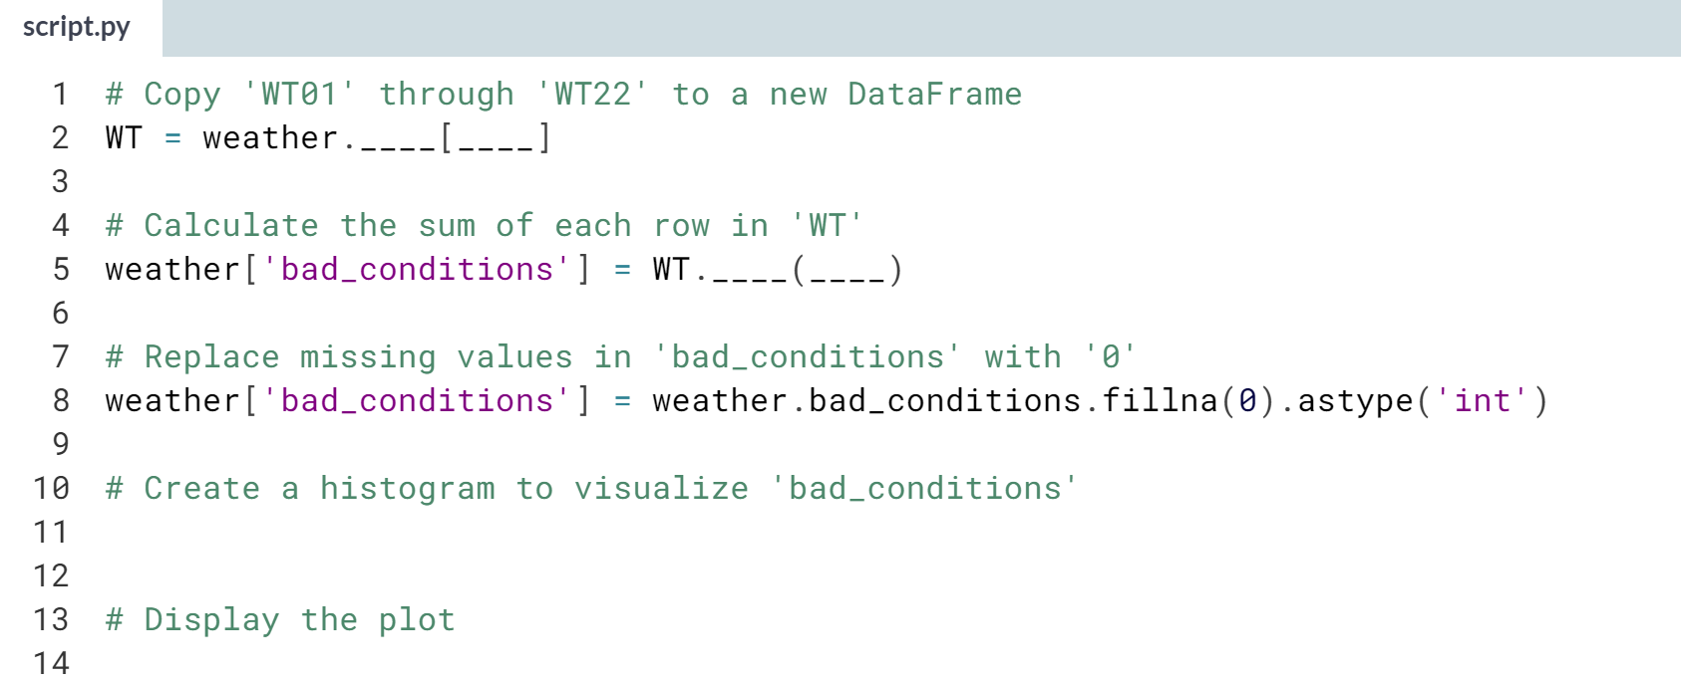

1. Use the **.loc[]** accessor to select multiple DataFrame columns that are side-by-side.
   1. For example, **weather.loc[:, 'TAVG':'TMAX']** selects the columns **TAVG** through **TMAX**.
2. To calculate the sum of each row in a DataFrame, use the ***.sum()*** method and include the argument **axis='columns'**.

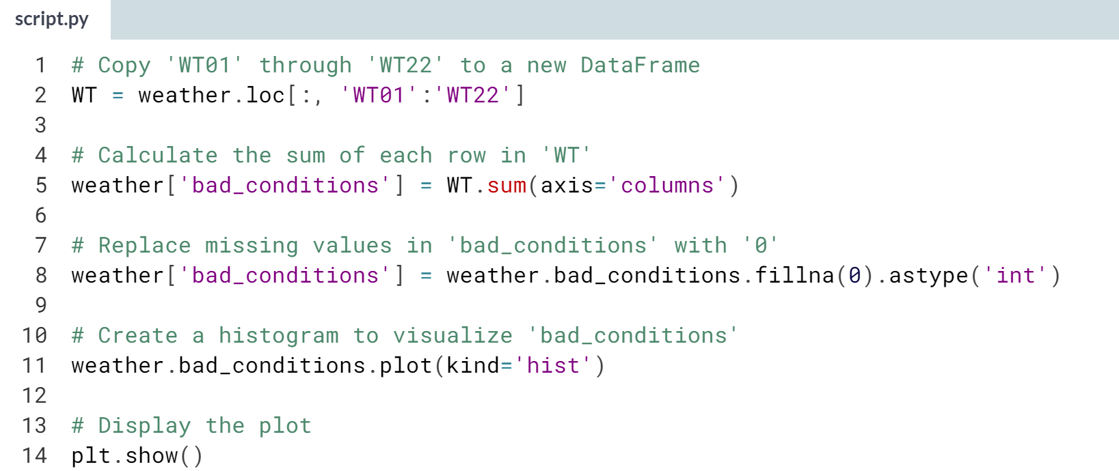

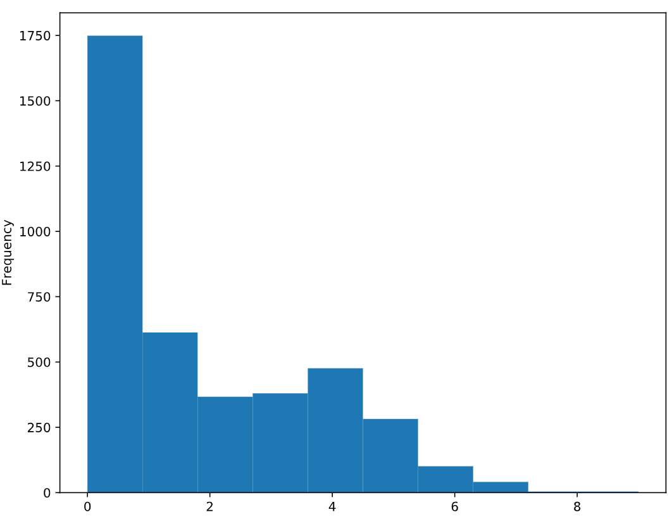

Excellent work! It looks like many days didn't have any bad weather conditions, and only a small portion of days had more than four bad weather conditions.

# Rating the weather conditions

In the previous exercise, you counted the number of bad weather conditions each day. In this exercise, you'll use the counts to create a rating system for the weather.

The counts range from 0 to 9, and should be converted to ratings as follows:

* Convert 0 to 'good'
* Convert 1 through 4 to 'bad'
* Convert 5 through 9 to 'worse'

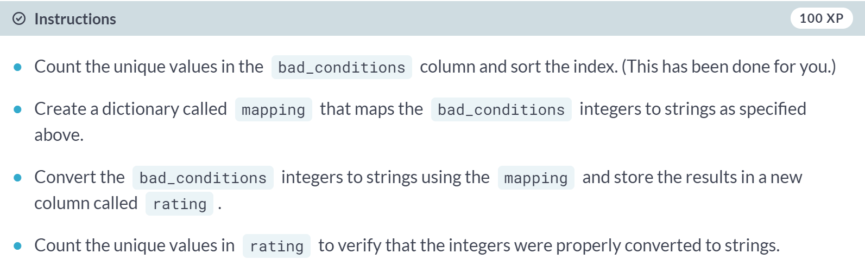

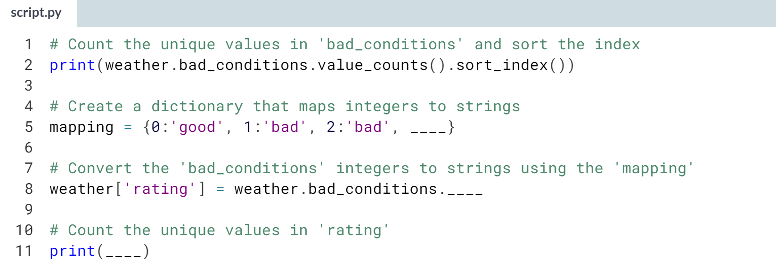

Hint

1. The **mapping** dictionary should consist of ten key-value pairs, such as **0:'good'** and **1:'bad'**.
2. Make sure that each dictionary key is an integer and each dictionary value is a string.
3. To convert the **bad_conditions** integers to strings, pass the **mapping** object to the ***.map()*** method.

(Solution on the next page)

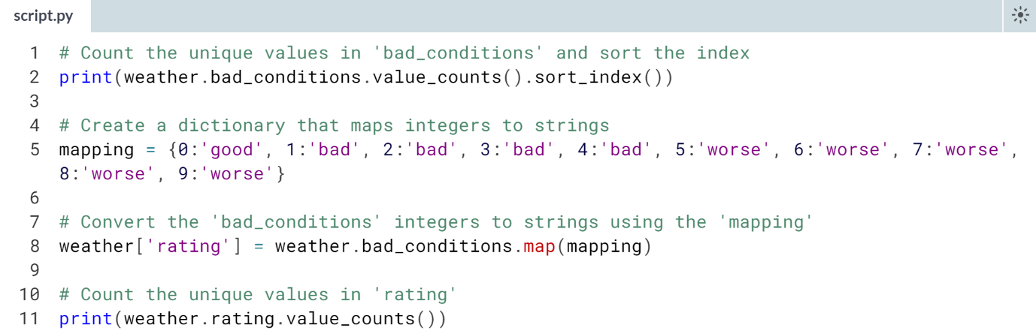

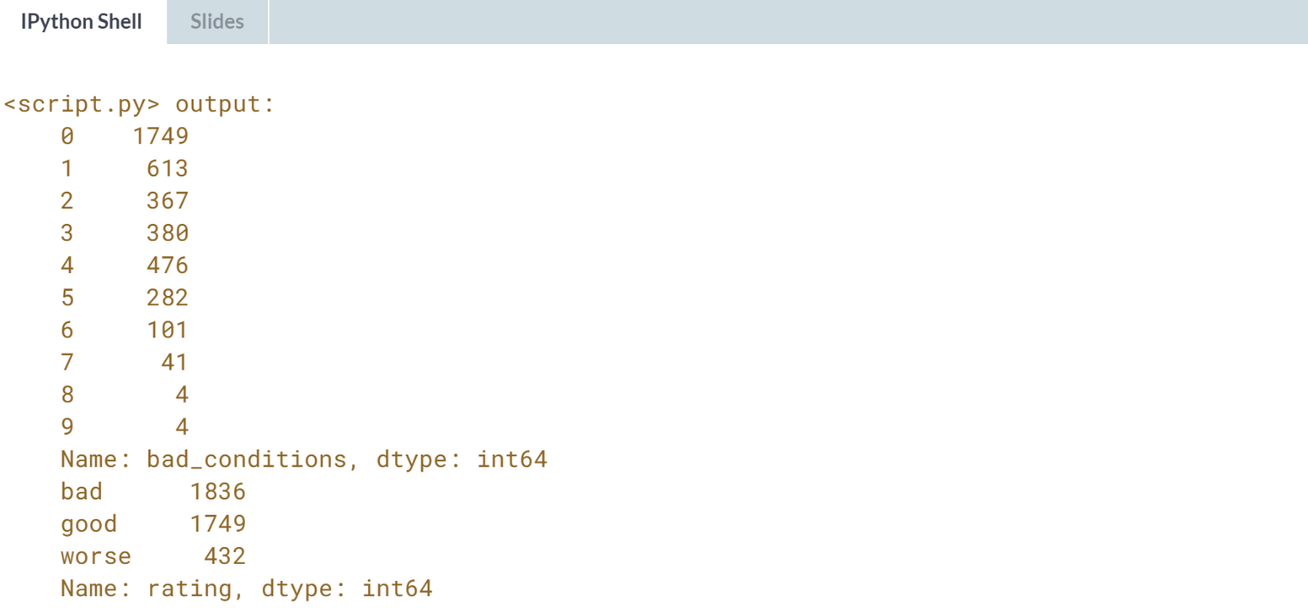

Nice job! This rating system should make the weather condition data easier to understand.

# Changing the data type to category

Since the rating column only has a few possible values, you'll change its data type to category in order to store the data more efficiently. You'll also specify a logical order for the categories, which will be useful for future exercises.

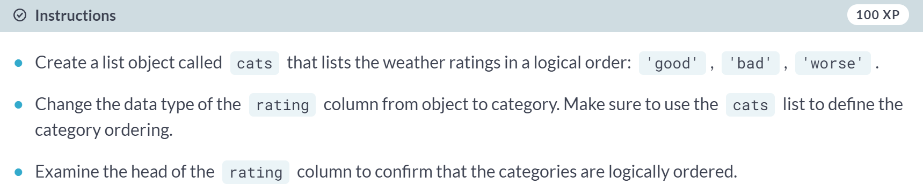

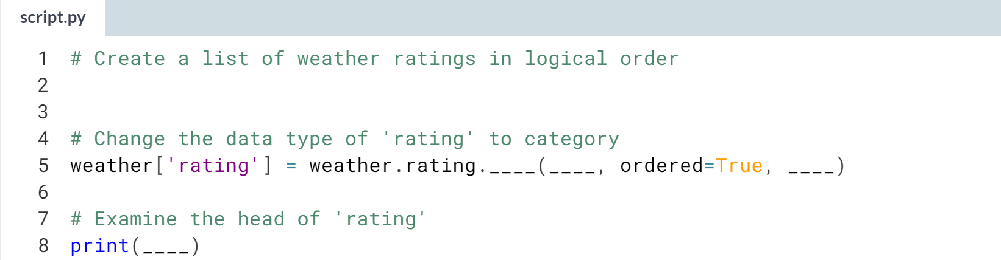

1. To change the data type of rating, use the ***.astype()*** method and specify the **'category'** type.
2. To create ordered categories, use the arguments **ordered=True** and **categories=cats** with the ***.astype()*** method.

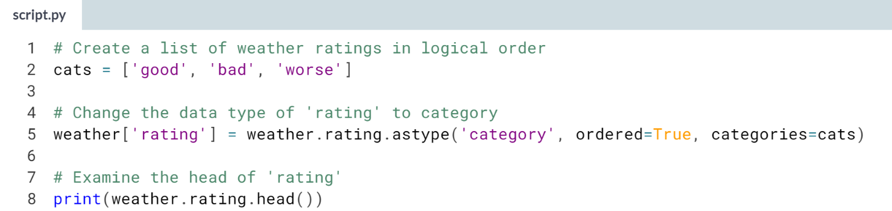

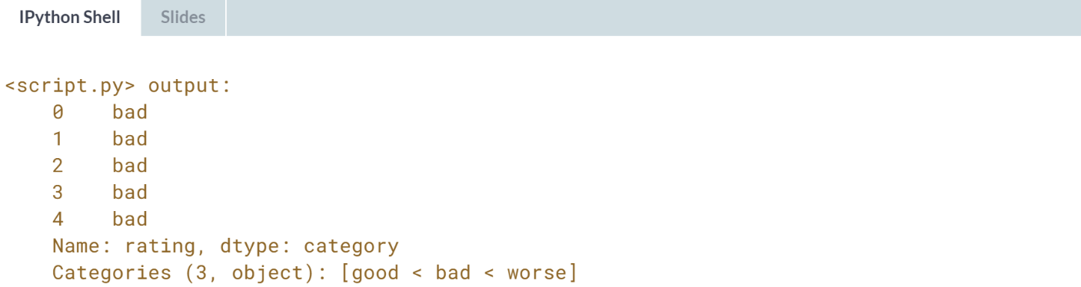



Now that we've assigned a rating to the weather conditions each day, we need to merge that data with the traffic stop so that we can analyze the relationship between weather and police behavior.

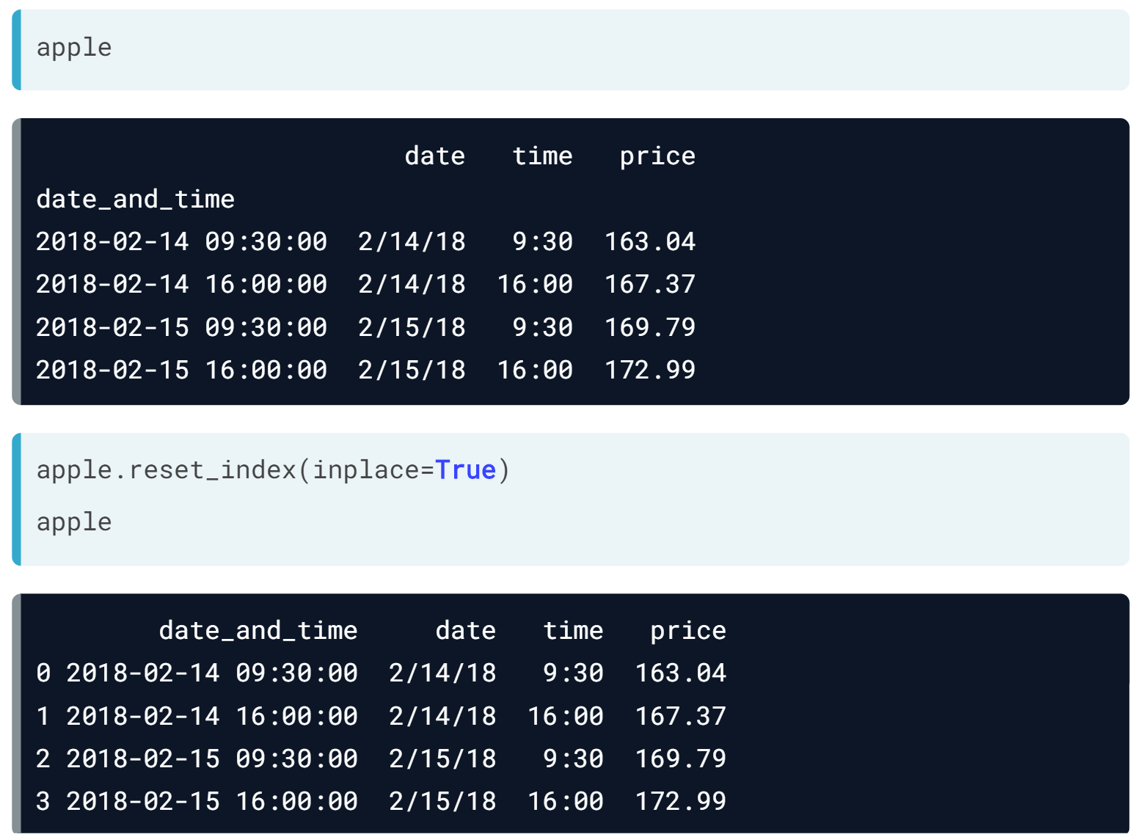We will return to the DataFrame of Apple stock prices that we've used throughout the course.

This time, the opening price at 9:30 AM and closing price at 4:00 PM are listed for each day in separate rows.

Shortly, we are going to merge the apple DataFrame with another DataFrame. Because the index will be lost during the merge, we want to save it by moving it to a DataFrame column.

We will do this by using the ***reset_index()*** method and specifying that the operation should occur in place. You can now see that *date_and_time* is now a DataFrame column, and the index is now the default integer index.

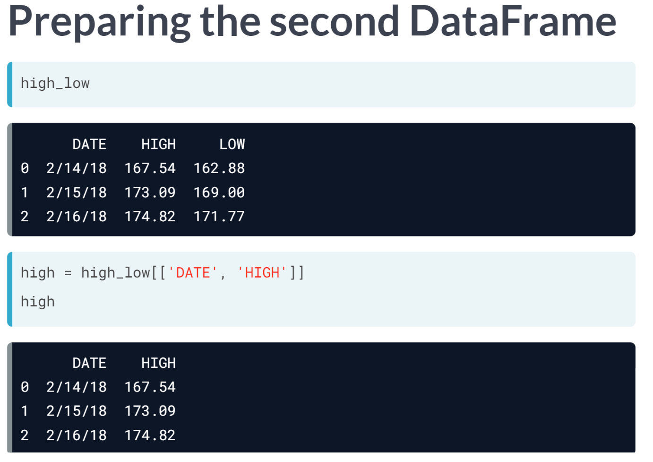The second DataFrame we are working with is called *high_low*, and it contains the highest and lowest prices the Apple stock reached each day.

We would like to include the high data in the apple DataFrame, which we can do by merging the DataFrames.

For the merge operation, we only need two columns from *high_low*: the *date* column, since it's the column on which the DataFrames will be joined, and the *high* column, since it's the column of interest.

Thus, we will create a new DataFrame called high that only includes these two columns.

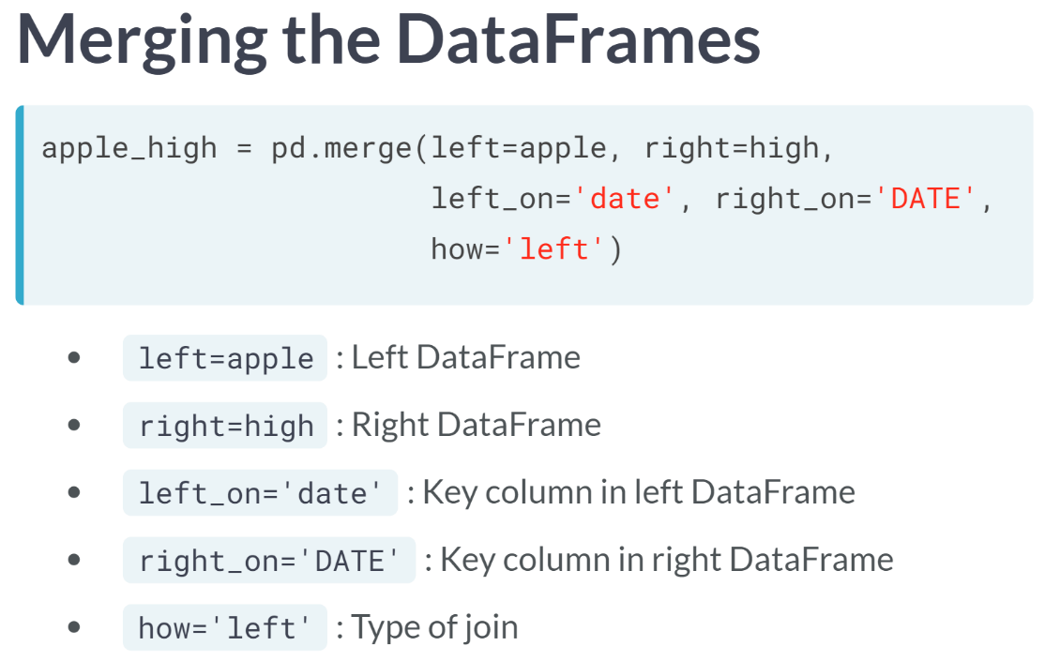  
To merge the apple and high DataFrames, we will use the ***pd.merge()*** function and save the result as *apple_high*. Let's review the five arguments.

First, we specified the left and right DataFrames. Apple is defined as left and high is defined as right because we wanted to join the high DataFrame onto the apple DataFrame.

Next, we specified the columns on which to join the DataFrames. Both DataFrames have a column containing the date, but we had to specify them separately because the column name is lowercase in the left DataFrame and uppercase in the right DataFrame.

Finally, we specified the type of join. We used a left join to keep all of the rows from the left DataFrame regardless of whether there were matches in the right DataFrame.

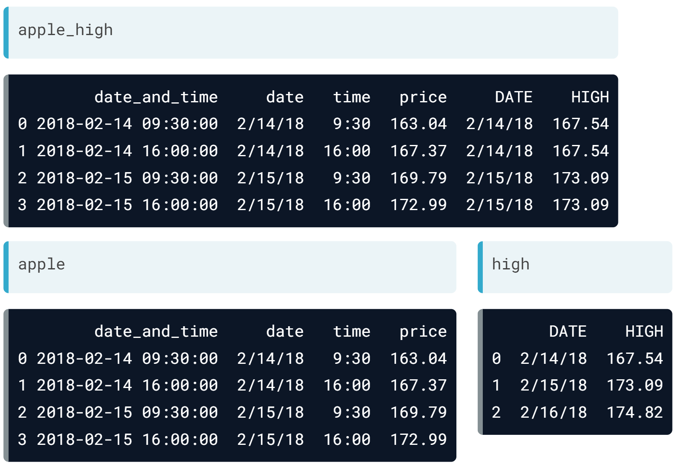Let's compare the merged DataFrame with the original two DataFrames.

The first four columns of *apple_high* are identical to apple. The data in the final two columns of *apple_high* came from the high DataFrame. Because the apple DataFrame contained two rows each from February 14 and 15, the high value of each of those dates appears twice in the *apple_high* DataFrame.

But since the apple DataFrame didn't contain any rows from February 16, the February 16 value from the high DataFrame was ignored.

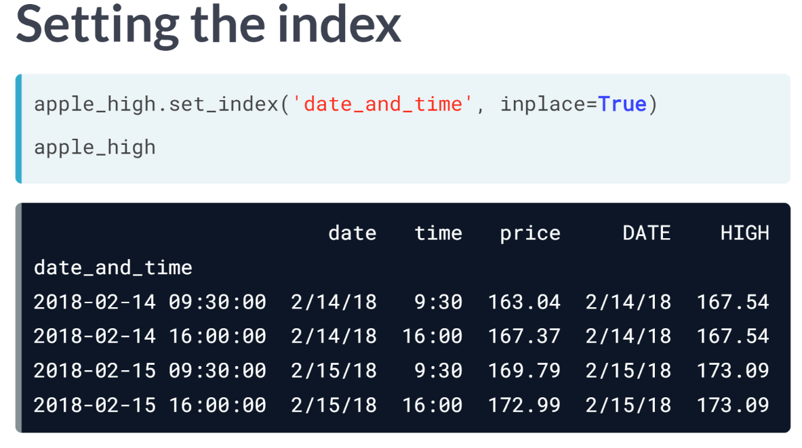   
Since the merge is complete, we will set the *date_and_time* column as the index of the *apple_high* DataFrame. This replaces the default index and reduces the number of columns to five.

# Preparing the DataFrames

In this exercise, you'll prepare the traffic stop and weather rating DataFrames so that they're ready to be merged:

1. With the ri DataFrame, you'll move the stop_datetime index to a column since the index will be lost during the merge.
2. With the weather DataFrame, you'll select the DATE and rating columns and put them in a new DataFrame.

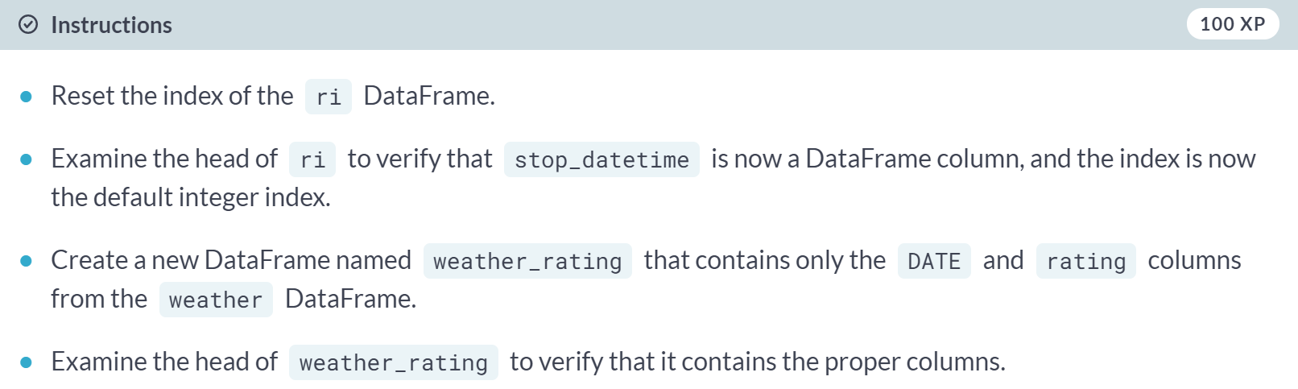

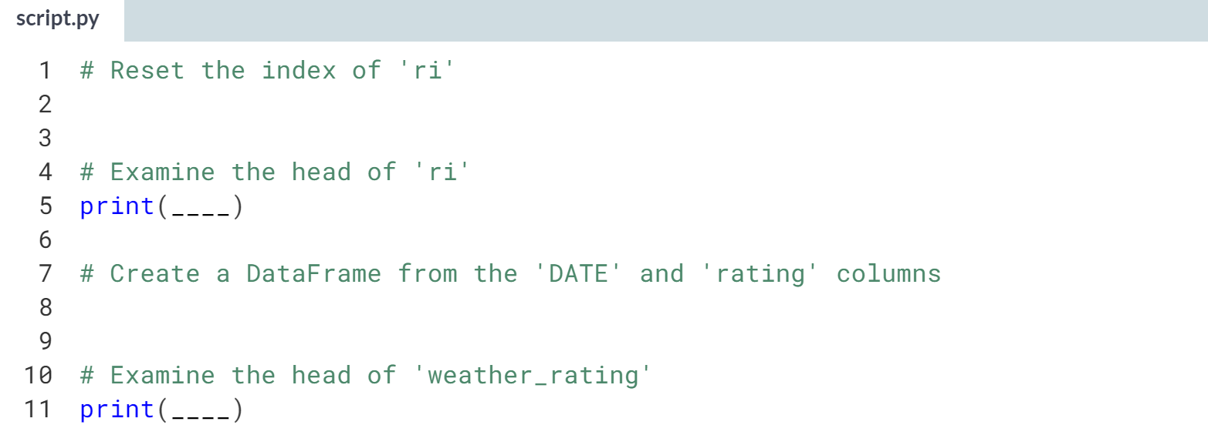

Hint

1. When resetting the index of *ri*, make sure to use the **inplace=True** argument.
2. Select the desired columns from **weather** using double brackets: **weather[[...]]**.
3. Keep in mind that DataFrame column names are case-sensitive!

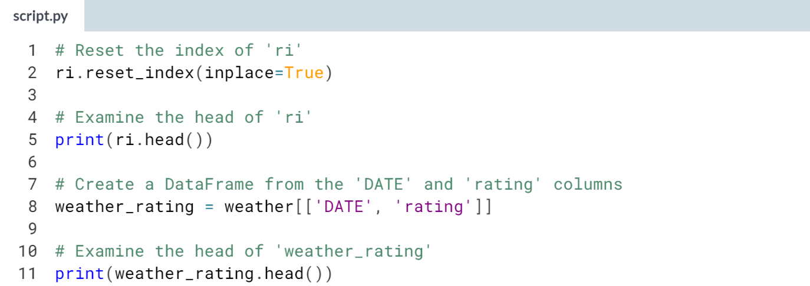

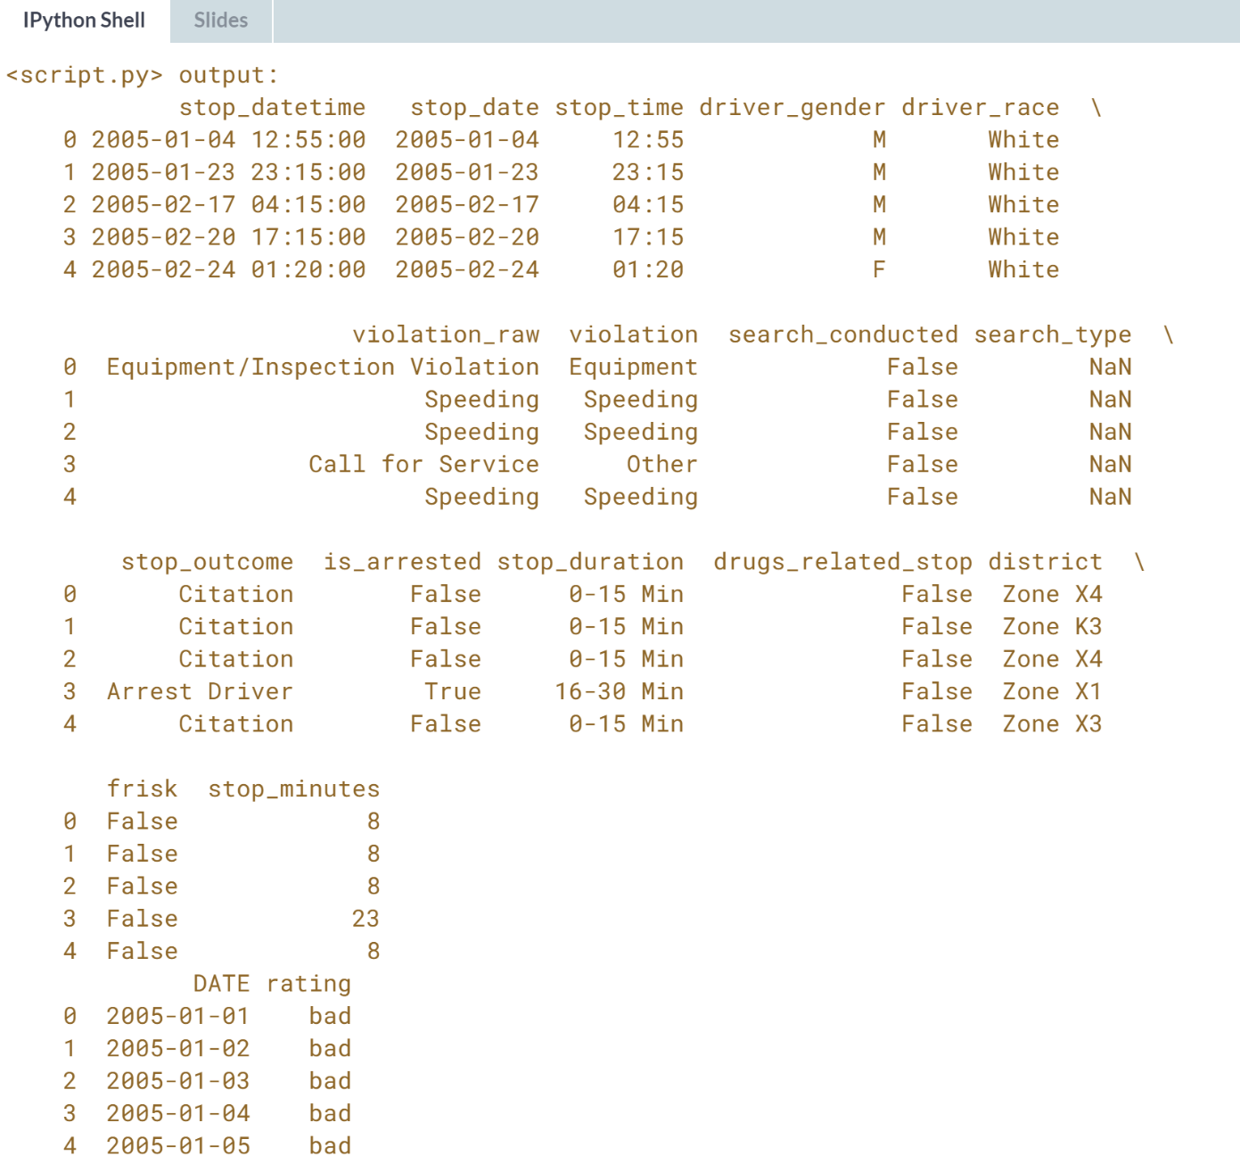

Great work! The **ri** and **weather_rating** DataFrames are now ready to be merged.

# Merging the DataFrames

In this exercise, you'll merge the ri and weather_rating DataFrames into a new DataFrame, ri_weather.

The DataFrames will be joined using the stop_date column from ri and the DATE column from weather_rating. Thankfully the date formatting matches exactly, which is not always the case!

Once the merge is complete, you'll set stop_datetime as the index, which is the column you saved in the previous exercise.

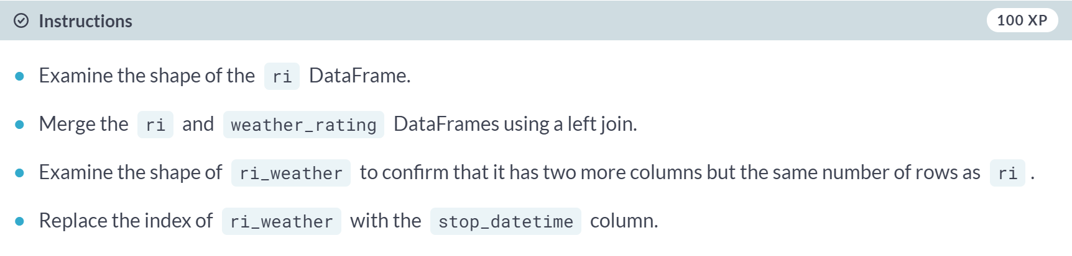

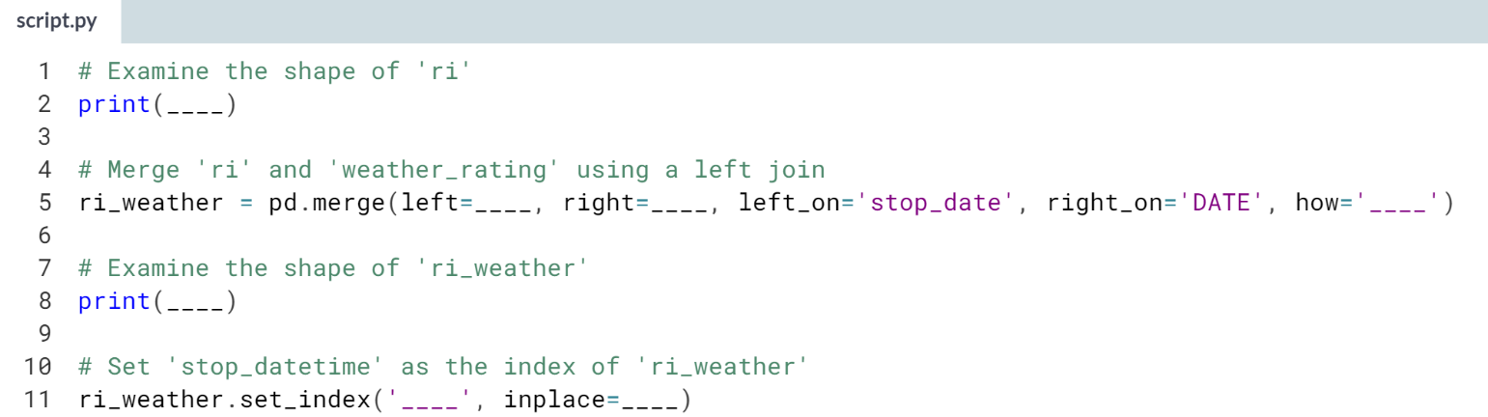

Hint

1. The **left** and **right** arguments specify the two DataFrames that should be joined.
2. The **how** argument specifies the type of join that should be used.
3. Use the ***.set_index()*** method to set an existing column as the index, and make sure to include the **inplace=True** argument.

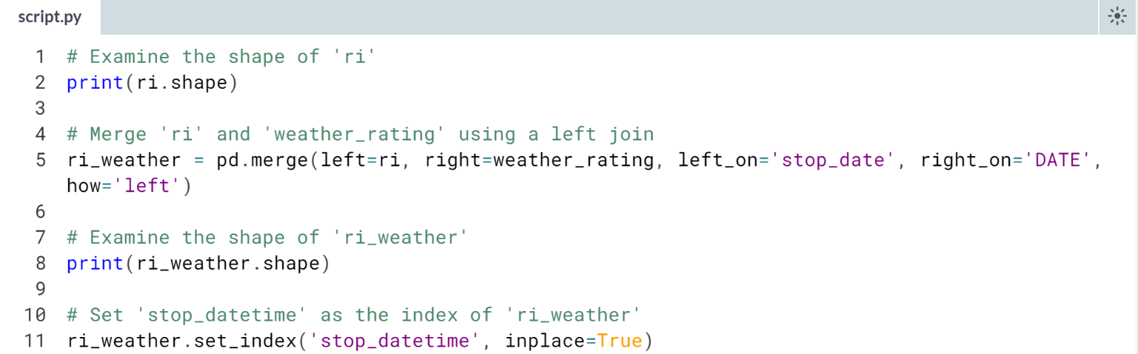

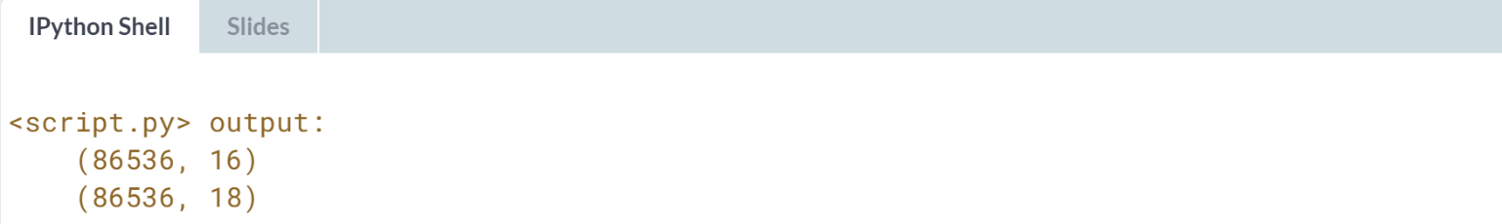

Fantastic! In the next section, you'll use *ri_weather* to analyze the relationship between weather conditions and police behavior.



Let's now analyze the relationship between weather and police behavior.

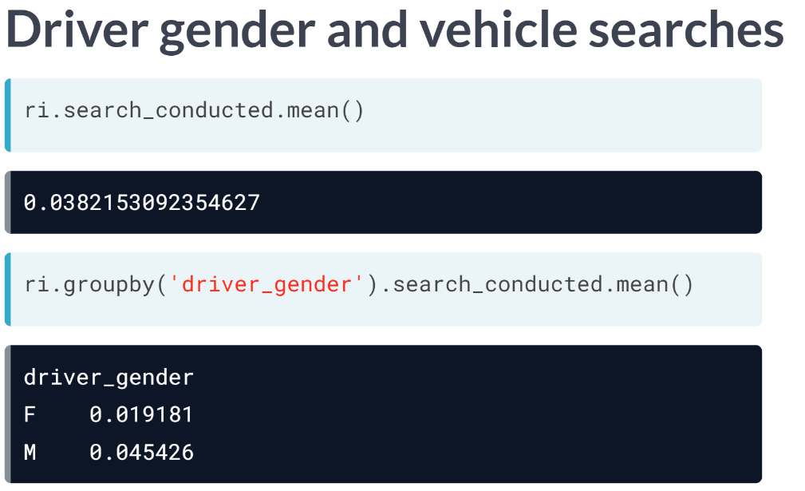  
In a previous chapter, we investigated the relationship between driver gender and vehicle searches. First, we calculated the percentage of all stops that led to a search by taking the ***mean()*** of the Boolean Series *search_conducted*. This is called the search rate.

Then, we compared the search rates for male and female drivers by using a ***groupby()*** on *driver_gender* before taking the ***mean()*** of *search_conducted*. We found that male drivers are searched more than twice as often as female drivers.

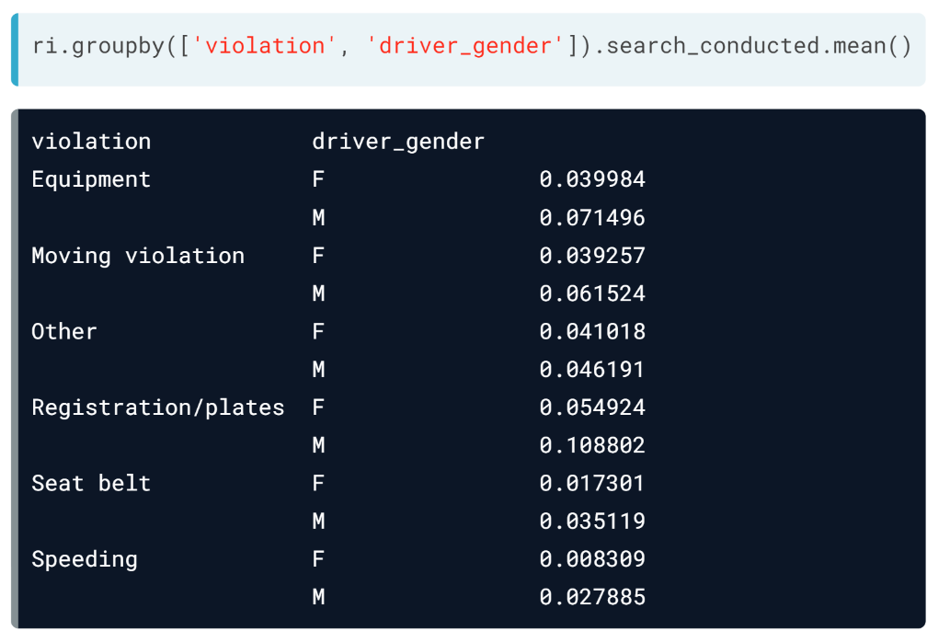  
Finally, we added violation to the ***groupby()*** operation. Our hypothesis was that search rate varies by violation type, and the difference in search rate between males and females is perhaps because they tend to commit different violations.

The results disproved our hypothesis, because the search rate is higher for males than for females across all violations. This doesn't provide a causal link between gender and vehicle searches, but it does show a correlation.

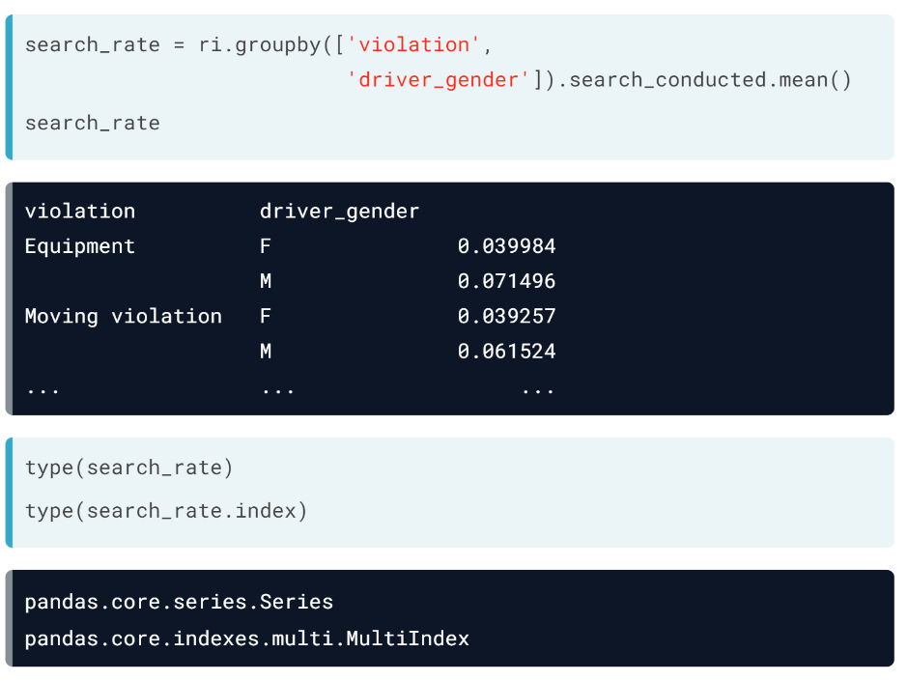  
Let's save the result of the previous operation as new object called *search_rate* and print out again. What type of object is this?

It may look like a DataFrame because of its structure, but it's actually a **pandas Series that has a MultiIndex**. *Violation* and *driver_gender* are not columns, rather they are the names of the index levels. You've seen the MultiIndex before in the context of a DataFrame.

With a DataFrame, which is normally two dimensions, the MultiIndex added a third dimension. With a Series, which is normally one dimension, the MultiIndex adds a second dimension.

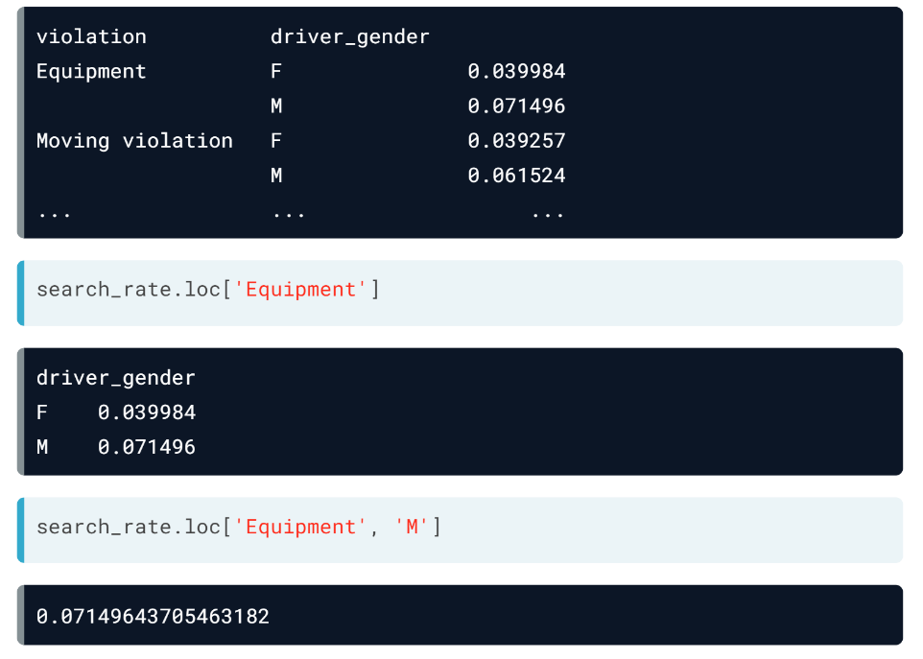  
When looking at *search_rate* Series again, we can see that working with a multi-indexed Series is actually very similar to working with a DataFrame. You can think of the outer index level, *violation*, as the DataFrame rows, and the inner index level, *driver_gender*, as the DataFrame columns.

For example, we can use the loc accessor to select the *Equipment* row. This returns the search rate by gender for equipment violations only.

Or, we can specify the Equipment row and the Male column to select a particular value in the Series.

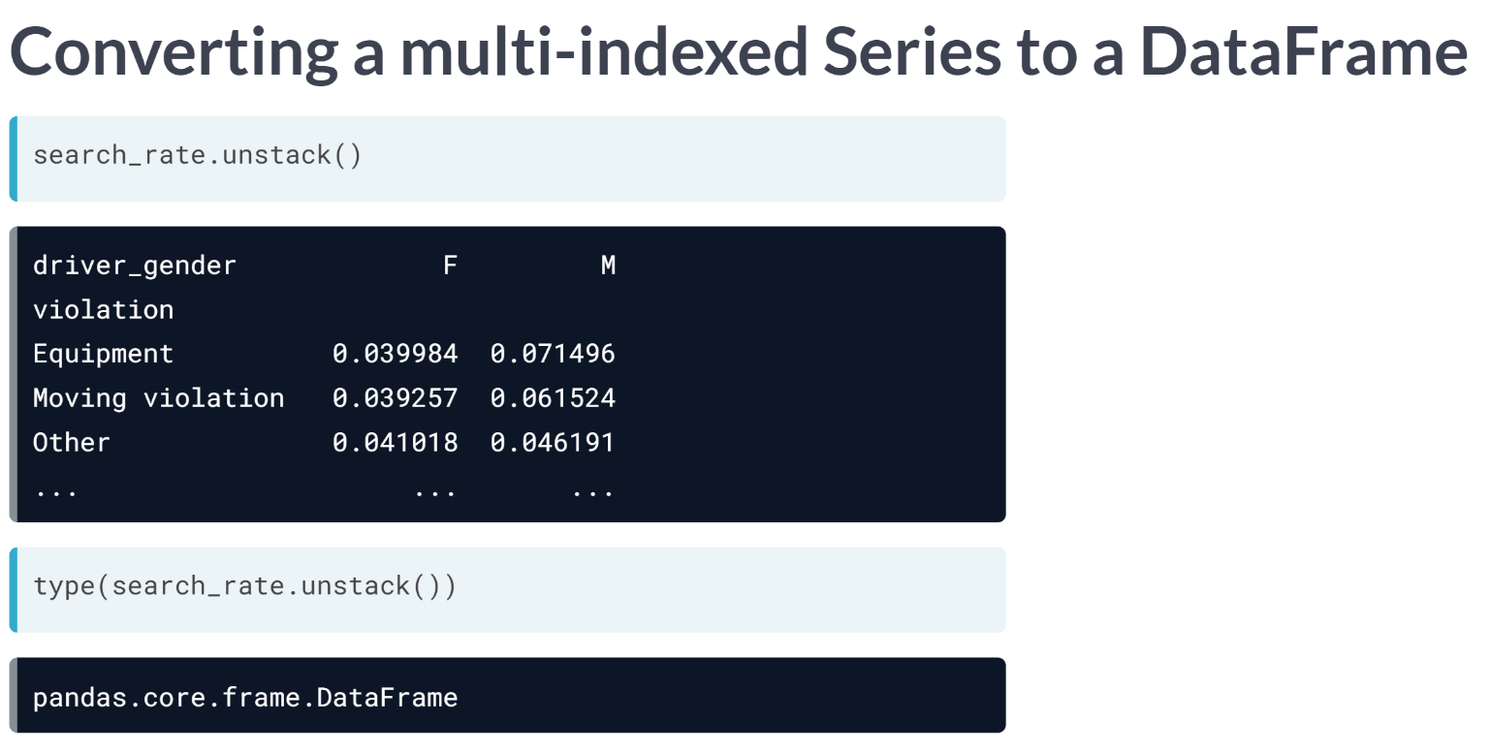  
You might think that if a multi-indexed Series is similar to a DataFrame, then there should be a way to convert one to the other.

In fact, if you unstack() the search_rate Series, it actually results in a DataFrame. This is a useful technique any time you have a Series with a MultiIndex, since you are probably more comfortable manipulating a DataFrame.

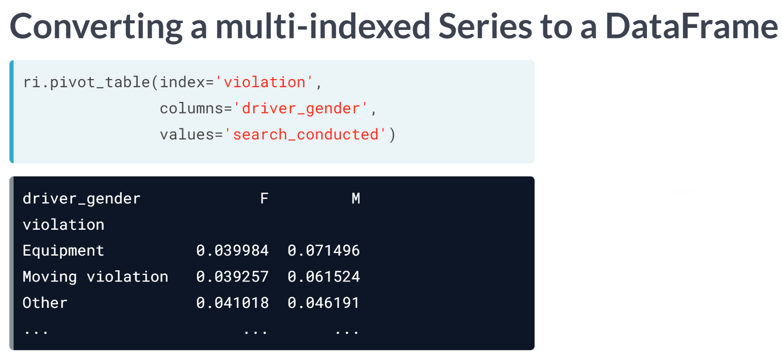  
You might also think that there is an easy way to create this DataFrame without using a ***groupby()*** and an ***unstack()***. In fact, you can use a pivot table to produce the exact same DataFrame.

# Comparing arrest rates by weather rating

Do police officers arrest drivers more often when the weather is bad? Find out below!

* First, you'll calculate the overall arrest rate.
* Then, you'll calculate the arrest rate for each of the weather ratings you previously assigned.
* Finally, you'll add violation type as a second factor in the analysis, to see if that accounts for any differences in the arrest rate.

Since you previously defined a logical order for the weather categories, good < bad < worse, they will be sorted that way in the results.

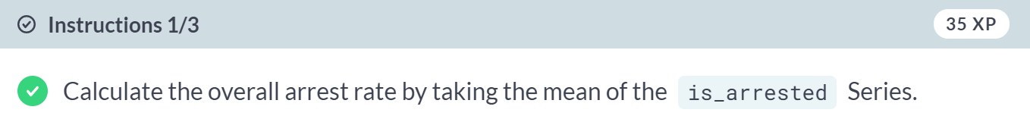

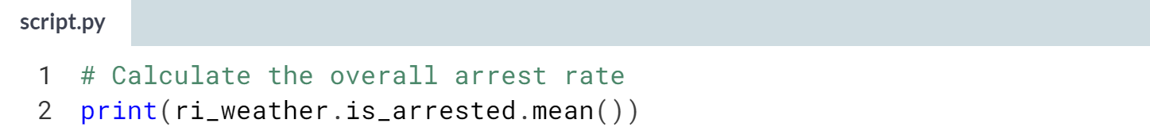

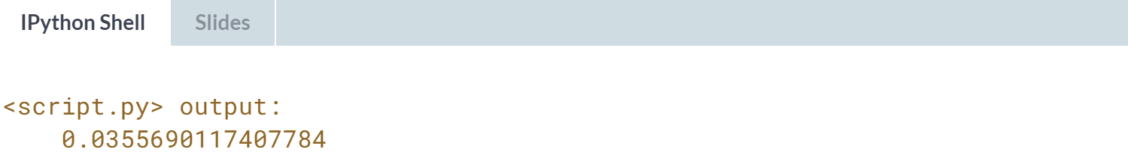

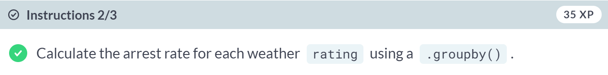

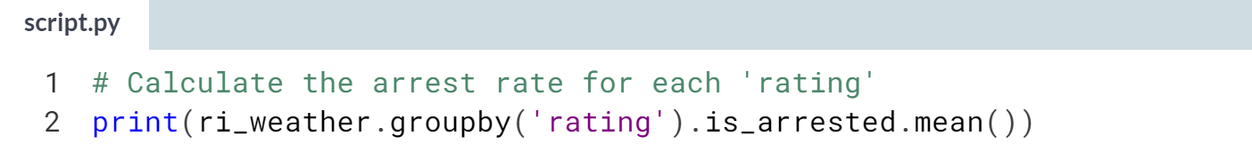

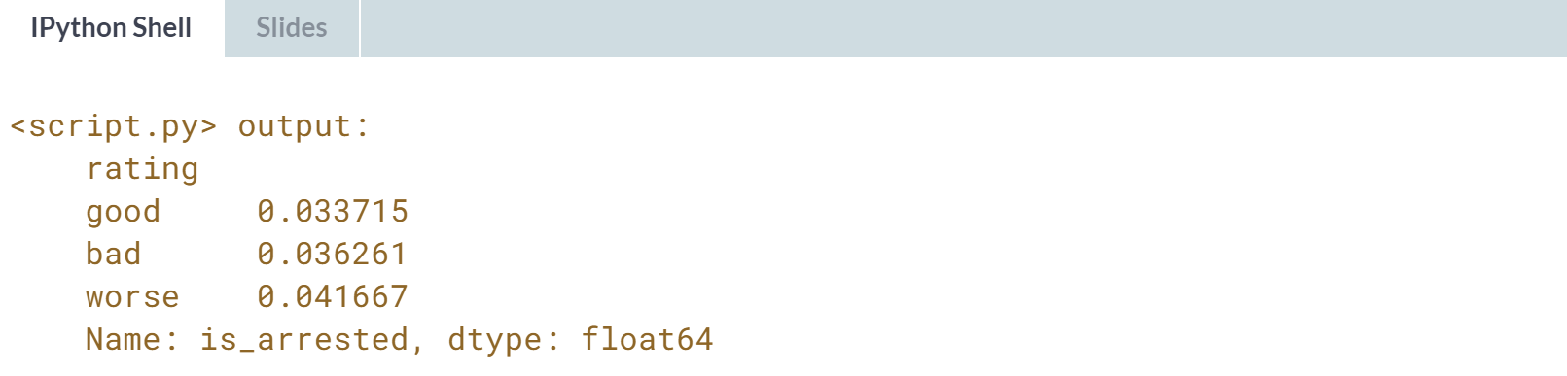

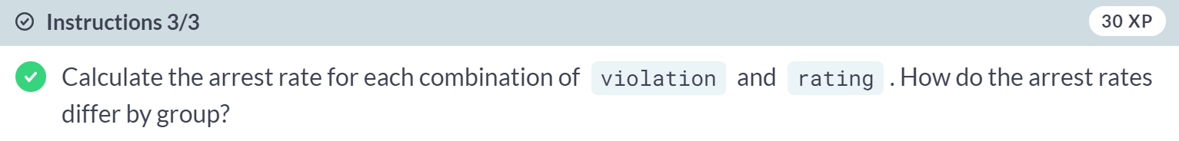



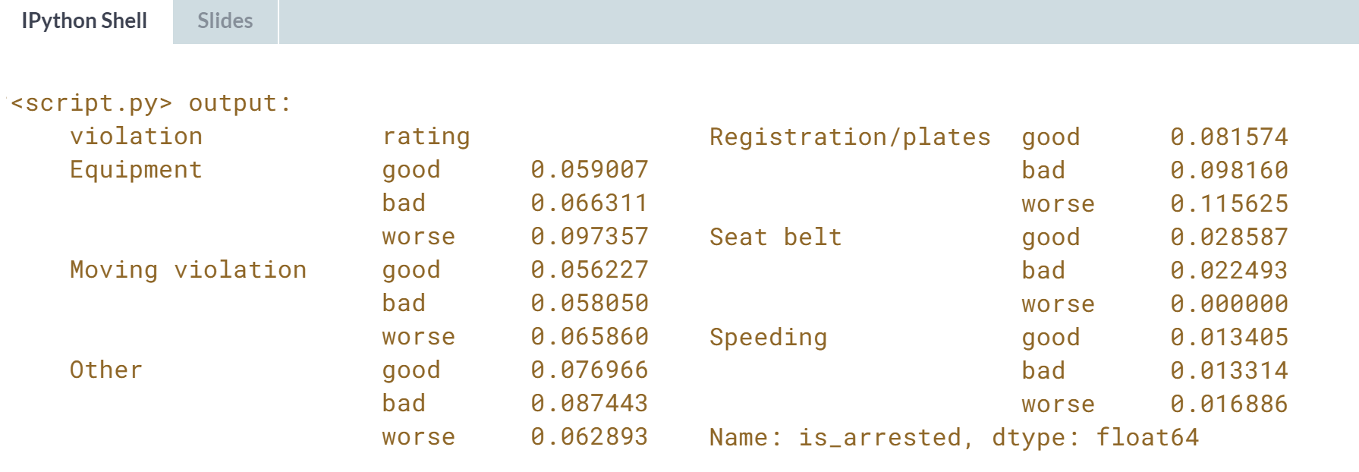

Wow! The arrest rate increases as the weather gets worse, and that trend persists across many of the violation types. This doesn't prove a causal link, but it's quite an interesting result!

# Selecting from a multi-indexed Series

The output of a single .groupby() operation on multiple columns is a Series with a MultiIndex. Working with this type of object is similar to working with a DataFrame:

* The outer index level is like the DataFrame rows.
* The inner index level is like the DataFrame columns.

In this exercise, you'll practice accessing data from a multi-indexed Series using the .loc[] accessor.

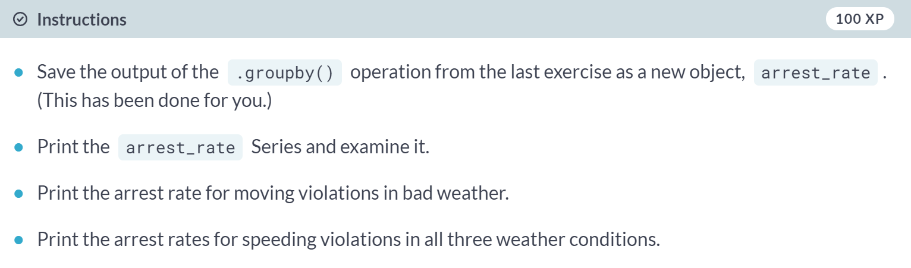

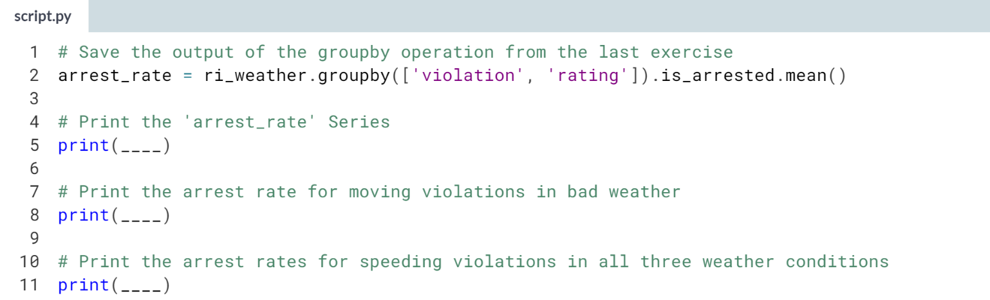

Hint

1. You can select a single value from the Series as follows: **series_name.loc['outer index level', 'inner index level']**.
2. You can select a row from the Series as follows: **series_name.loc['outer index level']**.

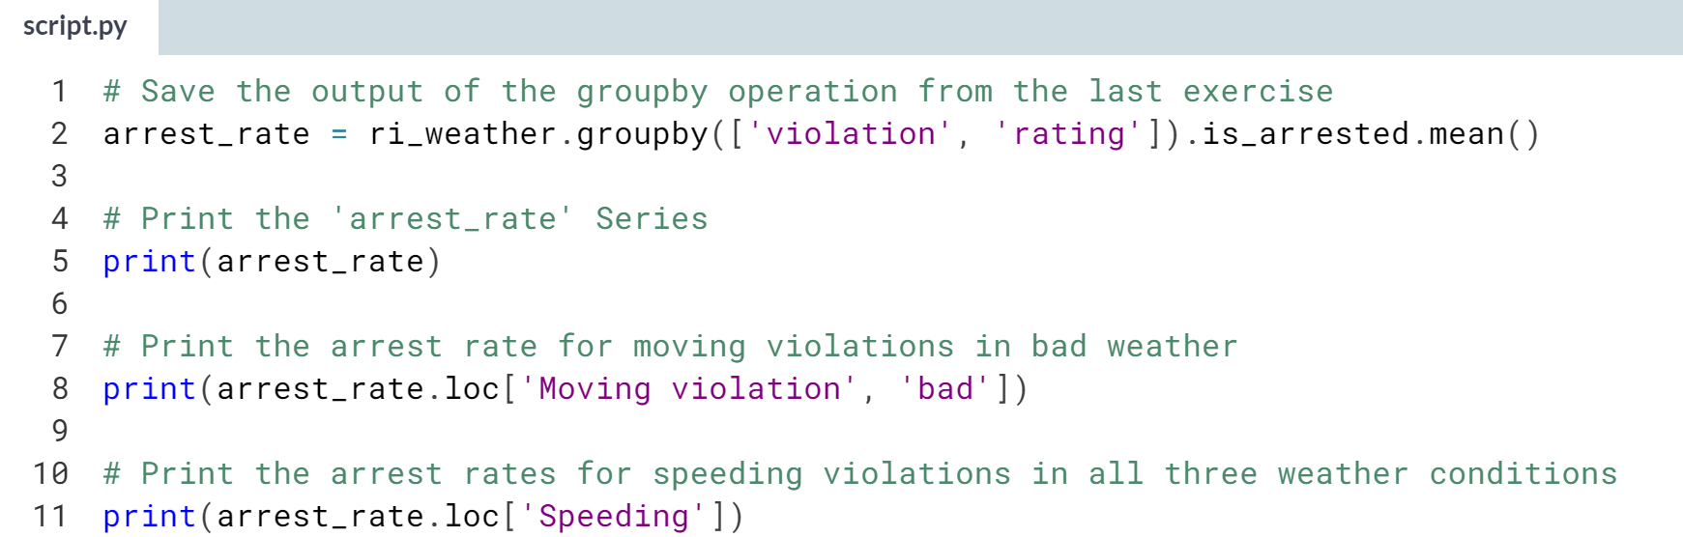

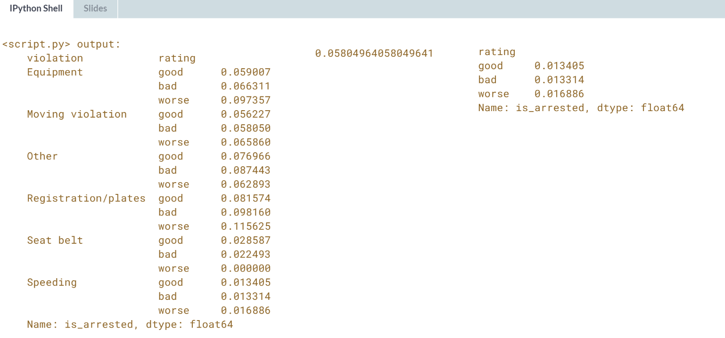

Great job! The **.loc[]** accessor is a powerful and flexible tool for data selection.

# Reshaping the arrest rate data

In this exercise, you'll start by reshaping the arrest_rate Series into a DataFrame. This is a useful step when working with any multi-indexed Series, since it enables you to access the full range of DataFrame methods.

Then, you'll create the exact same DataFrame using a pivot table. This is a great example of how pandas often gives you more than one way to reach the same result!

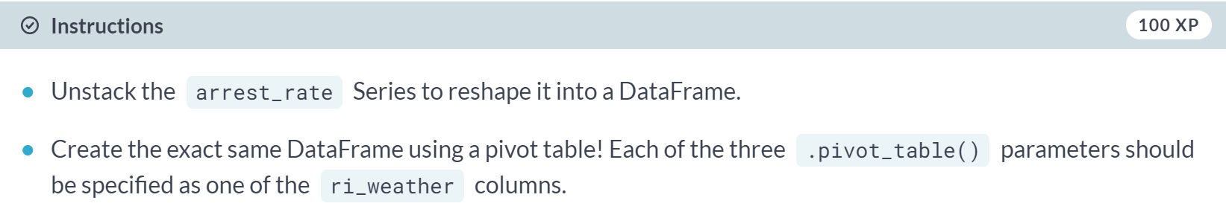

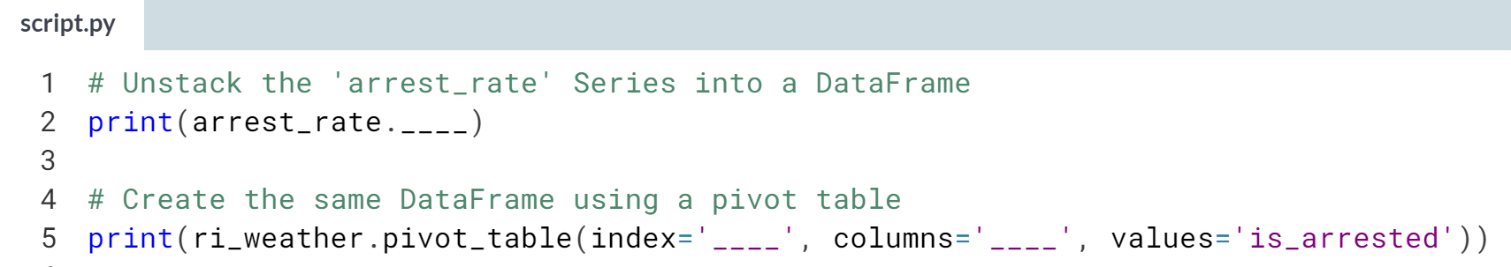

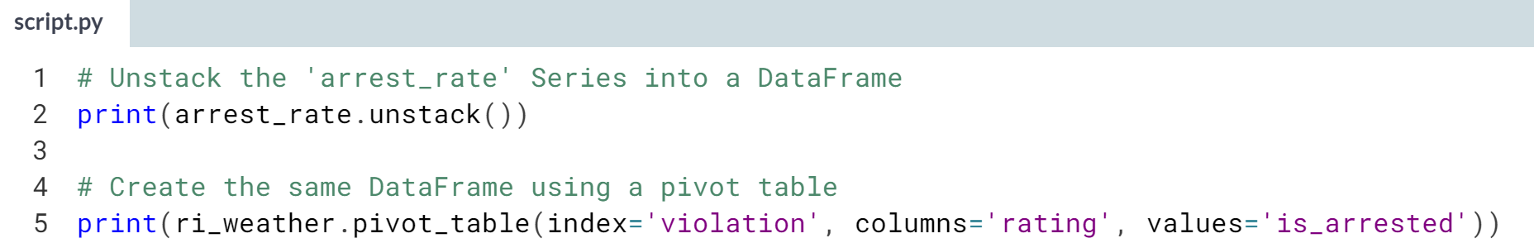

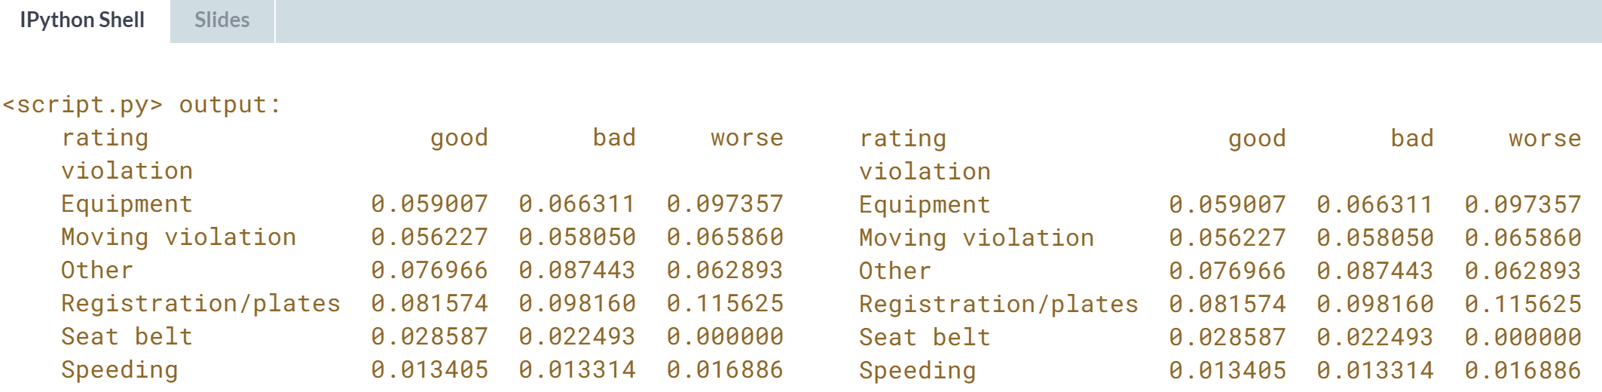

Excellent work! In the future, when you need to create a DataFrame like this, you can choose whichever method makes the most sense to you.